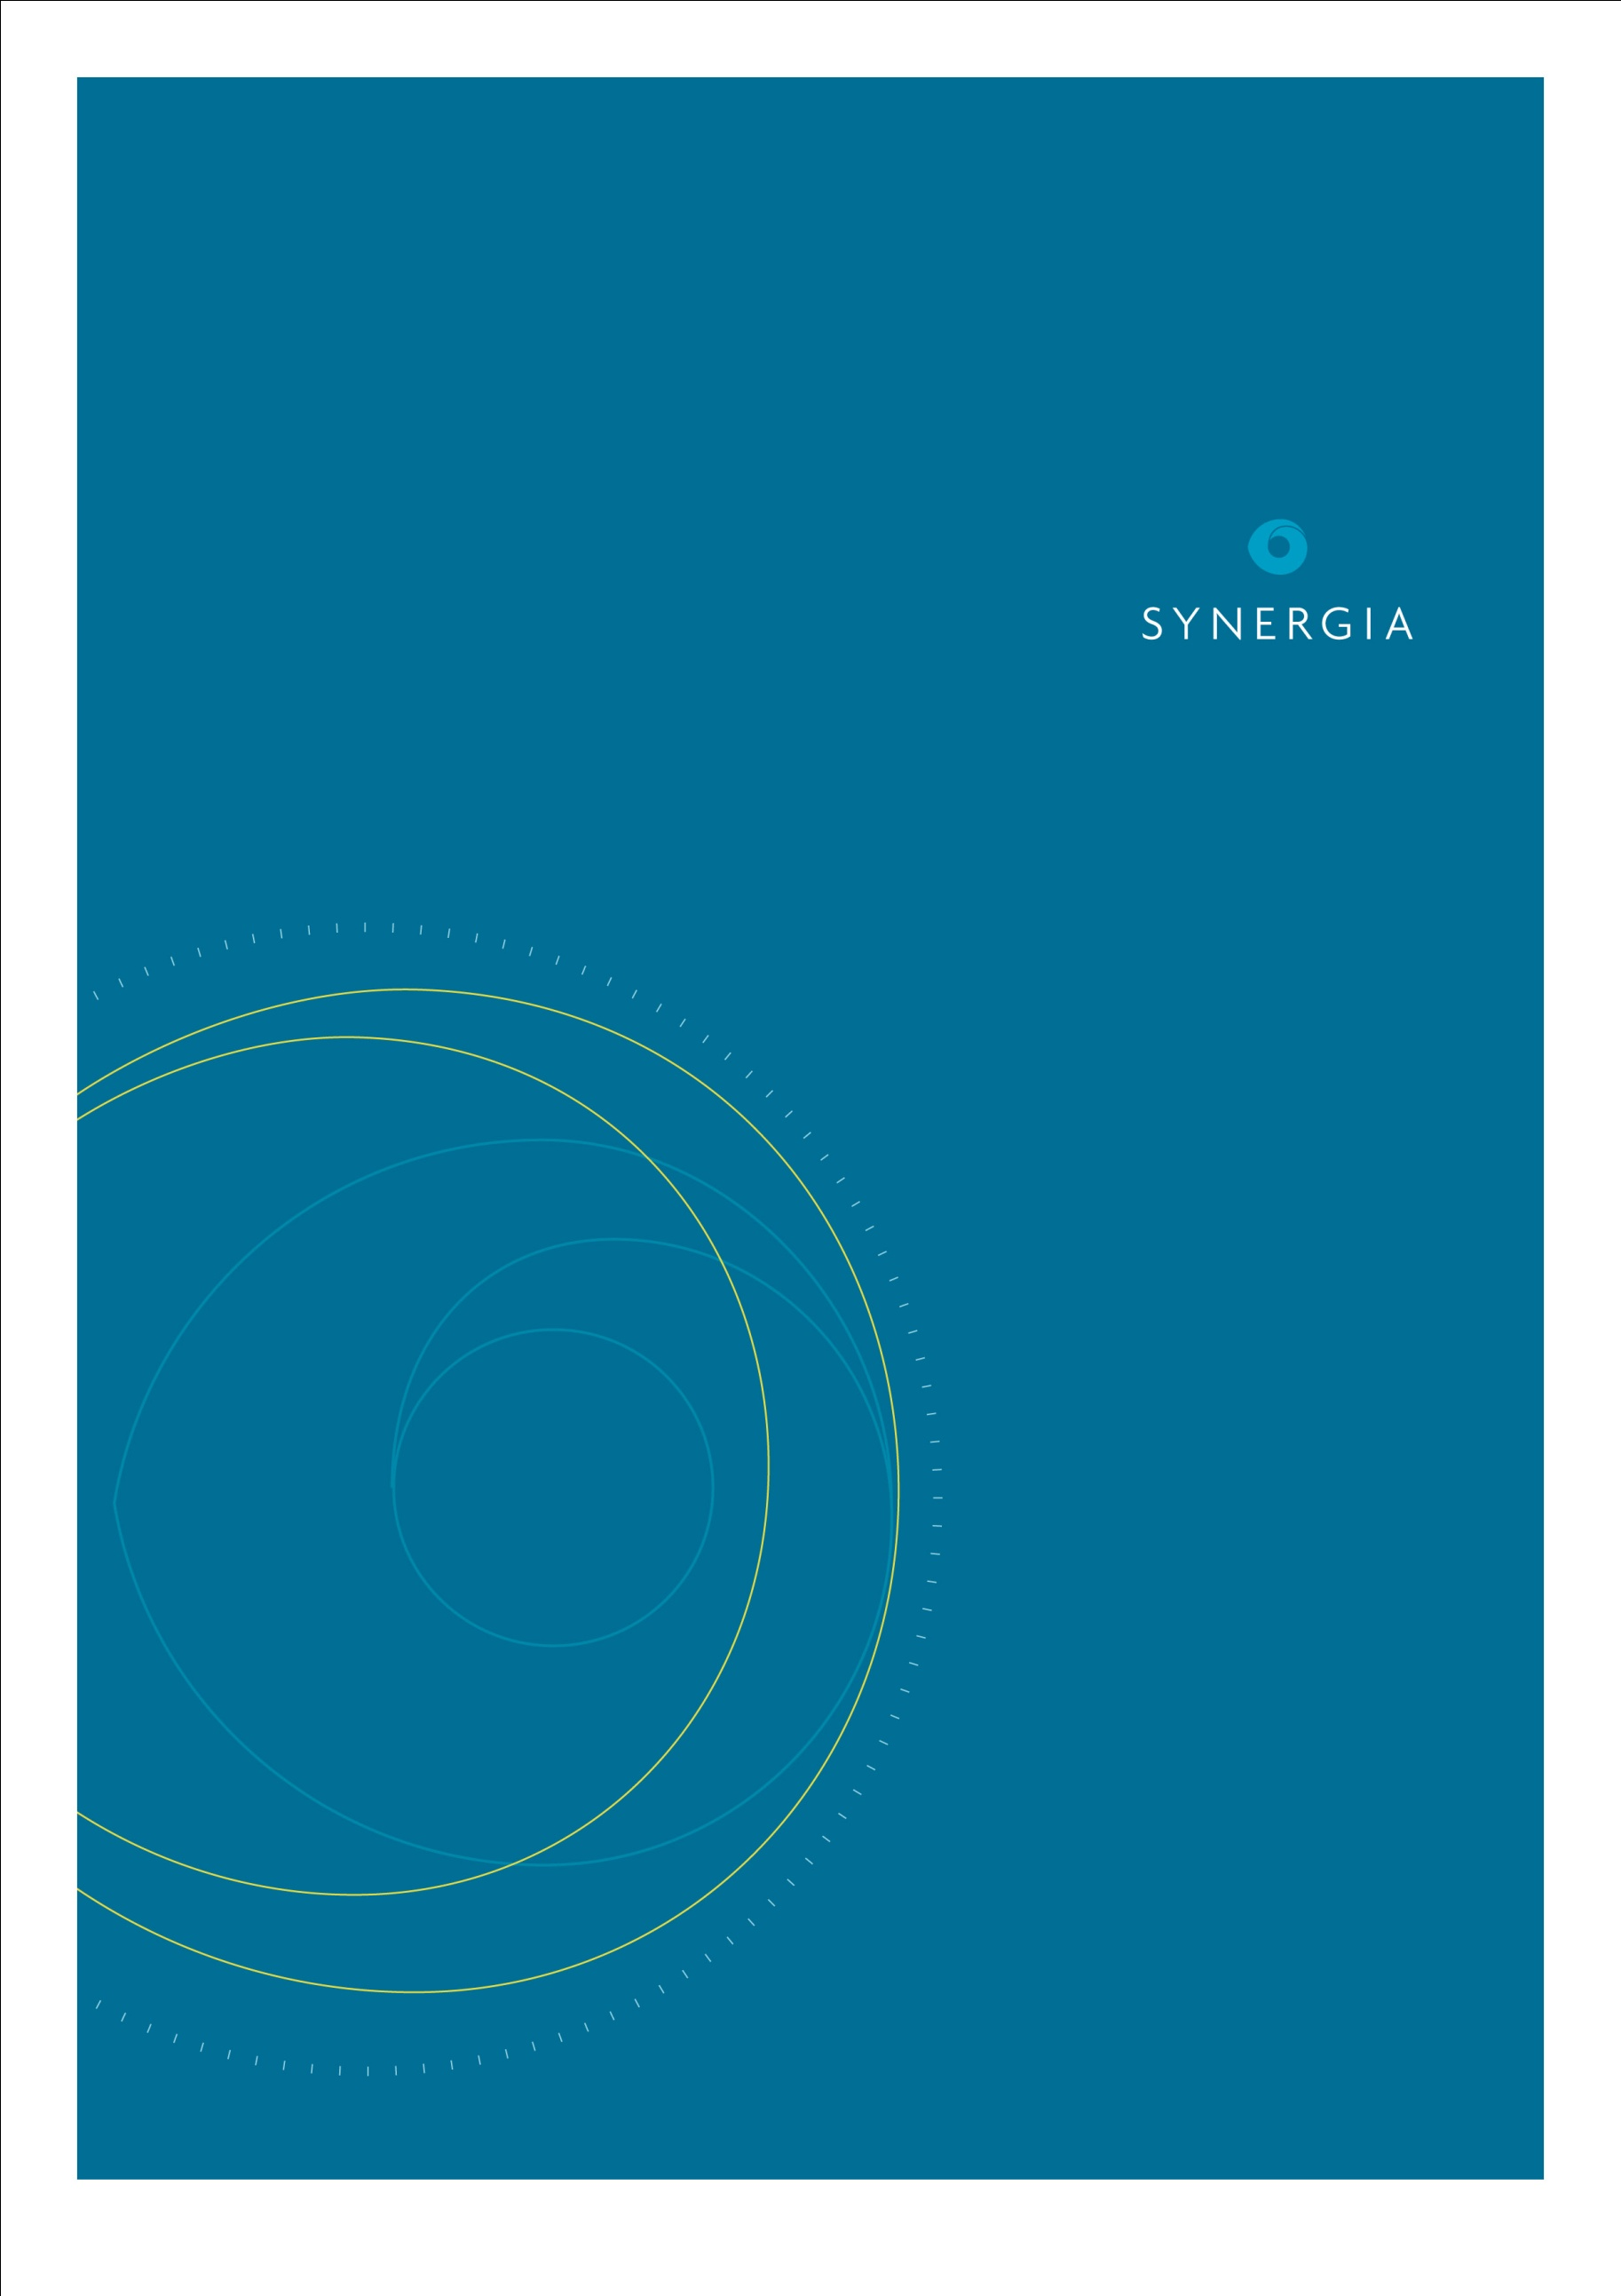
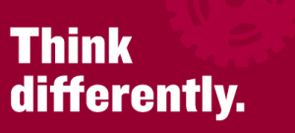

Think Differently: Case Study Summary Report

Report for Ministry of
Social Development

Dr Sarah Appleton-Dyer
Nishadie Edirisuriya
Dr Adrian Field
Angela Boswell

28 September 2015
Synergia Ltd
P.O. Box 147 168
Ponsonby
Auckland 1144
www.synergia.co.nz

Contents
Acknowledgements 4
1 Executive summary 5
1.1 Methods 5
1.2 Case Studies 6
1.3 Summary of Findings 6
1.4 Conclusion 7
2 Introduction 9
3 Method 10
3.1 Evaluation aims and objectives 10
3.2 Case selection, recruitment and data collection 10
3.3 Data analysis 13
4 Case Studies 14
5 Phab Phusion 14
5.1 Defining the problem 22
5.2 Intention 22
5.3 Project delivery 24
5.4 Outcomes and reflections 25
5.5 Looking ahead 28
6 Arts Access Aotearoa– I’m an Artist Campaign 29
6.1 Defining the problem 29
6.2 Intention 29
6.3 Project delivery 30
6.4 Outcomes and reflections 32
6.5 Looking ahead 34
7 Hamilton City Council - Accessible Maps 36
7.1 Defining the problem 36
7.2 Intention 36
7.3 Project delivery 36
7.4 Outcomes and reflections 38
7.5 Looking ahead 40
8 Taranaki Disabilities Information Centre Trust - Accessibility Audits 41
8.1 Defining the problem 41
8.2 Intention 41
8.3 Project delivery 42
8.4 Outcomes and reflections 42
8.5 Looking ahead 46
9 An integration of the key findings 47
9.1 Key success factors 47
10 Key project outcomes 49
11 Conclusion 52

Acknowledgements
We would like to acknowledge the support of the Think Differently project leaders, their collaborators and communities. Your experiences and insights have supported the evaluation in understanding the implementation and outcomes of your Think Differently projects. We would particularly like to acknowledge the support of the project leaders in facilitating the site visits.
We would also like to acknowledge the collaboration and support of the Think Differently team.

Executive summary
Think Differently is a social change campaign that seeks to encourage and support a fundamental shift in attitudes and behaviours towards disabled people. As part of its campaign it has funded local community action projects throughout Aotearoa, New Zealand.
This report draws together findings from case studies conducted by Synergia with five Think Differently projects that received funding through the Round 4 funding (2013-14). These case studies were designed to provide a more in-depth insight into the implementation and outcomes of a sample of Think Differently projects.

Methods
Cases were selected to reflect the different types of Think Differently projects. The Round 4 project leader survey was used to ensure that selected projects were past the initial stages of implementation to ensure achievements and outcomes could be evaluated. The selected case studies are:
- Accessible Marae - Te Piri o te Ha
- Phab Phusion – Young leaders
- Arts Access Aotearoa – I am an artist campaign
- Taranaki Disabilities Information Centre Trust – Disability audit and advice
- Hamilton City Council – Accessible maps.
These case studies draw on a range of data sources provided by the project leaders, as well as interviews with project leaders, project collaborators and those targeted through the projects to identify:
- The problem that the projects were seeking to reduce
- The barriers and enablers to the implementation of the projects, and the factors that supported success
- The specific changes that have been made as a result of the projects; their influence, reach and sustainability
- The potential for the project to address individual, organisational and community wide barriers to inclusion
- The contribution of the project to the key Think Differently outcomes.
Data was collected through site visits to each of the five projects. This involved a range of data collection approaches including:
- Key stakeholder interviews
- An analysis of existing project documentation and reporting.
A general inductive approach was used to analyse the qualitative data. This approach allows us to analyse the data using the evaluation aims and objectives as a framework to explore the data. This method was useful in recognising the different contexts and purposes of the five case study projects.

Case Studies

Accessible Marae - Te Piri o te Ha
Accessible Marae seek change to make all marae in Te Tai Tokerau fully accessible to all whanau. They aimed to change the environment and behaviours to reduce the exclusion of disabled Māori. Their aims have since broadened to include greater societal awareness and action.

Phab Phusion
Phab Phusion is a dance group that is part of Phab Pacifika. They are a group of both disabled and non-disabled youth that come together to learn cultural dances and perform at different community events. They aimed to increase awareness of the great talent that disabled people have and reduce the stigma associated with disabilities.

Arts Access Aotearoa
Arts Access Aotearoa developed and implemented the “I am an artist” campaign. The key focus was to promote the work of five disabled artists and the creative spaces they attend from across New Zealand.

Taranaki Disabilities Information Centre Trust
Taranaki Disabilities Information Centre Trust developed an accessibility audit and piloted its implementation with New Plymouth businesses. This aimed to provide businesses with knowledge of how to increase the accessibility of their business premises and raise awareness within the wider community of accessibility issues faced by a broad range of people including disabled people.

Hamilton City Council
Hamilton City Council developed accessible maps to meet the needs of blind and vision impaired people. This aimed to increase the confidence and independence of disabled people to access Hamilton City.

Summary of Findings
There was a range of key success factors exhibited by the case study projects. All of the projects were well planned and executed. Some feedback from many of the projects highlighted the critical role of the project leaders in ensuring they were successful.
There was a high degree of partnership and collaboration within each project. The partners involved also suggested that they benefited from being involved in the project. Partnerships were often cited as a key success factor.
Most of the project leaders identified the Think Differently funding as a key success factor for the implementation of their projects.
The diverse range of projects all had different target groups and intentions for contributing to reducing the exclusion of disabled people. This breadth and diversity of projects reflects the multiple drivers of exclusion identified in a literature review on the key drivers of social exclusion conducted by Synergia in 2014. The evidence in this review provides support for selecting a range of projects designed to influence change at an individual, relationship, community and societal level. Further, the review suggests that tackling the drivers of exclusion at these multiple levels is important for sustained change.
While the approaches and target groups were different, all of the projects demonstrated changes in attitudes and behaviours towards disabled people. This often occurred directly in their target group, as well as in the project leaders themselves and their partners.
The different projects also targeted different types of change. The case studies provide evidence for the impact of the projects on:
- Disabled peoples’ confidence and wellbeing, as well as their ability to choose to participate and control how they lead their lives, including everyday activities, cultural traditions, and careers. This resulted in increased inclusion of disabled people in the community.
- Awareness of the exclusion of disabled people.
- Awareness of the need to reduce the exclusion of disabled people; as well as some simple but effective ways in which this can be achieved.
- Attitudes and behaviours towards disabled people.
- Specific changes to support the inclusion of disabled people in the community, their culture and local services.
- Societal and social norms towards disabled people. This is particularly well illustrated through the Phab Phusion case study that identified a shift in attitudes and behaviours towards disabled people at church.

Conclusion
Think Differently funds a broad range of projects to reduce the exclusion of disabled people. The selected case studies provide a good insight into the breadth of projects supported by the fund and the types of outcomes that they can achieve. Specifically, the case studies provide evidence of the role of the fund in:
- Supporting the capacity, independence and control of disabled people. This is well illustrated through the Hamilton Accessible Maps, I’m An Artist Campaign and Phab Phusion case studies.
- Engaging the wider community and businesses in understanding the need for increasing inclusion and supporting them to do so. Accessible Marae and the Taranaki Disabilities Information Centre provide useful examples of the value of this type of approach. The Taranaki Disabilities Information Centre case study is also an excellent example of facilitating change in the community, and local businesses more specifically, in a way that is supportive and hooks into some of the factors that are of value for local businesses.
- Shifting attitudes and behaviours towards disabled people, as demonstrated through the activities and partnerships in each of the case studies.
- Reducing the stigma that is attributed to disabled people in a local community. This is illustrated through the I’m An Artist Campaign and Phab Phusion.
Overall, the case studies provide support for the breadth of activity supported through Think Differently. The case studies identify the value of the projects in improving outcomes for disabled people in terms of increased confidence and control, increased access to their local communities and cultural supports, and increased social contact and reduced exclusion.

Introduction
Think Differently, led by the Ministry of Social Development, is a social change campaign that seeks to encourage and support a fundamental shift in attitudes and behaviours toward disabled people. It works across community and national level activities to:
- Mobilise personal and community action
- Change social attitudes and beliefs that lead to disabled people being excluded
- Increase people’s knowledge and understanding of disability and the benefits of inclusive communities.
To achieve this Think Differently is working with disabled people’s organisations, employers, educators, businesses, families, whānau, and influencers. This approach is designed to address the multiple drivers that can contribute to the exclusion of disabled people.
Key strategies adopted by Think Differently include:
- The Making A Difference Fund that provides funding to support local community action
- National Partnerships that receive funding to bolster and strengthen local action across Aotearoa, New Zealand
- The development and sharing of tools and resources, such as the Social Change Toolkit
- The commissioning of research and evaluation.
In terms of evaluation, Think Differently has commissioned Synergia to provide evaluation capacity building and mentoring to its projects, to identify project leaders’ views and experiences of their projects, and to conduct a series of case studies with a sample of Think Differently projects.
This report draws on the findings from case studies conducted with five Think Differently projects that received funding through the Round 4 funding (2013-14). These case studies were designed to provide a more in-depth insight into a sample of Think Differently projects.
The findings from the case studies are then integrated to provide an overview of the factors that supported success and the key outcomes and achievements of the projects. The projects were specifically selected to provide an insight into the range and types of projects that have received Think Differently funding.

Method

Evaluation aims and objectives
The Think Differently evaluation is designed to evaluate the implementation and outcomes of the Think Differently community projects and National Partnerships.
This evaluation report contributes to the evaluation of the community projects through presenting a sample of case studies. These case studies aim to provide a more in-depth insight into the implementation and outcomes of a sample of Think Differently projects. This is designed to build on the findings from the project leader survey, by providing evidence from a broader range of key stakeholders. Specifically, these case studies draw on a range of data sources provided by the project leaders, as well as interviews with project leaders, project collaborators and the local community to identify:
- The problem that the projects were seeking to reduce.
- The barriers and enablers to the implementation of the projects, and the factors that supported success.
- The specific changes that have been made as a result of the projects; their influence, reach and sustainability.
- The potential for the project to address individual, organisational and community wide barriers to inclusion.
- The contribution of the project to the key Think Differently outcomes of:
  - Increased awareness of the exclusion of disabled people
  - Increased knowledge of how to reduce the exclusion of disabled people
  - Changes in attitudes towards disabled people
  - Commitment to making change to reduce the exclusion of disabled people
  - Changes in behaviour and environment that exclude disabled people
  - Changes in the cultural and social norms about disability and difference
  - Increased participation and inclusion of disabled people including a change in the capacity of disabled people such as increased confidence.

Case selection, recruitment and data collection
In reflection of the multiple drivers of social exclusion and the exclusion of disabled people, Think Differently provides funding to a broad range of projects working within a diverse range of contexts. When selecting cases it was important to reflect the different types of Think Differently projects.
The findings from the Round 4 project leader survey were also used to inform the selection of the case studies. For example, projects that reported a degree of implementation that was supporting initial indicators of change were more likely to be invited to take part than those who were still at their initial stages of implementation. This was designed to support the evaluation in sharing the achievements and outcomes of the projects.
Our engagement with the projects through the evaluation capacity building and mentoring activities, and discussions with the Think Differently team were used to finalise the projects selected for the case studies.
Table 1 identifies the projects that were chosen for the in-depth case studies and the change that each project was seeking to achieve:
Table 1: Think Differently projects selected for the case studies
Project | Change sought
Accessible Marae - Te Piri o te Ha | Te Piri o te Ha is a group of disabled people that initially aimed to engage with five marae to promote physical and behavioural change to include disabled Māori. They have engaged 17 marae and extended their vision to create societal awareness and action to reduce exclusion of disabled people.
Phab Phusion – Young Leaders | Phab Phusion is a dance group that is part of Phab Pasifika. Phab Pasikifa is a community group that aims to improve access to activities for young Pacific disabled people and their families. Phab Pacifika works with young people in a unique and culturally appropriate way to support social inclusion. Phan Phusion is a group of disabled and able bodied youth that come together to learn dances and perform at different community and church events.
Arts Access Aotearoa – I’m an artist campaign | Arts Access Aotearoa developed and implemented the “I’m an artist” campaign. The key focus of the “I’m an artist” social marketing campaign was to display and promote the work of five artists and the creative spaces they attend from across New Zealand. The “I’m an artist” campaign was launched in five cities over the course of five weeks.
Hamilton City Council – Accessible maps | Hamilton City Council developed accessible maps, to meet the needs of blind and vision impaired people. These maps were developed with the support of a steering group which included people from the blind foundation and other community members. It has provided a tool that increases the confidence and independence of blind people to access Hamilton City.
Taranaki Disabilities Information Centre Trust – Disability audit and advice | The Taranaki Disabilities Information Centre developed and implemented an accessibility audit. This was piloted with businesses in New Plymouth. The accessibility audit showed businesses their strengths and areas for improvement in terms of having an accessible business environment for their customers. The audits provided businesses with practical next steps for making their businesses more accessible.

Project recruitment
Synergia contacted each of the project leaders to arrange a time to conduct a site visit. This included liaising with the project leaders to organise dates and secure a list of interviewees. The project leaders very kindly supported Synergia by setting up interviews with a broad range of key stakeholders including the project leaders, project partners and project participants or those that the project was seeking to change or benefit.
Engaging with project partners and project participants who have experienced the Think Differently projects was designed to triangulate the evidence from the project leader survey and to provide a more robust insight into the projects’ achievements.

Data collection
Data was collected through site visits to each of the five projects. These site visits involved a range of data collection approaches including:
- Key stakeholder interviews
- An analysis of existing project documentation and reporting.
Synergia developed a set of interview schedules for each of the different stakeholders. This enabled us to engage a broad range of stakeholders in the evaluation. These interview schedules were also specifically tailored to each of the project sites.
In total, 25 interviews and three focus groups were conducted across the five sites (Table 2).
Table 2: Interviews by key stakeholder role across the five case study projects
Project | Number of Interviews
 | Project leaders and partners | Target audience | Number of Focus Groups
Accessible Marae - Te Piri o te Ha | focus group | focus group | 2
Phab Phusion – Young Leaders | 3 | Focus group | 1
Arts Access Aotearoa – I’m an artist campaign | 6 | 2
Hamilton City Council – Accessible maps | 5 | 2
Taranaki Disabilities Information Centre Trust | 5 | 2

Existing documentation and reporting was made available by the project leaders during the site visits or sent to the evaluation team electronically. The relevant documents were identified in collaboration with the project leaders, and were selected due to their evidence on the implementation and/or outcomes of the projects.
Table 3 outlines the specific data collection methods for each of the case studies.
Table 3: Data collection methods for each case study
Project | Document Analysis | Existing data | Project leader and partner interviews | Target audience interviews | Focus groups
Accessible Marae - Te Piri o te Ha | ● | ● | ● |  | ●
Phab Phusion – Young Leaders |  | ● | ● |  | ●
Arts Access Aotearoa – I’m an artist campaign | ● | ● | ● | ●
Hamilton City Council – Accessible maps |  | ● | ● | ●
Taranaki Disabilities Information Centre Trust | ● | ● | ● | ●

Data analysis
The interviews were analysed using a general inductive approach for analysing qualitative data in evaluation (Thomas, 2006). This approach allows us to explore the data using the evaluation aims and objectives as a framework to explore the data. The analysis results in a number of codes and overarching themes that are useful for providing insight into the aims and objectives of an evaluation. This method was particularly useful here for recognising the different contexts and purposes of the five case study projects.
The documentation and reports were used as data supplements to provide evidence on the implementation and outcomes of the projects, and to inform our understanding of the background to their development and design.

Case Studies

Te Piri o te Ha – Accessible Marae

The new beginning
The Ngati Hine Health Trust’s Whānau Leadership group began in 2011, from a need to offer disabled whānau the same opportunities on marae as the wider whānau. By 2015, the group had spread its activities and influence across Te Tai Tokerau (Northland) and beyond.
At the time of this evaluation, the group had taken on a new name ‘Te Piri o te Ha’ – the closeness of one’s breath, in loving memory and dedication to Patrick Thompson, a great leader and advocate for whanau turi and Esther Muriwai, a gifted and aspiring young Māori woman, who inspired her whānau with her love of life and te Reo. The Bronchiectasis Foundation was launched in 2015 in her memory.
As her father, Cameron Muriwai, said at a hui to celebrate Te Piri o te Ha:
“She worked out that we are given the breath of life. And to look after and cherish that, and for every breath that we take, to do something powerful with it. That the earth might move and that with each breath we can bring about change, just one person sharing, planting the seed in the garden and others joining.”

The drivers of change
Te Piri o te Ha began as a small group of disabled whānau from throughout Te Tai Tokerau saw the need to work with local marae on how to make the social and physical environs of the marae more accessible to disabled people. The whānau group saw that in many ways, many Māori were being excluded from taking up their full role and responsibilities on the marae and participating in activities on the marae because of their disability, age or other conditions and the impacts of this on their connections with their culture and whanau:
“Maori deaf have always been put in the kitchen to peel the potatoes forever, they've never ever been put into a position of paepae. They put deaf people at the back, and make them stay there. But deaf people, they have feelings inside of real frustration, and anger, and hurt. And don't tell them to be patient because, you know they want to be a part of the paepae, or be a part of the tangi. They want to know what’s being said on tangi – that’s my family member, that’s my mother, that’s my sister.”

The leadership group also recognised the need to explore the changes needed to be more inclusive of disabled people and the considerations that this would bring to Māori tikanga and better ways to be more inclusive:
“It was actually about talking to whānau about those things that have been barriers for our whānau with disabilities… Everybody feels that, you can just tag along with someone’s hand and they can carry, and they can guide you. But we all know that we don't like people taking us somewhere when we don't even know who they are, and it’s just people having considerations for that.”
“Enable sign language interpreters on our marae... and if one of the sign language interpreters was a female, where would they sit, how would they feel about that? And our whānau who require special shoes for balance, those are barriers for them being able to come into the wharenui. Our kaumatua, kuia, we want them to be there every day and stay on our hui for the three days, and then we put them on the floor. And they're struggling to get back up again, and you wonder why they disappear and not come back.”

The original intention
Ngati Hine Health Trust have been supported by Think Differently since 2011 to bring a message of inclusion for all whānau to Te Tai Tokerau marae. A small group of whānau, with differing abilities, came together to meet constructively with local marae, to highlight the challenges faced by whānau on marae, and to work with the marae and others able to support the kaupapa of the group to bring about change.
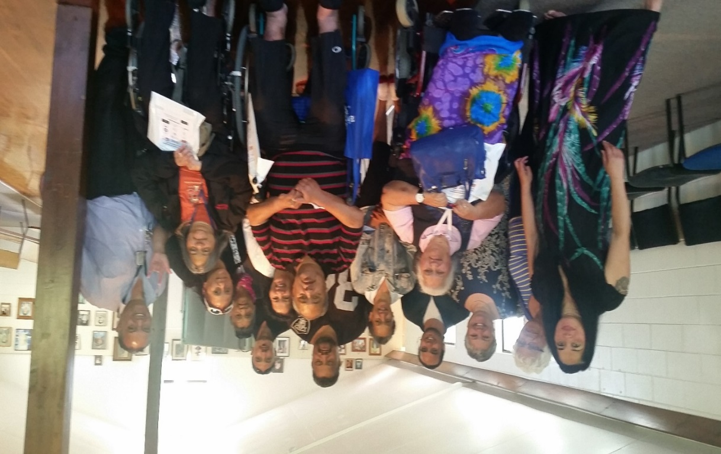

That the leadership and action was led and undertaken by whānau was a critical part of its design and implementation. By visiting and meeting with marae trustees, the challenges faced by whānau on the marae became quickly evident, and these moments of understanding laid the foundations for constructive dialogue and change on the marae. These challenges were multi-faceted and included:
- For a person with hearing impairments to speak through an interpreter
- For the interpreter to be accepted on the marae if she is a woman
- For a person with mobility impairments to be able to enter a marae and use the same facilities and entrances as others
- For a person with vision impairments to bring a guide dog on to a marae
- For a person who wears shoes to support balance to be able to keep them on in the wharenui
- For a person with learning disabilities to be able to be a part of the everyday life of the marae
- For an older person to be able to partake in marae activities despite the challenges of age and mobility.
Through discussions with marae trustees, a range of changes to both the physical aspects of the marae, as well as the tikanga of the marae, were able to be offered and implemented. The whānau were able to link the marae with organisations, particularly CCS Disability Action and Barrier Free Trust, who could make specific recommendations and designs for the marae, and to support with funding applications.
What is notable is that through the process of implementation, the horizons of Te Piri o te Ha expanded significantly from the original idea of working with five local marae. The growth of Te Piri o te Ha’s vision and activity is discussed in the sections that follow.

Implementing accessible marae
In its first year, the group had aspirations to meet with five marae to enable positive change in the marae community. This proved to be a springboard for sustained activity by Te Piri o te Ha over subsequent years, working with many more marae (totalling 17 by 2015), as well as creating dialogue more widely through television and social media platforms, and linking with regional and national organisations to take the message of change to a far wider audience.
Marae trustees were chosen as the starting point for the initial programme, because they provided the leadership for supporting change on marae. But the simple process of meeting with each marae was logistically challenging; it needed to be at a time when the marae trustees were all meeting, which was usually the monthly marae committee meeting, yet these were often times when the marae was dealing with a great deal of other business. For the whānau to be able to reach these marae, many of which were in rural areas, was also challenging. Nevertheless, over time, 17 marae around Te Tai Tokerau were engaged.
The opportunity for marae leadership to see first-hand the restrictions their buildings and facilities placed on access by disabled whānau was an important step in creating realisation of the need for change:

“It was the vehicle getting into our driveway, the person with the concern getting into the wheelchair, and then that’s when it went in. You realise, you see, you feel, you touch, you know you have to make change.”

An important factor in engagement and creating change in marae settings was the ability to link with a local representative of CCS Disability Action and Barrier Free Trust to advise and support changes:
“He would go through the marae and do Barrier Free Audits. He’s still doing that today, people are still, marae are still ringing him up today and asking him to come in. He has a vast knowledge of funding, where to get funding from, how to do up a proposal. So those are the things that being part of this group, visiting the marae, and having that resource was a godsend. Because you'll hear the stories of some of the marae that have [worked with] him, and have made great progress in making their marae barrier free.”

Building on accessible marae
The marae engagement created a realisation that there was also a need to create a wider conversation on accessible marae, one which enabled a broader reach than could be obtained by the small group working directly with marae. This led Te Piri o te Ha to begin working with Attitude Live to develop a series of videos that are screened on Māori Television and can also be accessed via social media. Under the banner ‘my role, my responsibility, our marae’, they show whānau working on the marae in multiple ways: a woman leading the karanga on to a marae, a man working with others on the marae in preparing and sharing food, and another using sign language in a mihi, with a Māori woman providing sign language interpretation. These all highlight how disabled whānau can be actively included in the life of the marae, and constructively challenged long-held assumptions and beliefs. These have subsequently been turned into a range of posters that reinforce the message.
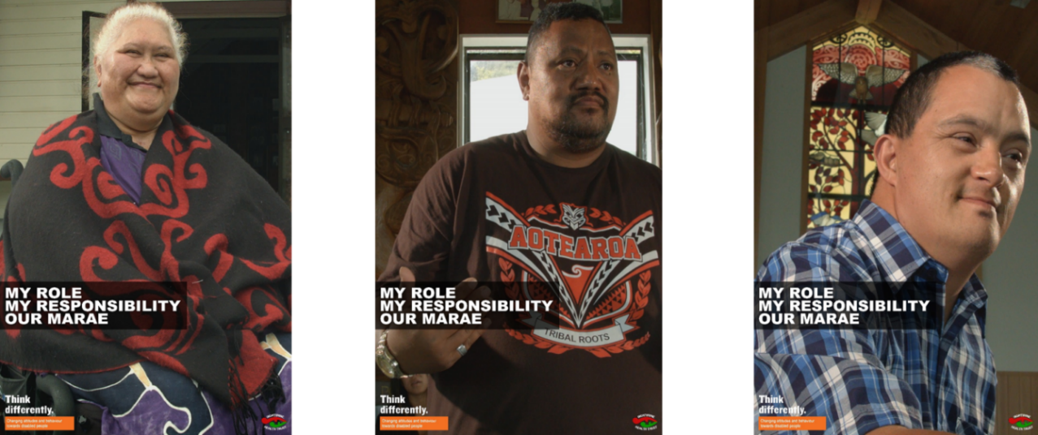

Te Piri o te Ha later worked with a local youth development group, Raid, to create a local video called ‘Life over Everything’ to provide a message from a disability perspective to help prevent youth suicide.
Te Piri o te Ha have subsequently worked with a range of regional and national Māori organisations to be part of the korero on improving accessibility and inclusion. In this sense, the group have taken on a leadership role regionally and nationally, contributing to the dialogue on accessibility and inclusion, and acting as exemplars for change, and in doing so reaching beyond Te Tai Tokerau. These activities have included:
- Sharing ideas with Te Roopu Wairoa who are designing and building a fully accessible marae in Tamaki Makaurau, with the support of Ngati Whatua
- Working with Te Piringa, a national Māori disability provider network, on a range of activities, including Te Matatini, the national kapa haka festival
- Working with The Māori Language Commission on the development of trilingual interpreters (Te Reo Māori, English and NZ Sign Language)
- Presenting at Ruamoko marae at the Kelston School for the Deaf
- Local presentation on accessible marae at the International Year of Disabled Persons
- Success with a placing in Social Innovation Awards, for supporting Māori wellbeing in the Northland region.
One local marae (kapa haka group), through its connections with Ngati Hine and Te Piri o te Ha, agreed to promote the Think Differently campaign at Te Matatini in Otautahi. They along with seven other kapa haka groups promoted full inclusion and participation on marae and within kapa haka. This group also performed a waiata in their bracket highlighting the need for us all to Think Differently. Te Matatini was televised globally for the first time.
Further from this, the local kapa haka groups continue to highlight these messages at every local festival, the last being Ahuareka, the Ngati Hine Festival in 2015.

Accessible Waitangi Day
In 2015, Te Piri o te Ha took their work in a new direction. The Waitangi Day celebrations were seen as a longstanding national treasure that disabled whānau had difficulty accessing, and so an opportunity was seen to make this ‘national taonga’ accessible to all whānau.
“What we found was not a lot of our whanau have actually gone around the actual treaty grounds. Because it’s not accessible, and the walk, if you go on that trail, it’s quite a long trail for people with wheelchairs, or our elderly and kaumatua.”
The solution they came to was to borrow golf carts and mobility scooters to enable people to get around the Treaty grounds easily, led by a whānau member who had once been a guide on the grounds.
Working with the National Trust Committee, the event created a new way of bridging the accessibility needs for disabled whānau on a day of national significance. Reflections on the day highlighted both the impact of the day and the new horizons and sense of opportunity it had created.
“I was talking to one of the kaumatua, he was 85… I said how do you like touring, he said to me many, many, many, many years ago girl, I tramped these grounds. And for many, many years I haven’t been able to mix in the crowd, go where everyone else can be, be a part of the vibe, be a part of the action, be a part of everything.”
“It was the first time Maori deaf had access to the information of Waitangi. Because we had someone at each of the locations talk about the whare, and Busby, and moving the whare. Our Maori deaf community were blown away, how many years has it been? To my knowledge nothing, until that day. And so now Maori deaf want to actually learn more about the tour of Waitangi, and they want to be the indigenous deaf to welcome overseas foreign deaf people to New Zealand and do tours themselves, because they can if they have the knowledge.”

For 2016, Te Piri o te Ha are planning to expand this event at the next Waitangi celebrations. Interest from Minister Nicky Wagner also supported the potential value of the innovative approach to inclusion.
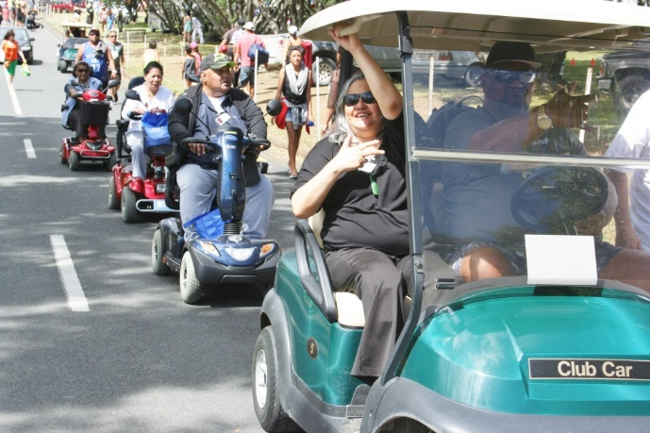
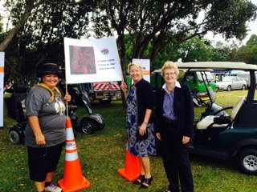
This approach also has the potential to be transferred to other tourism activities to provide a more inclusive Aotearoa New Zealand.
“The Minister for Disability Issues is really interested in it as being an initiative for accessible tourism around Waitangi… People have thought about it, but have never done it and this, our small group decided not only have we thought about it, but we’re going to do it and we’re going to make it happen.”

Outcomes and reflections
This case study highlights the impact that a small seed grant, in this case via Think Differently, can have in fostering dialogue and action to challenge attitudes and behaviours toward disabled people. The work of Te Piri o te Ha has fostered change and reflection in the marae they have worked with, but just as importantly, has created new activities and aspirations to advance the position of disabled whānau.
It is important that the outcomes of the Think Differently investment are not simply considered in terms of the number of marae engaged; rather, the engagement of marae should be seen more as the beginning of a ripple of activity that has moved from engaging marae, to challenging established practices, and to providing a leadership exemplar to others working in this area.
The process of creating change in marae settings has had its challenges, and Te Piri o te Ha are working in environments where there are long and deeply held practices and beliefs. However, over the course of this case study, a number of marae representatives spoke of the contribution Te Piri o te Ha have made to changing the marae environment. For some this has been about making physical changes:
“We saw how, we had our wheelchairs, that were motorised ones, there wasn’t enough room in our dining room the way we set it to suit those people in the bigger wheelchairs. So we learnt by that and we’ve changed the tables around and things like that.”
“They were always growling, our kuia, they're always growling us, those steps, because you have to step in, and everyone finds it really difficult with their walkers… So what they've done, they've taken those steps away, so now it’s a ramp right through into the disabilities toilet. In the kitchen… they've put a ramp from the dining room into the kitchen area, it’s so that all whānau, if they're in a wheelchair, you can actually go in and help out in the kitchen, you can go anywhere you want.”

But it is also clear that the work of Te Piri o te Ha had created conversations about the tikanga and kawa of marae, and created more opportunities for disabled whānau to become more involved in the day to day activities. These changes have marked a turning point for many marae in how they consider accessibility and inclusion. As some marae representatives noted:
“We said look we saw a sign out there that said no dogs, and all the committee didn't really have a come back to the sign that was outside, after we delivered our kaupapa. The response from them was we accept [guide] dogs, but not just stray dogs from the local iwi, rubbish dump, running around. But they accepted guide dogs that are trained working dogs.”

“You know, who are we to come through the front door and then tell our brother and our sister, because they have a mobility scooter, or because they have crutches, or because they're in a wheelchair, it’s whānau, we built a side door for you. That’s not okay, those days are gone.”

The importance of having a group like Te Piri o te Ha to be a voice for change was acknowledged by a marae representative:
“To have a group like you guys in the region that are pushing these kinds of initiative is really, really helping us to keep on our toes and make sure that we are continuing to develop our place.”

These reflections highlight the impact that straightforward solutions of ramps and walkways, and providing mobility solutions, guides and interpreters, can have on the sense of inclusion for disabled whānau in their participation on the marae and in significant events, and more importantly in connecting to their culture.
Te Piri o te Ha themselves acknowledge the importance of the support they have received from Ngati Hine Health Trust leadership, in fostering their own aspirations and confidence to work in this area:
“We could not have made it if it wasn’t for Louisa, and Janice, how magnificent that they have brought in their leadership role to allow us to become leaders in our own rights. To manage and conquer some of the steps that nobody else would have known … It wasn’t about how far we need to go, it was about how far we can go, and that in itself tells a whole story.”

Looking ahead
From the initial idea of working with five marae, the horizons of the whānau group members have shifted considerably, and they are now actively campaigning for creating accessible tourism in the region; establishing a Māori sign language dictionary; developing more tri-lingual interpreters; and are even considering a political party. Other initiatives planned are to set up a Māori diabetes group, a Facebook page, and equipment services.
It is clear from the stories woven by Te Piri o te Ha, that their journey has not just been one of the marae they have been working with, but also of their own vision and aspirations. The vision for marae becoming fully accessible remains, but this is now part of a broader set of social change aspirations that has taken them beyond marae. The success and development of Te Piri o te Ha also highlights the value of investing in and nurturing the potential for disabled people to be leaders of change.

We gratefully acknowledge the generosity of Ngati Hine Health Trust and Te Piri o te Ha in their time, the stories they shared and the welcome that they extended to the evaluation team in this case study.

Phab Phusion

Defining the problem
Disabled people within the Pacific community have fewer opportunities to participate in cultural activities. They were considered by their communities and families to be incapable of participating in cultural activities. There were also families that would be overprotective and exclude their disabled children from participating in the wider community. Families are over protective due to the stigma associated with disability in Pacific communities, and the potential for their child or family to be bullied.
“It’s an idea that came among young people wanting to know how they could be accepted in the community, which is nearly overprotective because of how disability is seen.” – Project leader

Intention
Phab Phusion intends to break down the barriers and the stigma associated with having a disability through reducing the social exclusion of Pacific young people with unique abilities. They provide a safe space where disabled children and young people can be accepted and engage in their culture through performing cultural dance items. This included ensuring that support was available in case their performances were not well received. It also aims to build confidence in those involved. The performances are also intended to raise awareness of the capabilities of disabled people in the wider community.
“And they [families] trusted us with the Phusion. It was like, are you sure my kids are going to be alright? Because, you know, these kids are used to bullying, mocking, the list goes on.” – Project leader
“When you get young people up there who have never been exposed to the public, or the communities, you know you’ve got to have that supporting system in place to wait for the reaction… That’s why we needed someone qualified, choreographer, support workers, youth workers, even a counsellor on call.” – Project leader
“We target everyone out there just to raise awareness around disability… We would never think kids with disability would be performing cultural events, cultural dances. So yeah, it’s just raising awareness around our Pacific community and every kind of community out there.” – Project leader/member

Phab Phusion has gained significant momentum and recognition after initially performing at only a few events. Their name has spread through word-of-mouth and they now have large demand for their performances. They have done back-to-back performances on the same day and are frequently invited back. They participated in breaking the world record for longest continuous line of moving wheelchairs at the Cube International Day of Disability event. They have performed 19 events in the 9 months from March to December 2014 (table below). Seven of these were during late November to early December, illustrating their increase in popularity.
Date | Performance
March 2014 | LeVa Conference
March 2014 | Pacifika festival western spring
March 2014 | De La Salle Fia Fia Night
April 2014 | Pati Umaga, Rehabilitation International
April 2014 | Taimua Passion Production
May 2014 | Parliamentary Rugby Game
July 2014 | Matariki
July 2014 | Meeting
July 2014 | I Am Auckland Awards
September 2014 | PHAB Ball
October 2014 | Youthline- youthlaw AGM
October 2014 | Performance in West Auckland
November 2014 | Delvins Graduation
November 2014 | PHAB PO SIVA Night
November 2014 | Otara Xmas Parade
December 2014 | Cube “International Day Of Disability”
December 2014 | Vaka Tautua “International Day Of Disability”
December 2014 | Interclub Royal Oak Phab
December 2014 | Dawson Lights
February 2015 | Otara/Papatoetoe Network Meeting  Family Fun Day at Murphy Park, Otahuhu
March 2015 | Pasifika Womens  Pasifika Festival - Samoan Stage  PolyFest - Diversity Stage (2 performances)  Otahuhu Festival Event
April 2015 | Youthline  Vaka Tautua - Celebrating
June 2015 | Disco for disability youth  Music video shoot for Pati Umanga
July 2015 | Fiefia Night
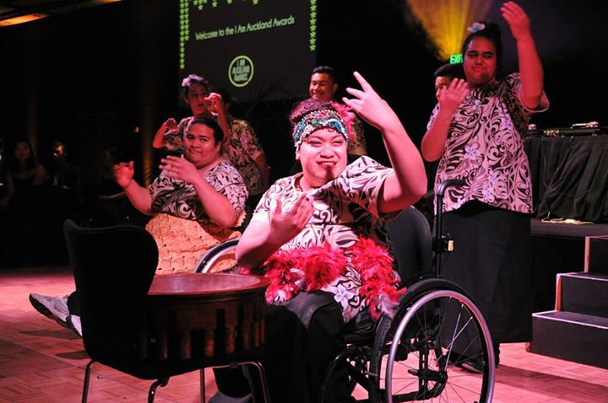
“It’s just grown bigger and bigger and there’s a demand for Phusion to come out and perform. There’s been a few times where we have been asked to come and perform at an AGM or meeting, or an event, but we so wanted to, it’s just we couldn’t because we were so booked with performances on that day.” – Project leader/member

Project delivery
Phab Phusion uses cultural performance to change knowledge and attitudes towards disabled people in Pacific communities. This is supported by 14 disabled and six non-disabled young Pacific people. Initially non-disabled members came from schools with a service programme as part of their service requirements, however they now consist of people who have volunteered to be part of Phab Phusion after events. This demonstrates the value and influence of Phab’s performances.
“Giving them the options of teaching their own cultural dance that they would like to teach the group.” – Project volunteer

Performances are led by the young people themselves and coordinators are there to facilitate any requirements that may exist. This approach is central to the leadership and capacity building of disabled youth.

Phab Phusion has experience a number of challenges and enablers. Some of these challenges included:
“[It’s challenging] sometimes when we’re not offered transport to go home… it’s the whole getting here.” – Phab Phusion Member
“Some of the places we go to are … not accessible for wheelchairs. Or there’s just no accessibility for disability… We just find a way to get on stage – if it’s just putting two planks of wood going up we’ll do it. So in doing that, it just raises awareness to the guys who are organising the events.” – Project leader/member

- Ensuring safe and accessible transport
- Providing uniforms
- Members attending practices consistently
- Accessible venues for performances.
It is important to note however, that the challenge of venue accessibility also supported Phab in sharing its key messages.
Some of the Think Differently funding was used to provide a qualified coordinator for the project and to address some of these logistical challenges.
Key enablers included:
- Enthusiasm, engagement and the supportive attitudes of members
- Partnership between disabled and non-disabled youth
- Youth led design of the project
- Relationship with Phab which provides existing youth services and assisted with transport.

Outcomes and reflections

Increased participation and inclusion of disabled people
One of the key outcomes from Phab Phusion has been the increased participation of disabled people who have participated in Phab Phusion. All stakeholders interviewed, including a group of members, mentioned that they had seen greater confidence in Phusion members. This confidence has helped them become more independent. For example, some members are now using local transport.
“I’ve seen the confidence that like having these kind of practices has on everyone else.” – Phab Phusion Member
“She’s in a wheelchair and she used to rely on the taxi all the time [for transport]. Now she’s actually catching buses from place to place… So with all that confidence, it actually gives them the courage to actually try something new.” – Project leader/member

Having non-disabled and disabled people in performances together also provided support for the disabled youth. There was a sense that having disabled and non-disabled youth performing together facilitated social contact between the disabled youth and the audience. They were not just a disabled dance group but a dance group that was inclusive of disabled people.
Members of Phab Phusion are now more able to embrace and participate in their culture. This was difficult as a disabled person from a Pacific culture but since Phab Phusion began they have been encouraged to learn their languages and cultural traditions.
“Everyone just stared at us. Kids were starting to get a bit uncomfortable, the young people, and I think that’s where a lot of our able bodied really sort of stepped up” – Project leader
“When he first came here he was shy: didn’t talk, didn’t joke around with us, he was quiet, hiding in his corner. But then after joining Phusion and going through Phab youth groups and everything, he started getting more confident in himself. He’s actually on the dance floor leaning it out, speaking Samoan, and speaking in front of crowds.” – Project leader/member
“I’m learning different languages and different songs and different cultures and being accepted around my community” – Phab member

Increased awareness of the exclusion of disabled people
Event organisers became more aware of how they exclude disabled people when Phab Phusion would attend. They would identify accessibility issues such as an inaccessible stage or lack of accessible toilets that exclude disabled people from attending.

Changes in attitudes towards disabled people
Performing at different events was intended to raise awareness that disabled people are able to participate in their culture. This message of inclusiveness is assisted by including disabled and non-disabled people performing together in the same group. Phab Phusion have reached a large audience with this message having performed at a large number of events. Some of the biggest include the Pacifika Festival, Vaka Tautua, Polyfest and I AM Auckland. They have been well received and have been invited back to many events. However, they acknowledge there is still more awareness to be raised and change needed, particularly at mainstream events.
“The biggest difference I have experienced from being part of Phusion 2.0 is that we finally got the chance to perform at Polyfest 2015, which to us is a dream come true.”- Phab member

Seeing Phab Phusion perform has changed the attitudes of many of these audiences. They are amazed at the level of talent and efforts of the performers in the Phab Phusion group. Those with disabled family members realise that the disabled people in their life could also participate in activities. Families of Phab Phusion members have been more supportive of their participation in the community since they have seen what they are capable of doing. They have allowed them to go out instead of keeping them at home.
People have also approached members after having seen Phab Phusion perform to tell them about a performance they had seen by Phab Phusion. Again illustrating the influence of their performances.
“They don’t recognise us, but they remember how we made them feel that day, so that’s how they’re able to come up and approach us.” – Project leader/member
“The communities that we work in… the perception of disability has changed” – Project leader
“The difference I have experienced with being a part of the group is the changed mind set of our audience, the inclusion we are creating within the group; that no other mainstream has within their [group]”- Phab member

Phab Phusion can see that they are changing the perceptions of people and communities, including churches, because they are invited back. They earn the respect of people from turning up and putting on a great performance – even when they have just come from another event.
“We’ve been invited back to participate; we’ve been invited back to be special guests. We’ve been invited back for a longer segment, they've given us more time to perform.” - Project leader

Changes in the social or cultural norms about disability and difference
There has been a noticeable change within some of the Pacific communities in South Auckland. Some of the stigma has been broken down as people see that disabled children can be talented cultural performers. This is a large step on the way to including disabled people. The church is a significant part of many Pacific cultures which means changes in stigma from their churches has the potential to lead to further changes in the community.
“A lot of the prayers are just on the empowerment now, it’s empowering our young people, it’s praying for energy… no praying now for healing, no praying that one day they’ll be normal. So that’s changed. However, it starts from the top so hopefully that trickles down.” – Project leader

Phab has also been able to break down the stigma attached to disability for the parents of the Phab members. Parents of Phab members had concerns about allowing their children to participate in community groups and activities for fear of their children being bullied. Phab has been able to break down this barrier for parents by showing them how their children can participate in the community in a space that is safe and where they can meaningfully engage with their peers and cultural activities. Phab members felt that their involvement with Phab led to greater trust with their parents in terms of being more independent. Phab members also mentioned becoming more social, confident and learning about their own and others’ cultures through Phab.
“When you have a child who has a disability there is that barrier where they want to keep you close to them. Where they think by keeping you close with them you’re safe, you won’t get hurt.”- Phab project leader
“Phab Pacifika has helped me with confidence and independence. Phab has gained the trust of my mum to allow me to participate with them.” – Phab member
“[My parents] trusted Phab Phusion. Whenever I came… they knew I was somewhere safe. So, coming [to Phab Phusion] actually got my Mum to dial down her overprotectiveness.” –Phab leader
“Most of all my confidence has sky rocketed and I'm more out of my shell than I was last year” – Phab member
“I have learned more about different cultures and dances plus being proud of my culture and trying new things. I have learnt a lot and by learning I have come a long way.” – Phab member
“Phusion and Phab Pacifika have impacted my life in a huge way. Before, life for me was basically school, home, school, home and that’s not a life. Since coming to Phab Phusion I’m doing a lot more with my life. It helps me find out what I actually want to do as a career.” – Phab leader
One of the Phab leaders who started as a member noted the difference Phab made to his life. This included increased participation in activities outside of home and school, and having the opportunity to make plans for their career.

Looking ahead
The Phab Phusion dance group intends to continue to perform going forward. Every time they perform a different item from a different culture so they always have something to practice and something unique to perform. They have some big events lined up already for the future including mainstream events.
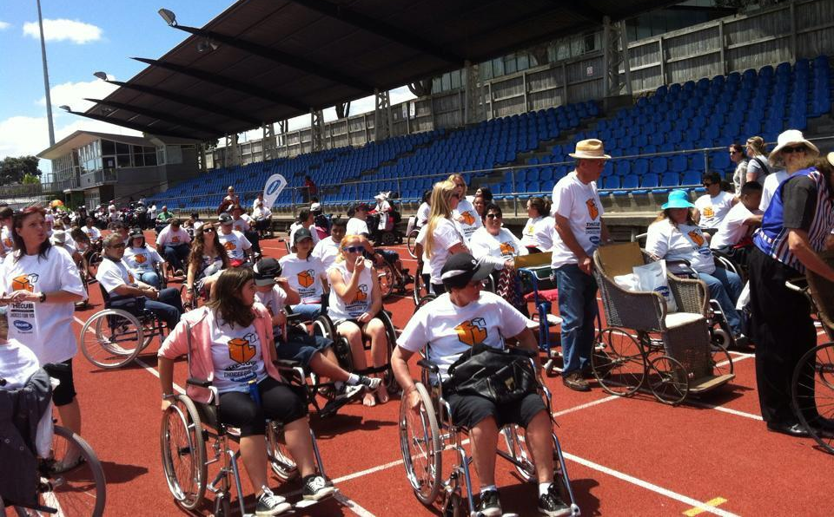
They hope to become more mainstream and participate in more schools instead of predominantly in the Pacific disability sector. This would allow them to challenge the attitudes that schools and broader society hold towards disabled people. This includes not only performing at schools but using their existing networks to support schools who want to do a dance group with disabled children.
The biggest challenge to the sustainability of Phab Phusion is funding. Transport and costumes for performances are costly. Phab Phusion does not charge for their performances, as they are trying to raise awareness. Although they receive some donations for performances, alternative funding sources need to be explored to sustain Phab Phusion.

Arts Access Aotearoa– I’m an Artist Campaign

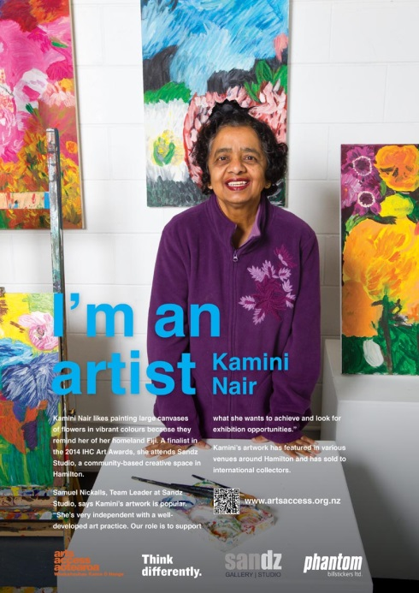
Defining the problem
The I’m an Artist Campaign was developed to change public perceptions, attitudes and behaviours towards disabled people. The campaign was designed to support Arts Access Aotearoa’s vision of a society where everyone can participate in the arts. Arts Access Aotearoa developed the I’m an Artist Campaign to showcase artists and their work, as well as promoting the value and function of creative spaces.

Intention
Arts Access Aotearoa was funded by Think Differently to develop and implement the I’m an Artist Campaign. The funding was used to implement a social marketing campaign where the key focus was to display and promote the work of five artists and the creative spaces they attend from across New Zealand. The I’m an Artist Campaign was launched in five cities over five weeks. The campaign focuses on posters that feature a photo of a local artist with a brief description about the artist and their work with the text “I’m an artist”. The campaign promotes disabled people and people with lived experience of mental ill-health as artists who create art, often with the support and guidance of community-based creative spaces. The posters were displayed on the streets of Auckland, Hamilton, Wellington, Christchurch and Dunedin. Postcard versions of the posters were also made available at each of the launches for guests to send to their contacts to further promote the messages of the campaign. The following five artists and the creative spaces they attend were featured on the posters:
- Allyson Hamblett, a visual artist and media assistant at Spark Centre of Creative Development, St Lukes, Auckland, has cerebral palsy.
- Kamini Nair, a visual artist at Sandz Studio and Gallery in Hamilton, has an intellectual disability.
- Fraser Hoffe, a visual artist at Vincents Art Workshop and Pablos Art Studios in Wellington, has lived experience of mental ill-health.
- Michael Krammer, a dancer and tutor with Jolt Dance in Christchurch, has autism.
- Tanya Faiva, a visual artist at Studio2 in Dunedin, has a physical disability.
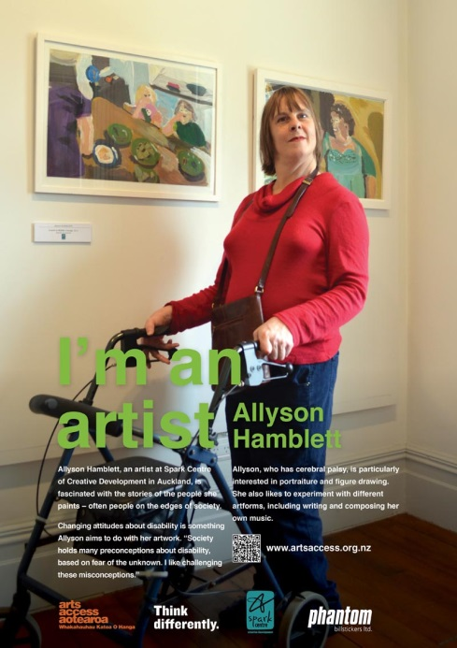
A total of 1000 posters were put up in the five different cities in A1 and A0 size with 276 in Auckland, 162 in Hamilton, 200 in Wellington, 200 in Christchurch and 162 in Dunedin. Most of the posters in each city focused on their local artist. These posters generally had an average life of seven days although some were up for 14 to 21 days depending on the location.
Each poster had its own launch over the course of five weeks. In Wellington, for example, the launch was held at CQ Hotels Wellington and featured Fraser Hoffe. A City Councillor and Wellington Central MP gave speeches at the launch, which was also attended by the local media. Where possible, the project team engaged high-profile community members at each event. The campaign was developed to raise the profile of the artists, to challenge attitudes towards disabled people by sharing their skills and to showcase local creative spaces. The posters will also be used to “strategically reach people who make decisions around policy, funding and planning” by using the digital copies in funding applications, reports and communications to key decision makers and people of influence.
“The I’m an Artist Campaign is a component in wider awareness and social change.” – Project leader

Project delivery
The key components supporting the design and implementation of the I’m an Artist Campaign included:
- PR and media coverage on the campaign
- Design and content of the campaign posters
- The artists, their work and the creative spaces that supported them
- The Arts Access team that worked on the campaign
- Funding to develop the poster and campaign
- Arts Access leadership attending and facilitating the launches and further strengthening Arts Access networks and connections

“Design of the suite of posters….that helped make it successful; it’s what I’d call the pillars of the campaign.”- Project team
“The staff here stepped up. This was the first and biggest campaign of its type that this office has done.” - Project team
“I think we really did need the support of Arts Access Aotearoa, I don’t really think that it’s something we could have pulled off on our own, as I say we are a small little studio.” –Creative Space

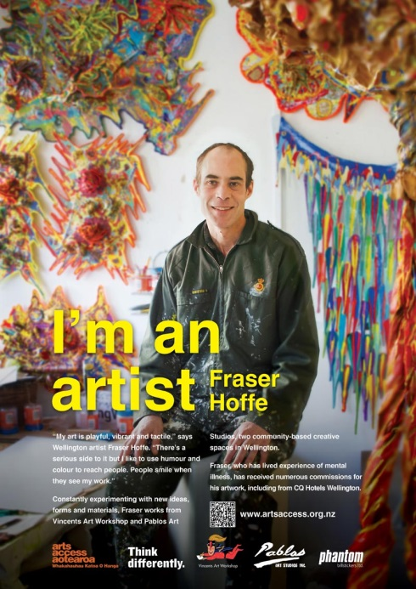
A challenge that Arts Access Aotearoa faced prior to the first campaign launch was when one of the artists pulled out of the campaign. Arts Access Aotearoa managed this risk in an appropriate way and found a suitable replacement for the campaign. This was one of the risks that the team had identified early on in the planning process.
A challenge for one of the creative spaces and the artist was managing the profiling of the artist. The creative space highlighted the importance of supporting the artist throughout the campaign and after to ensure the artist could maintain a balance and return to normal life after the hype and activity of the campaign. For example, it was important to ensure the artists did not experience emotional lows after being lifted up by the campaign. Arts Access Aotearoa was aware of this risk and developed mitigation strategies prior to the campaign to resolve these challenges with the support of the creative spaces. Arts Access and the creative spaces were also conscious of the other artists and their perceptions of only one artist being profiled from the creative space. This was identified as a challenge for some of the artists. One artist noted the challenge of the level of exposure from the campaign and that it was overwhelming at times, however they knew it was still a positive opportunity for them to be involved.
“…so we work a bit harder to make sure that other people feel as important and that they see our artist in the campaign as being a representative of our creative space…everybody here is equally important.”-Creative space
“Just the physical money side not having a lot of funding to spend a lot of time organising. Fortunately Arts Access passed some of the funding on so we were able to actually put two staff on for a day to actually do the hanging and stuff like that, which was really great.” -Creative space
For some of the creative spaces it was a very busy time of year for them and resources to support the campaign were limited. Arts Access Aotearoa provided ongoing support, including sharing funding to enable the creative spaces to manage their successful involvement in the campaign while continuing to provide the regular art sessions for their artists.
In terms of improvements, one creative space suggested that future campaigns could use larger spaces, such as billboards, to display messages in other parts of the city. Another creative space also suggested that more artists could be invited to participate in the future.

Outcomes and reflections

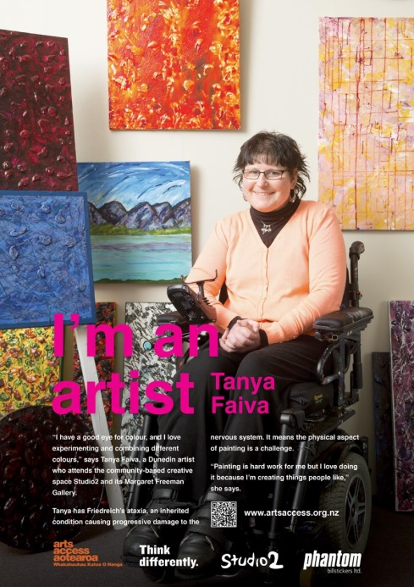
Increased awareness of the exclusion of disabled people
One of the functions of the I’m an Artist Campaign was to raise awareness among the general public about the abilities and value that disabled people can offer. It is difficult to measure the number of people who saw each of the posters in the five cities across New Zealand. The content of the posters displayed a clear message about each of the artists and their work and 1000 posters were displayed.
Arts Access Aotearoa also implemented a comprehensive media and PR plan to promote the campaign across a range of different media outlets, including:
- Segments on current affairs and specialist content TV programmes
- Opinion editorials in national and regional papers
- Media releases and feature articles online
- Facebook posts
“The opportunity that the campaign provides us has helped our organisation, Arts Access Aotearoa. We can change attitudes and behaviours towards disabled people who want to do art in the future… We’re now in a better position to change attitudes and behaviours towards all disabled people.” – Project team
“Creative spaces want them [Arts Access Aotearoa] to speak for the sector and I think in this campaign they’ve done that really well and I think that… it just raises the, kind of, awareness nationally of what creative spaces are doing.” –Creative Space
- Twitter posts
- Radio interviews.
In terms of volumes that can be measured there were approximately 35 people attending each of the five I’m an Artist Campaign launch events. This equates to directly reaching approximately 170 people through the launch events. Statistics from the Arts Access Aotearoa website and social media showed that over October and November there was a record total of 2849 unique visitors to the website and a record 7253 Facebook post clicks, likes comments and shares. There was also an increase in twitter followers: 68 additional followers over the two months.
Arts Access Aotearoa, the creative spaces and the artist we interviewed for the evaluation all felt that the campaign has raised the profile of their organisations, their work and the key messages of the campaign.

Changes in attitudes and behaviours towards disabled people
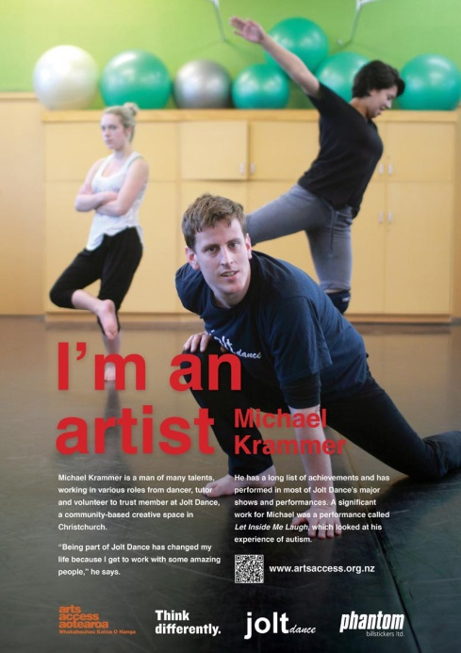
Arts Access Aotearoa being a national organisation was able to push the agenda of the campaign at a national level to enhance the voice of the local creative spaces. This campaign has enabled one of the creative spaces to apply for more funding by raising awareness among their local community and connecting with high-profile community members to support their funding applications. The campaign provided a means of connecting creative spaces to their community and changing awareness and attitudes toward the work that they were doing. It also opened up opportunities for one of the creative spaces to link in with mainstream art events and activities that they otherwise would not have connected to.
The commitment of local key players like councillors and MPs to support the creative spaces in funding applications is also an example of how the campaign has resulted in commitment from the community to making a change to enhance the inclusion of disabled people. Key stakeholders suggested that the campaign highlighted the importance of inclusion within local communities and increased the profile of inclusion as a relevant and local issue. The support from key influencers was also seen to give credibility to the campaign and its key messages.
Profiling the artists’ work also challenged people’s perceptions of the quality and contribution of disabled people’s art:
“It’s really part of that growing awareness. I mean, hopefully, it helps with things like funding from Creative New Zealand, who tend to not consider it as proper art”- Creative Space
“They say an image is worth 1000 words. It’s made society look at what disabled people can do. It’s promoted pride in having a disability.” - Artist
“I think having more high profile people involved in [the artist’s] campaign, like the city councillors and the mayor… lends credibility to our applications.” – Creative Space
“I think a lot of people were surprised at the quality of the artist’s art. People treat disabled people’s art like they treat children’s art… We actually got it recognised as art in its own right.”- Creative Space
“One other thing we have tried on the back of this is we’ve made an application to the art gallery, the Dunedin Art Gallery. They have what they call a back window which is a little space that fronts out on to the street round the back of the gallery which they invite people to, artists to, exhibit in. And we’ve made an application for Tanya to put an exhibition in the back window. Now [before] we wouldn’t have dreamed of doing that.” -Creative space

Increased participation and inclusion of disabled people
"The best thing is that people come to look at my work and see my flowers.” – Artist
“It’s been particularly great to have had two exhibitions at the Pah Homestead because it’s such a prestigious place to exhibit art.” - Artist
The I’m an Artist Campaign enabled the five artists involved to participate in social marketing exercises with mainstream media. This opportunity has provided artists with exposure to the general public and potential buyers of their art. Artists’ work was exhibited at the poster launches. Some of the artists sold a lot of their work throughout this campaign and at the launches. The campaign has enabled the artists to have their work recognised in its own right.
For some of the artists, the campaign provided them with a sense of self-worth and self-confidence in seeing others acknowledge the quality and value of their art. Arts Access Aotearoa built on the work of the creative spaces to enable the artists to showcase their work to their local community and family.
“When I first saw her art, I couldn’t believe she had done such huge works. Her family, not only from New Zealand but also from all over the world – Fiji, America and Australia – are all so proud of [the artist].” – Artist’s relative
“Someone came in off the street because she loved my paintings that were on exhibition. She commissioned me to make a work to match a colour she brought in to show me… She loved the end result and that made me happy.” – Artist
“Had other positive comments from people who had seen the posters and other media articles that I was involved with writing, including “I see you everywhere, you’re so famous”. That made my day.” – Artist

Looking ahead
Most of the stakeholders saw this campaign as a base foundation to lead to further attitude changing and confidence building activities. Having completed this campaign, Arts Access Aotearoa has increased its skills in implementing a social marketing campaign and would like to develop another campaign to bolster outcomes for their stakeholders.
Creative spaces appreciated Arts Access Aotearoa fronting their cause at a national level and see value in continuing their partnership. Creative spaces also see the opportunity to increase the sense of social value and self-esteem of people who use the creative spaces.
One creative space highlighted the importance of building on this campaign while it is still fresh in people’s minds. The creative spaces hope that with increased awareness of their creative spaces they can increase the number of people using the spaces and the funding available to support their work.
One creative space discussed the important role that creative spaces play in supporting disabled people. The manager highlighted some of the significant health and social impacts of the services they offer for the people who have used their space. She also reiterated the need to build on the momentum of the campaign to support the work of the creative spaces. Artists from the creative spaces could also see the benefits of the campaign for artists using the creative spaces and disabled artists more broadly.

Hamilton City Council - Accessible Maps

Defining the problem
The accessible maps projects were developed out of sense that there was insufficient information available on how disabled people could access the Hamilton city centre area and key points of interest or need.

Intention
Hamilton City Council was granted funding by Think Differently in 2012 and 2013 to develop accessible maps of the Hamilton central business area. The accessible maps projects arose from an idea that the disabled community would benefit from maps that would assist with reaching key points of interest in the city centre:
The first initiative developed a map (pictured overleaf) designed for mobility impaired people, and shows accessible routes around the city area, as well as key services, amenities and facilities. Shops and amenities that were assessed by the separate Be.Accessible initiative were also included (described in this report as the ‘accessible mobility map’). The map had two key benefits:
- A useful contribution to supporting the accessibility of Hamilton for disabled people
- Drawing attention to being more inclusive of the needs of disabled people.
The second initiative produced two sets of maps focused on the needs of blind and vision impaired people. The maps offer a series of tactile maps of the city centre, which a blind or vision impaired person can read by touch, or in large print (described in this report as the ‘tactile maps’).
Both initiatives are examples of low-cost innovation that support accessibility, and have also drawn attention to being more inclusive of disabled people among city decision-makers.

Project delivery
Key factors supporting the implementation of the accessible maps project included:
- Buy-in from council leadership, who supported the initiatives
- External funding from Think Differently that enabled the initiatives to occur in an environment of fiscal constraint within the Council
- Buy-in from council staff to support the initiatives
- Partnership from the disabled community in Hamilton to support the development of the maps.
“For us, it’s another little piece in the jigsaw of how disabled people move around. Because we’re not considered in the same way that other members of society are in planning and access to facilities.”

The picture below features the Hamilton CBD accessible map, the Braille and enlarged text/tactile maps.
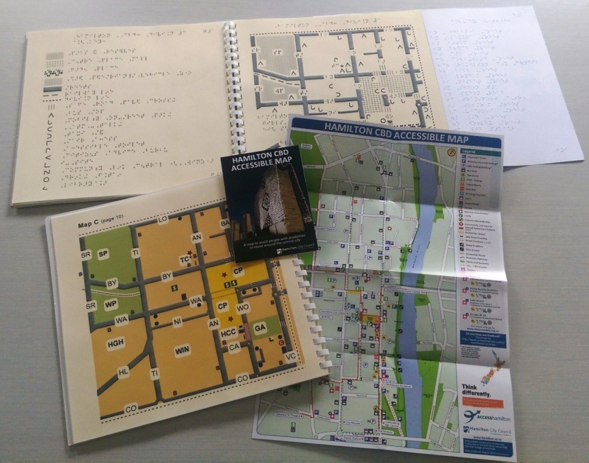

“Everybody was absolutely taken with the idea, no one had thought of it before. And half the people that were there had never really seen a tactile map of anything. So the whole concept of a tactile map was new to many.”
For the accessible mobility maps, a success factor of implementation was a council staff member who drove the initiative from the beginning, from the funding application to managing the map to completion. The staff member was widely seen to have led a collaborative process that brought in the disabled community as important stakeholders. This then provided the springboard for the tactile maps.
For the tactile maps, the goodwill from the blind community to support the project from start to finish enabled its implementation, despite scepticism about the value by some participants. Two focus groups were held to discuss the design of the maps, and enthusiasm built as the maps developed.
Although tactile maps have been developed elsewhere, this was the first time one had been done in Hamilton and awareness of tactile maps, even among the blind community, is fairly limited. One of the stakeholders noted that the street names are in code on the enlarged map and it would be good to have the full name on each page rather than on a key.

In the picture below, Judy Small, the Disability Advisor, is demonstrating use of the tactile map.
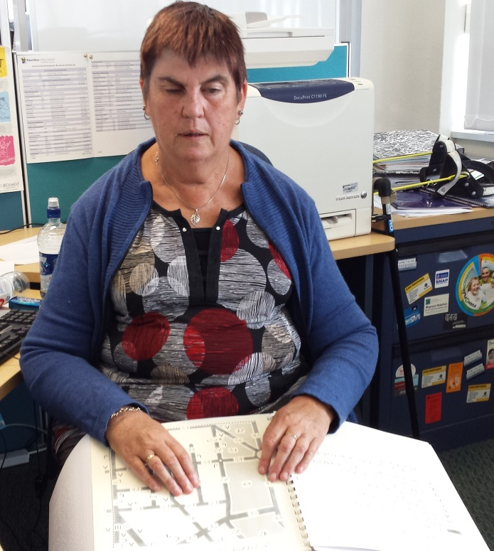

Outcomes and reflections
There are a number of areas where the maps are particularly innovative:
- In bringing together existing information on accessibility, including existing accessibility audits, in different ways into a single format that supports navigation around the city centre
- In embracing accessibility at the levels of both mobility, and blindness and vision impairments
- In bringing together two tactile forms of the written word (Braille, and the more symbol-oriented Moon); no equivalent is understood to be available elsewhere in the country
- The tactile maps were the first time such maps had been produced for general use by blind and vision impaired people, rather than the specific needs of an individual.
In terms of use, the CCS Disability Action Waikato - Hamilton office reports that about 10 accessible mobility maps per month are taken from their front desk. This is seen as a reasonably positive sign of uptake in the physically disabled community. The Braille and large print maps are available at the Blind Foundation office as well as at all Council Facilities. For example, copies of the tactile maps are held at the Visitor Information Centre; and copies of the accessible mobility map are also held there but were not on public display at the time of Synergia’s visit.

Increased participation and inclusion of disabled people
An online survey was developed for users of the accessible mobility map; although only a few people accessed the survey, the feedback was very positive, with all saying they could plan their route easily with the map, and that it is easy to follow.
The tactile maps were reported by the council interviewee, and two people involved in the map’s development (both of whom are blind or vision impaired), as useful tools that support their independence and access to the city centre. One stakeholder noted that it could be particularly useful for visitors to Hamilton who require an accessible map. Because of their size, people don’t always carry them with them, but often use it for planning trips. It provides a sense of confidence in using the city centre. The large print maps were also seen as important for vision impaired people, as they were for blind people, for similarly promoting accessibility, and in particular for the carefully chosen colours for the map, that helps with contrast.
“I think it’s mostly that it’s great to know it’s there. People aren’t saying to me that they consult it every day before they go out. But they’re saying that it’s just, for all sorts of reasons, many of them sort of psychological, it’s great to have it there. And it means a lot that the city could be bothered doing it.”
“And it’s great to have the map there in the house to consult when you want to. There’s things that you can find out from the map that you don’t actually have to ring up a family member or friend to find out. You can do it for yourself… And it doesn’t need anyone else’s involvement. It’s just me and the map. And if I find out what I need to know from the map then it’s a sense of independence.”
“I now know where Seddon Park is in relation to Ward Street. Or I now know where the bus, the transport centre is in relation to the Council building. And all this helps you to feel like you know the place better on a macro level.”

Increasing knowledge of reducing exclusion of disabled people
In Hamilton, it is estimated that the Braille reading community only numbers 20-30 people, and the reach of the tactile maps was always going to be limited. However, more broadly, the disabled community in New Zealand is now estimated to reach 24% of the population. The maps were seen to be an important way of communicating to city leaders the importance of accessibility for the disabled population, and in building dialogue with city planners.
“We had quite a bit of connection with various staff through Hamilton City Council throughout the development of the process. So then those staff get to see us as ordinary people with something useful to say. There’s quite a few layers through it really, of how it would benefit us. In some ways we see it a little bit as a community development opportunity for our community of people.”
The mapping projects were also seen as important means of communicating in a positive sense the contribution of disabled people and the need for equity for disabled people in city planning:
“We still find that it is difficult, from an equity point of view for us as a community of people, that decisions are made about us in the same way as they are for walking and seeing people – they’re not. And it’s quite difficult to get that equity message across to people of privilege and without disadvantage. And we need to seize leverage off every opportunity so that we are portrayed as contributors to society and people of value.”

Changes in attitudes towards disabled people
Furthermore, the maps were seen to have prompted a new appreciation among the council and business community in the central city:
“[The CEO of the] Central Business Association has a greater awareness now of access type issues. And I don't know that she would say her position’s changed, but it seems to us her position’s changed. She was at the launch of the braille map, and I think it was a bit of an eye opener for her. Seeing all the guide dogs talking to each other and the sense of community among disabled people; that was actually a bit of an eye opener to all the council people that were there.”

Looking ahead
The Council’s next project was a Focus Group report about people with learning and intellectual impairments. This was funded by the Council and its outcomes will inform the Council’s Disability Action Plan and work programme for 2015.
Some participants from the disabled community are keen to explore new directions, leveraging off the accessible maps projects. Two people interviewed independently spoke of interest in exploring new technology to support navigation by people who are blind or vision impaired, including Smartphones and other handheld devices that describe where you are. One of the stakeholders interviewed was keen for people to be made aware that the maps are available for people who need to use them.

Taranaki Disabilities Information Centre Trust - Accessibility Audits

Defining the problem
The 2013 census illustrated that 30% of the Taranaki population indicated that they have a disability. However, many shops and business places are not easily accessed by many disabled people. In an exercise to identify how accessible New Plymouth shops actually were to people using wheelchairs, the project leader took a person in a wheelchair around 20 shops in New Plymouth and found that over 25% of shops were not wheelchair accessible. They were also aware that shops and businesses had other accessibility barriers. There were also service barriers with retail staff not being aware of how to serve disabled customers.

Intention
“The retailers were going to benefit because they could attract more customers. The disabled were going to benefit because more stores would be accessible. And the whole community was going to benefit because we feel that it will increase understanding about disabilities and increase accessibility for everybody.”- Project leader

Taranaki Disabilities Information Centre Trust (TDICT) was funded by Think Differently to run an “accessibility audit” pilot with New Plymouth businesses. The intention behind the accessible audits was to encourage businesses to think about ways they could increase the accessibility of their shops. This was designed to create a win-win situation for all parties involved.
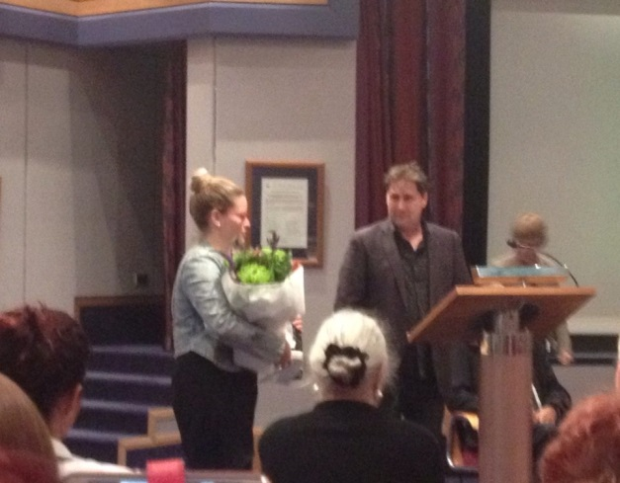
The audits involved a person from TDICT visiting the shop and doing an inspection with the owner which took about 30 minutes. TDICT would then produce a report for the shop which focused on things they were already doing well along with suggestions for improvement.
The project also bolsters other work undertaken by TDICT to promote awareness and educate the wider community on what it is like to live with a disability.
An Accessibility Awards evening was hosted at the New Plymouth Council Chambers. This included giving out window stickers for shops that were accessible, or had a good attitude towards improving access. This process was designed to celebrate successes and further promote awareness among retailers and the wider community. The Accessibility Awards will continue annually as part of the Chamber of Commerce Awards.
“We’re holding this function tonight which is dually to acknowledge those who’ve done well and generate some publicity.” – Project leader

Project delivery
“I think that’s definitely a credit to him [project leader], is that he was so passionate about it and he knew exactly what he was doing and why he was doing it and he was able to communicate that really easily and really freely.”- Project partner

Key factors that supported the implementation of the accessibility audits included the following:
- The commitment and personality of those involved in conducting the accessibility audits was mentioned by all involved as important to implementation (see right)
- Support from volunteers in carrying out the pilot – including leadership from disabled people to ensure the process was informed by disabled people
- Businesses consented to the audit before it happened and there was little burden as the audit only took 30 minutes and had no direct monetary cost
- A positive approach towards audit implementation that recognises strengths as well as suggestions for improvement
- Having the approval of the New Plymouth District Council and the Chamber of Commerce
- Funding from Think Differently provided the resources required.

TDICT initially wanted to provide training workshops to businesses. They already provide workshops that have evolved over the last 20 years. However, they found it a challenge to encourage businesses to commit to the workshops. As a result, the accessible audits provided a simple way to educate businesses thinking about accessibility issues, provide actions for solutions to these issues and illustrate the benefit they could receive from attending a training workshop. These are now one of the next steps for TDICT.
Time constraints were the one challenge that TDICT had in implementing their accessibility audits project. TDICT only has 2.5 full time staff and volunteers make a large contribution towards their work. The number of shops they intended to reach reduced from 50 to 30 due to the lack of time available. All 30 were visited and only one shop declined to participate. All others had an accessibility audit and received a report.

Outcomes and reflections

Increased awareness of the exclusion of disabled people
As a result of the accessibility audits, there has been an increased awareness in the retail sector of both the issues disabled people face and the things they can do to make things easier. This increased awareness was a key theme mentioned by all stakeholders, including businesses that were involved in the pilot (see box on following page).
“There’s an article in the local rag today about it so that’s huge exposure…” – Project partner

The stakeholders interviewed for this case study also anticipated that the project had increased awareness within the general public and the business staff teams. This was through media exposure that their project has received along with the awards event and window stickers.
“Just awareness, there’d definitely be awareness. That’s what this programme’s all about is being aware and celebrating the businesses that are doing well and then giving input into the businesses that maybe just didn’t know.” - Auditor
“Just a general lifting of awareness and understanding I think. And gratitude that someone’s bothered to take the time to point it out to them.” – Project leader
“It is good having stickers like that because it does make people more aware” – Business staff

Increased knowledge of how to reduce the exclusion of disabled people
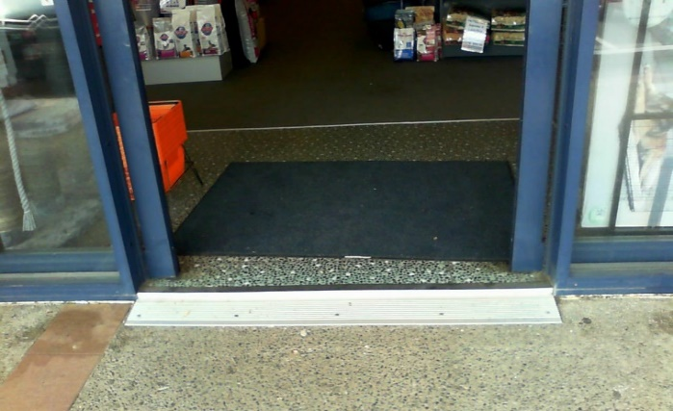
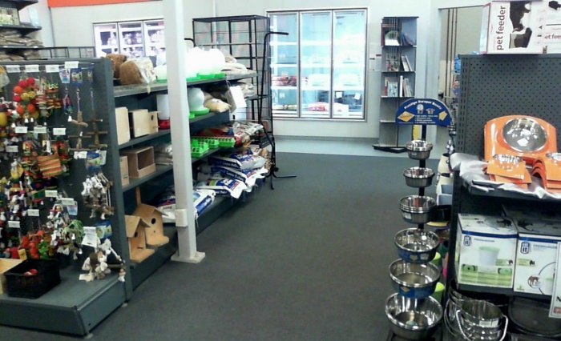
The reports received by retailers provided suggestions on ways the business could increase the accessibility of their shop for disabled people. An excerpt of a report is shown below. This illustrates the positive approach that was used to engage the businesses in reducing the exclusion of disabled people by identifying what local businesses were doing well, as well as what they could do to increase the inclusion of disabled people.

Question Six:
All people can easily enter our front entrance including parents with pushchairs, wheelchair users and someone using crutches.
Summary
A shop that has good access and close parking for the Access customer, There is a need for a low counter and some seating otherwise a roomy shop that would be suitable for the access customer
[Excerpts from Accessibility report]

This approach was also well received by the business owners and had also broadened their perceptions of what “being accessible” meant for a broader range of people:
“And then there was just some really good little suggestions that I hadn’t thought about because we had always approached it from a wheelchair point of view.” – Business owner

The workshops that have been implemented through the Think Differently Fund have also received feedback that demonstrates that participants are:
“A valuable session – an inkling in 3 hours of how challenging life might be, and how we, as non-disabled, can be more helpful, empathetic, and able to engage more easily with people who have disabilities.” – Workshop participant
- More aware of the issues that disabled people face
- More aware of the things they can do to create a more inclusive community.
TDICT has conducted these workshops with organisations such as the Taranaki District Health Board, Puke Ariki Museum, the South Taranaki and Hawera Regional Councils. Synergia Ltd also supported TDICT to develop post-workshop feedback surveys. These provide evidence for the benefits of the workshops in increasing participants’ awareness and understanding of the issues that disabled people are currently facing in the community:

Changes in behaviours that exclude disabled people
This increased awareness and understanding from the accessible audits has led to changes in behaviours that exclude disabled people. Many shops have already implemented some changes.
“Their fire escape was completely inaccessible, so they’ve worked out a new plan that if they do have [a fire] they can use another shop to get out.”- Auditor
“We took them into one of their so-called accessible loos. And they were horrified to discover that it wasn’t really accessible at all and the thing’s being rebuilt.”- Project leader
“We had some things in the hallway that we moved into another room… We have to look at car parking and whether we do anything with this, we’ve got a really large area for people to come and drop off type thing, it’s whether we officially brand it or whether we just put a notice up. So there’s some thought about how we manage that and obviously we want a sign for the hearing impaired.”- Business owner

The initiative is also likely to have ongoing benefits as people involved in the audits and workshops now have a greater understanding of the challenges facing disabled people, and their role in supporting change; both through the look and feel of their businesses, and their individual behaviour.

Commitment to reducing the exclusion of disabled people
The response from the retail sector has been very positive. Feedback from shops that had an audit completed was all positive. It is also useful to note that some of the changes are still underway, and businesses have made commitments to make a number of changes to increase the inclusion of disabled people in their community. When reviewing the audit reports we also noted that many of the changes reflected pragmatic small steps, such as having chairs available for people to sit on or putting up signs to encourage people to let the staff know if they are hard of hearing. These small initial steps have supported organisations in engaging in changes that are feasible. They also demonstrate that even small changes can make a difference to the inclusion of disabled people. This is an important learning for businesses that think that changes to better include disabled people are costly.
“I’ve talked about it with some of the people who haven’t done it [the audit] … and they were very interested in how it all works and what it actually was as well” – Project partner
“They feel that what they got back was totally worthwhile, it wasn’t a big effort for them to have that feedback and it’s not going to be a big effort for them to make changes that need to be made, but the outcome will be positive for them.” – Project partner
The case study also found that the Chamber of Commerce has had queries from other retailers who were not involved in the accessibility audit pilot. This demonstrates the value of the audits and the willingness of local businesses to support a more inclusive community. This is an exciting finding for the project who would welcome being approached to conduct accessibility audits.
“We had a guy come in on his mobility scooter yesterday. Which was good, he can whip it round and go in and out quite easily.” – Business staff

Increased participation and inclusion of disabled people
These changes to shops are increasing the accessibility for disabled people and the rest of the community. One of the businesses that was considered highly accessible gave an example of how their accessible design has allowed for inclusion of disabled people (see below).

Additional outcomes
In addition to promoting awareness of accessibility issues, the accessibility audits have also made retailers more aware of the TDIC itself. The businesses have learnt who they are, the types of services they offer, and trust them to be professional and knowledgeable.

Looking ahead
“I would feel comfortable to go back and talk with the centre again about what we would need to look at, it’s nice to know that that resource is available.” – Business owner

The accessibility audit pilot has been successful in supporting local businesses and organisations to increase the inclusion of disabled people. The project had resulted in changes in attitudes, knowledge and importantly behaviours. TDICT are looking at expanding this project to more retailers within New Plymouth and the rest of Taranaki. Stakeholders also believe the increased awareness and changed attitudes among those who have been part of the pilot will be sustained. The Accessibility Awards will be continued as part of the Chamber of Commerce Business Awards. The accessibility audits will be sustained and in the future will become a service that businesses can request. This will be important for responding to inquires received by the Chamber of Commerce.
The Think Differently project is part of the broader scheme work that TDICT does to increase accessibility within Taranaki. It is hoped that the accessibility audits will lead into greater uptake of training workshops that TDICT runs (see right). These are two hour sessions designed to give people a better insight into life with a disability.
The support of the Local Council was identified as a key success factor for sustaining the changes achieved through the Think Differently project. It is anticipated that an ongoing relationship will lead to long term and sustained improvements. For example, the Local Council can support the enforcement of the building code when shop buildings are being built or structurally renovated. This will also encourage businesses to think about accessibility issues.
Recommendations from TDICT
The Taranaki Disabilities Information Centre Trust are running a series of workshops for disability responsiveness and these are for a 2 hour duration. This as a free workshop and we recommend that staff attend this nationally recognised workshop to gain an insight into what is required in dealing with a person who has a disability including the elderly, people that have a short term impairment and ladies with babies.
[Excerpt from Accessibility report]
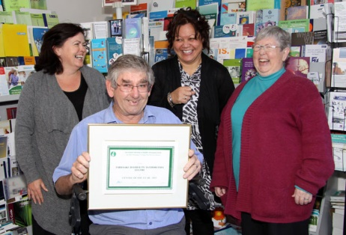
Strategically, TDICT aim to coordinate the efforts of disability groups as well as ageing groups to encourage accessibility for everyone. This will strengthen the work and voice of the TDICT. TDICT have also received funding for the next round of Think Differently and are looking forward to building on their success.
“It’s really good, but the next one, and we already have another one granted to us, is certainly going to be planned a little bit more strategically. And more people involved.”

An integration of the key findings
This section of the report draws together the key findings from the report to provide an overview of the key factors that supported the success of the Think Differently projects and the outcomes that they have achieved. We anticipated that this will be useful for sharing with other Think Differently projects, informing the selection of future projects and identifying some of the achievements of the fund so far.

Key success factors
The case studies identified a number of factors that supported the success of the projects. Key success factors that appeared to provide value across all of the case studies included:
- Project planning and execution
- Diverse target groups
- Partnerships and collaboration
- Funding.

Project development, planning and execution
The case studies suggest that the Think Differently projects were all well planned and executed. This planning supported the quality of the projects and ultimately their outcomes. Arts Access, for example, had a thorough consultation process that included engagement with industry experts, a well-planned strategy for launching the posters across Aotearoa, New Zealand. This level of organisation and planning supported the implementation and outcomes of the campaign. Another example of the value of sound planning is the level of engagement and testing Hamilton City Council did with their steering group to develop the accessible maps.
Some of the feedback from the project leaders and partners identified the importance of the project leaders and project team in implementing the projects. The interviews often emphasised the passion and drive of those involved in the projects.

Diverse target groups
Each of the projects involved different targets groups and this appears to be a key success factor for supporting the campaign to respond to the multiple drivers of social exclusion. While all of the projects involved disabled people in their project, the populations they were targeting and the way that they promoted their message was broader. Synergia’s earlier literature review suggests that this approach is important for supporting changes to exclusion. For example:
- The Hamilton City Council involved local blind people in their steering group to design and test the accessible maps. The maps were then made available at the Hamilton City Council and the local Disability Information Centre. Raising awareness of the need to reduce exclusion in local partners and the council was also an outcome for this project.
- The Phab Phusion projects initial target group was the disabled youth who wanted to participate in the cultural performance group. Now the wider audience for the project is their local Pacific and church communities.
- The I’m an Artist Campaign engaged heavily with the artists and the creative spaces they attend on the posters. The posters were then launched and displayed in New Zealand’s five largest cities to target messages at a societal level.
- The Taranaki Disability Information Centre involved disabled people in the design and implementation of the accessibility audits. They then focused on creating change at a community level by implementing the audits with businesses in the Taranaki region.
- Te Piri o te Ha is a group of people with varying abilities who first targeted local marae in Te Tai Tokerau. They have since expanded their target group in marae nationally as well as targeting their efforts at a societal level.

Partnerships and collaboration
Most of the projects in the case studies either partnered with or collaborated with another organisation or individuals to implement their projects. For these projects their partners were a key success factor to making their project work. For some of the projects the value from their partnerships was the buy in from key decision makers, such as the local council. For other projects the partnerships enabled them to access certain facilities or resources. For example, Te Piri o te Ha connected with CCS Disability Action and Barrier Free Trust to provide access to expert advice.
Partners also benefitted from their involvement in the project. For example, the Chamber of Commerce gained more exposure to businesses by being part of the Accessibility Audit Awards. The I’m an Artist poster campaign launches also promoted the work of the artists and the creative spaces they attend. These were considered to be valuable benefits by the artists who sold more of their work and for the perspective of the creative spaces.
Leadership from disabled people was also an important component of these partnerships. The projects involved a high level of leadership from disabled people. This appears to have been important for ensuring the relevance of the projects to reducing the exclusion of disabled people, and for ensuring that disabled are leading the decision-making and choices on the ways in which exclusion can be reduced.

Funding
Most of the projects commented on the role of the funding from Think Differently. They identified the funding as a key success factor for the implementation of their projects. For many of the projects the funding enabled them to secure professional services required to implement the projects. For example:
- Phab Phusion used some of their funding to acquire the services of a choreographer
- Arts Access Aotearoa used professional designers, photographers and an advertising company to produce and display the I’m an Artist campaign posters
- Hamilton City Council engaged with professional map designers and developers to produce the accessible maps.
The use of these professional services and resources contributed to the credibility of the outputs of the projects.

Key project outcomes

Table 4 presents the key outcomes identified through each of the case studies. The integrated summary indicates that the projects are making impacts in three to four of the key Think Differently outcomes. The case studies suggest that all of the projects were raising awareness and changing attitudes and behaviours towards disabled people. This is an important outcome, particularly as the case studies engaged those people that the projects’ were seeking to influence or change.
Table 4: Key outcomes from each project
Project | Increased awareness of the exclusion of disabled people | Changes in attitudes and behaviours towards disabled people. | Increased participation and inclusion of disabled people. | Increased knowledge of how to reduce the exclusion of disabled people | Commitment to making a change to reduce the exclusion of disabled people | Changes in the social or cultural norms about disability and difference
Phab Phusion
Arts Access
Taranaki Disabilities Information Centre
Hamilton City Council
Accessible Marae – Te Piri o te Ha

The case studies provide evidence for the impact of the projects on disabled people. For example, the artists in the I’m an Artist campaign received considerable exposure of themselves and their art work. This impacted on their self-confidence and sense of self-worth. The Phab Phusion members also experienced similar impacts in terms of self-confidence after performing at local churches and events due to the feedback they received from the audiences. Many of the young people involved in this project experienced increased inclusion through their choices to use public transport and take greater control of their own engagement with their community. Phab Phusion also provided examples of commitment from their audience to change their behaviour and changes in their knowledge and awareness of disabled people.
The accessible maps have also had an impact on some local people with vision impairments. Specifically, the map has supported some vision impaired people to independently access Hamilton City. While this project had a greater emphasis on reducing exclusion from the level of the individual, the partnerships with the Council have also raised awareness about the importance of reducing the exclusion of disabled people. This provides evidence of the influence of the projects at a relationship level. Further evidence in this space is also provided through the Phab Phusion case study. Specifically, this case study identified the impact of the project on the families of the young people involved in the project.
At a community level, the accessibility audit supported businesses to become more inclusive of a broader range of consumers in their community. This increased the business communities’ awareness of the need to reduce the exclusion of disabled people, while also improving accessibility for disabled people. Building on the potential to generate more business through being more inclusive also supported this project in achieving its outcomes. A simple step by step approach was also important here so that businesses were not put off by large scale costly changes to their premises.
Te Piri o te Ha have also supported community level change. Māori communities, specifically marae, have a greater awareness of the challenges faced by disabled people and have changed behaviours to reduce exclusion. The communities targeted have continued to grow in number and size. Activities have also changed to build on their success in creating community level change and starting to make an impact on the societal level.
At a societal level, some of the changes through Te Piri o te Ha offer some useful learnings. The literature review conducted by Synergia in 2014 identified the role of individual capacity, family and the wider community in excluding many disabled people from society. Te Piri o te Ha demonstrate the level of change that can be achieved when a project seeks to increase the capacity of disabled people, increase awareness and generate behaviour change. This project is particularly useful for identifying the potential role of multifaceted projects in facilitating the inclusion of disabled people.
It is also important to note the shift from the earlier evaluations conducted by Synergia. These often suggested that the Think Differently projects had achieved a commitment to making a change. The case studies suggest that the projects and their target groups are now making the shift to actual behaviour change.
Overall, the projects are supporting outcomes at an individual, relationship, community and making some progress at a societal level for specific groups. Specifically, the case studies provide evidence for:
- Direct impacts on a disabled person’s confidence, wellbeing, their ability to choose to participate and control how they lead their lives, including everyday activities, cultural traditions, and careers.
- Changing attitudes and behaviours towards disabled people and increasing awareness
- Increasing the knowledge around exclusion of disabled people, which is leading to a commitment or actual changes in the communities to support inclusion.
- Initial shifts in the societal and social norms to be more inclusive towards disabled people.

Conclusion
Think Differently funds a broad range of projects to reduce the exclusion of disabled people. The selected case studies provide a good insight into the breadth of projects supported by the fund and the types of outcomes that they can achieve. Specifically, the case studies provide evidence of the role of the fund in:
- Supporting the capacity, independence and control of disabled people. This is well illustrated through the Hamilton Accessible Maps, I’m An Artist Campaign and Phab Phusion case studies.
- Engaging the wider community and businesses in understanding the need for increasing inclusion and supporting them to do so. The Taranaki Disabilities Information Centre provides a useful example of the value of this type of approach. The case study is also an excellent example of facilitating change in the community, and local businesses more specifically, in a way that is supportive and hooks into some of the factors that are of value for local businesses. Te Piri o te Ha also demonstrates how the engagement of one community can lead to engaging with other target groups as the impact snowballs into something larger.
- Shifting attitudes and behaviours towards disabled people, as demonstrated through the activities and partnerships in each of the case studies.
- Reducing the stigma that is attributed to disabled people in a local community. This is illustrated through the I’m An Artist Campaign and Phab Phusion.
Overall, the case studies provide support for the breadth of activity supported through Think Differently. The case studies identify the value of the projects in improving outcomes for disabled people in terms of increased confidence and control, increased access to their local communities and cultural supports, and increased social contact and reduced exclusion.

These can be accessed at http://attitudelive.com/blog/dan-buckingham/staff-picks-accessible-marae
Statistics New Zealand, (2013) The New Zealand Disability Survey. Retrieved from: http://www.stats.govt.nz/browse_for_stats/health/disabilities/other-versions-disability-survey-2013.aspx

