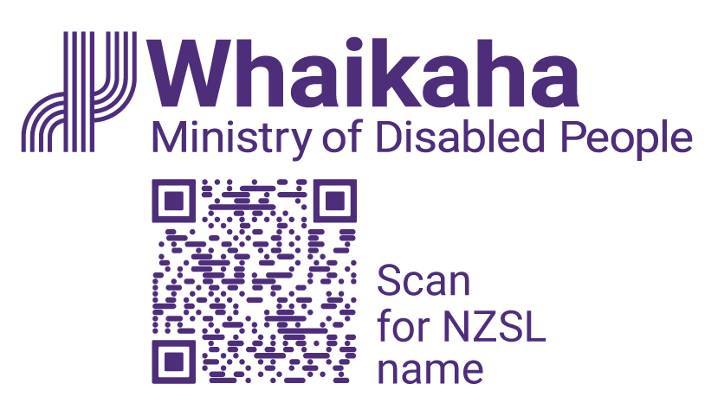
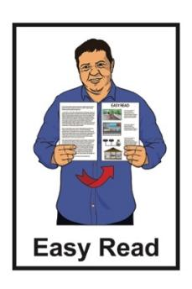

Expression of Interest –
do you want to join the Accessibility Advisory Group?
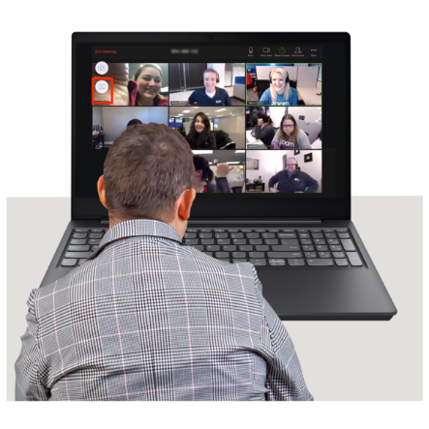

Published: October 2025

What you will find in here

Page number:

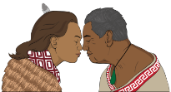
Whakataukī 3


About this Easy Read 5


What is the Accessibility Advisory Group? 8

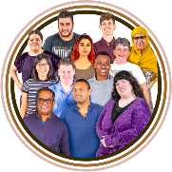
What kind of people does
Whaikaha want? 11


How much work will the rōpū / group
do? 18

Page number:

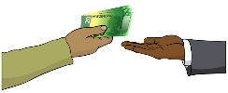
How much do rōpū / group
members get paid? 21


What skills and experience do
rōpū / group members need? 23

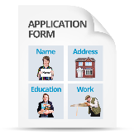
How to apply 28


What happens next? 30

Whakataukī

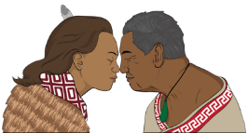
A whakataukī is a Māori saying that shares an important message.


Kia hiwa rā kia hiwa rā.

Kia kōkiri ake, kia mataara.

He karanga atu ki te ao whānui
ki te ao whaikaha.
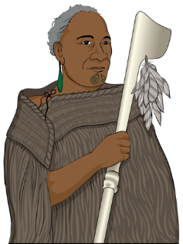

Haere mai ōu whakaaro rangatira ki tēnei kaupapa whakahirahira nau mai e te iwi e.


Here are the English words of the whakataukī.

Be watchful, be alert.

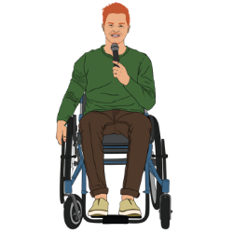
Rise up, come forward.

Be counted, be alert.
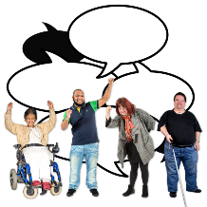

A call going out to the world, to the disabled world.

We welcome your chiefly thoughts to this important discussion.

We welcome all.

About this Easy Read

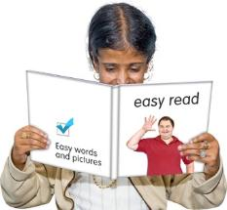
This Easy Read is from the Ministry of Disabled People – Whaikaha.

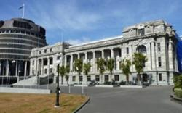
The Ministry of Disabled
People – Whaikaha works to make things better for disabled people by working with:
the Government
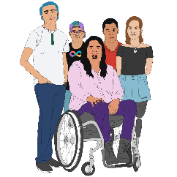
the community which includes:
- disabled people

- tāngata whaikaha
Māori / Māori disabled
people
businesses.

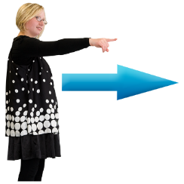
In this Easy Read when we say Whaikaha this means the Ministry
of Disabled People – Whaikaha.

Where it says we / our this means Whaikaha.

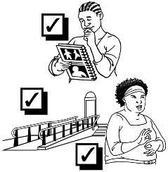
We are leading work to make accessibility better in Aotearoa New Zealand.

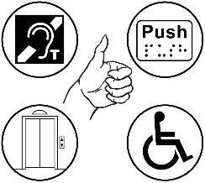
Accessibility means making sure disabled people can be part of something.

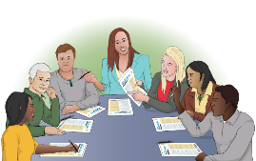
We are making the Accessibility Advisory Group to support us to do this work.

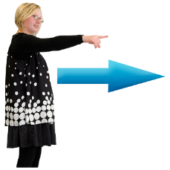
In this document the Accessibility Advisory Group will be called the rōpū / group.


We are looking for people to join
the rōpū / group.

What is the Accessibility Advisory
Group?

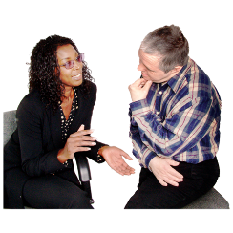
Members of the rōpū / group will give us advice on how to make accessibility in Aotearoa New Zealand better.


The rōpū / group will have 10 people from the disability community in it.


We want the members of the
rōpū / group to:
be creative / come up with interesting ideas
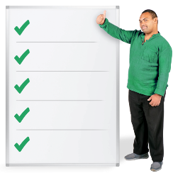
know lots of things about accessibility issues
be strategic thinkers.
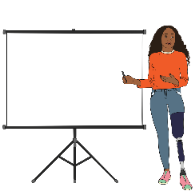
A strategic thinker is someone who knows:
what is going on with an issue
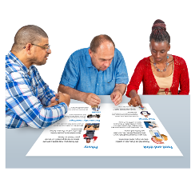
how to make plans
how to use information to solve problems.

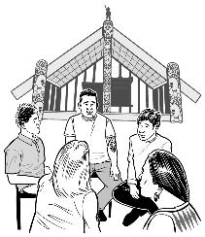
The rōpū / group will:
use tikanga / Māori ways of doing things
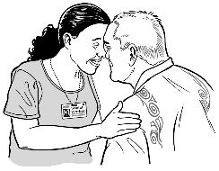
use whakawhanaungatanga / Māori ways of getting along with people
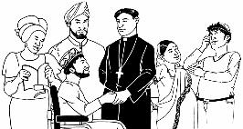
know what is important to other cultures about accessibility.

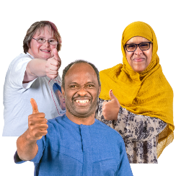
Culture is a way of:
thinking that a group shares
doing things as a group.

What kind of people does Whaikaha want?

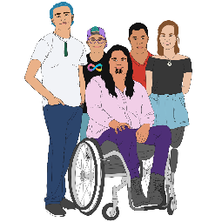
We are wanting people for the
rōpū / group who are:
disabled

tāngata whaikaha Māori / Māori disabled people
Turi Māori / Māori deaf people
from the Deaf community
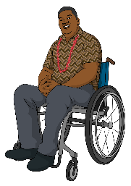
Pacific disabled peoples / Pacific person with a disability
neurodivergent
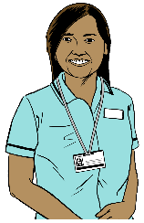
whānau / families of disabled people
carers of disabled people.

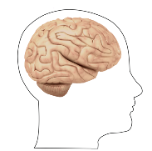
Neurodivergent people have brains that are different to:
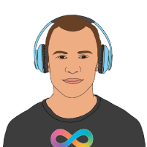
how most brains work
what some people think our brains should be like.

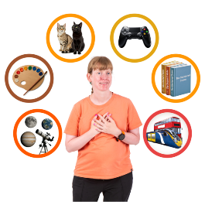
For example neurodivergent people include people who:
are autistic
have Attention Deficit Hyperactivity Disorder / ADHD.

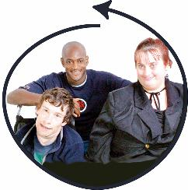
We are also wanting people for the rōpū / group who are from
diverse / different:
backgrounds / kinds of lives
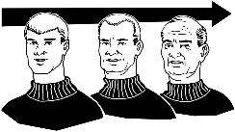
parts of the country
age groups
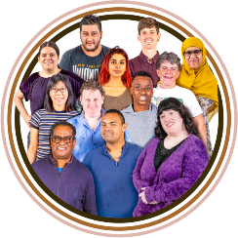
genders
identities.

Gender is if you are:
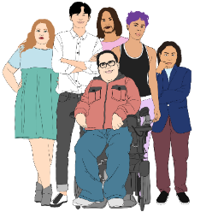
a man
a woman
another gender like nonbinary.

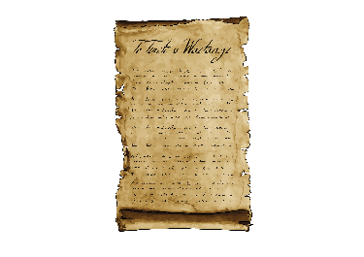
We want people for the rōpū / group who are committed to:
Te Tiriti o Waitangi / The Treaty of Waitangi

the United Nations Convention on the Rights of Persons with Disabilities
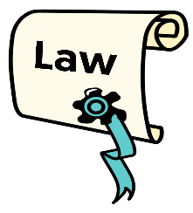
The Human Rights Act 1993
our Strategic Intentions.

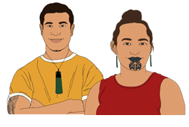
Te Tiriti o Waitangi / The Treaty of Waitangi is an important agreement between:
Māori
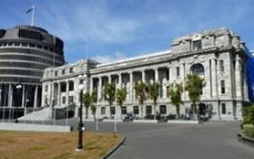
and
the Crown.

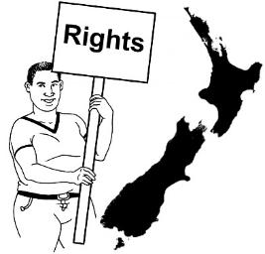
The purpose of Te Tiriti is to:
protect Māori:
- rights
- taonga / things that are very important to Māori
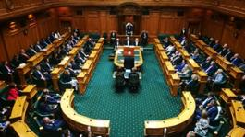
keep peace and order
set up government.

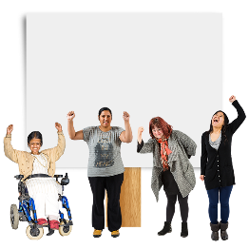
Rights are things that the
law says every person should:
have
be able to do.

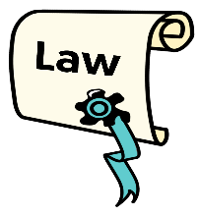
Peace and order means to follow laws / rules.

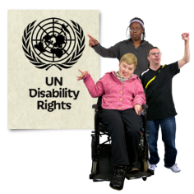
The United Nations Convention on the Rights of Persons with Disabilities / UNCRPD is a law lots of countries have agreed to.

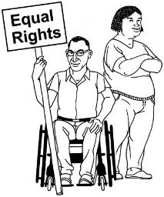
It says what governments must do to make sure disabled people get the same rights as everybody else.

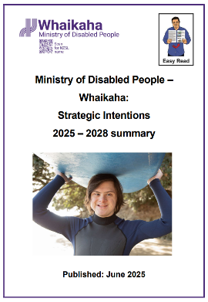
You can find the Easy Read version of our Strategic Intentions at this website:

https://tinyurl.com/58eb9fzc

How much work will the rōpū /group do?


The rōpū / group will meet online 4 to 6 times a year.


We would like the first meeting to be:
in person
in Wellington.

Members of the rōpū / group will be paid for the:
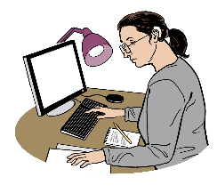
time they spend at the meetings
work they do to get ready for the meetings.

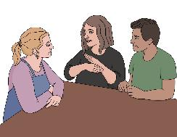
We will provide for supports like:
New Zealand Sign Language / NZSL interpreters
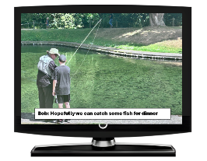
captioning
meeting assistance
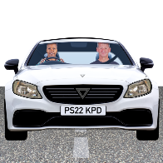
note takers
travel costs.

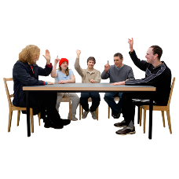
The members of the rōpū / group will elect a co-chair of the group.

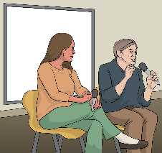
A co-chair is a person who shares leading a group with someone else.


1 or 2 members of the rōpū / group will also be part of the Whaikaha Steering Group for the Accessibility Work Programme.
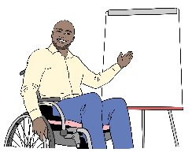
A steering group is a group of people who lead the work being
done on something.

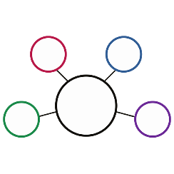
The Accessibility Work Programme is a list of the work that will be done to make accessibility in Aotearoa New Zealand better.

How much do rōpū / group members get paid?

Rōpū / group members will get paid
61 dollars an hour for:
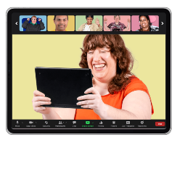
each meeting which goes for 4 hours
up to 2 hours for getting ready for the meetings.

The co-chair will be paid 77 dollars an hour for:
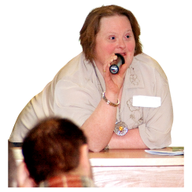
each meeting which goes for 4 hours
up to 2 hours for getting ready for the meetings.

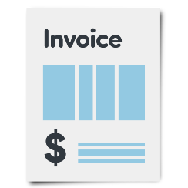
Rōpū / group members will invoice Whaikaha after each meeting.

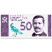
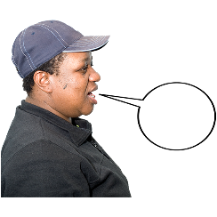
An invoice is a type of letter you send asking to be paid for work you have done.

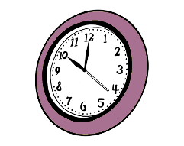
The letter has information like:
how many hours you worked
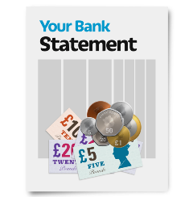
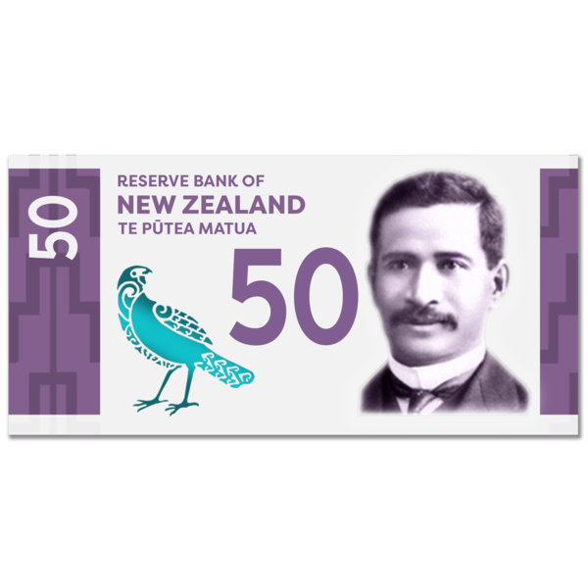
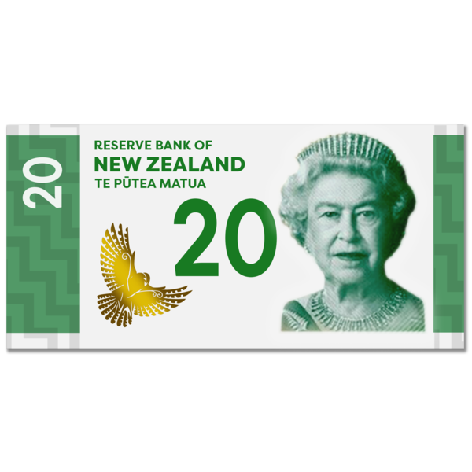
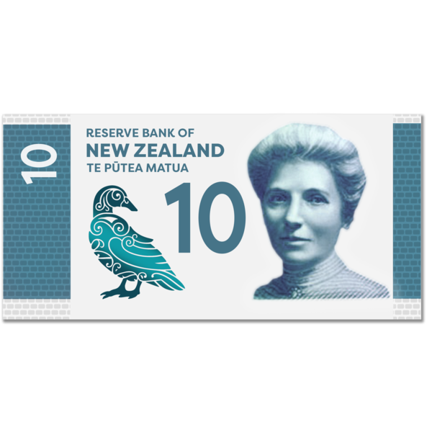
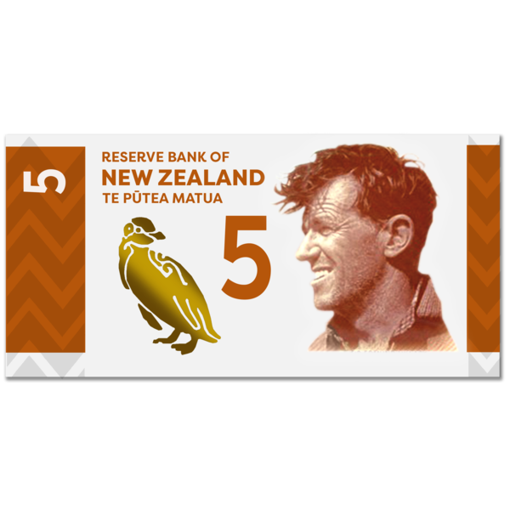
the rate / money you get paid every hour
where the money should be sent like a bank account.

What skills and experience do rōpū / group members need?

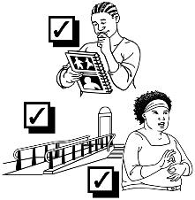
We want people who:
understand accessibility
understand barriers

and
can come up with
solutions / answers.


Here barrier means something that stops things from being accessible for disabled people.

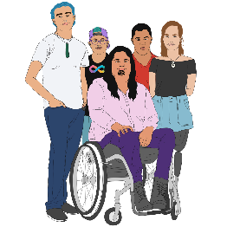
We want people who think it is important to include everyone especially:
tāngata whaikaha Māori / Māori disabled people
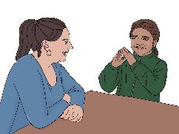
Turi Māori / Māori deaf people
Pacific peoples.

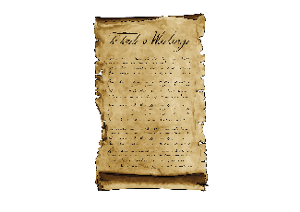
We want people who understand:
Te Tiriti o Waitangi / The Treaty of Waitangi
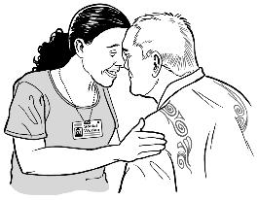
how kaupapa Māori works to make things better in Aotearoa New Zealand.

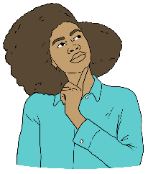
Kaupapa Māori means using all the parts of Māori:
knowledge
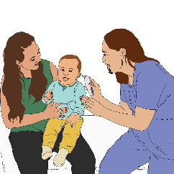
skills
attitudes
values / things that are important.

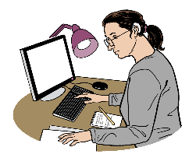
We want people who:
have worked on accessibility projects
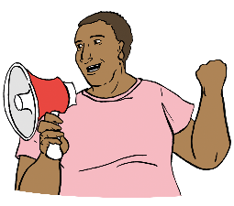
know how to advocate / speak up for disabled people
understand social change.


Social change means:
doing work that makes things better for people
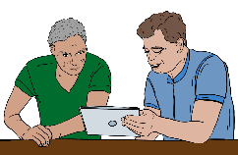
supporting people to understand how those changes work for everyone.

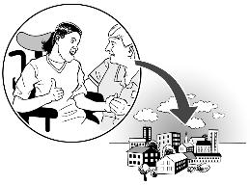
We want people who have good connections in:
their community
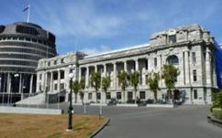
the Government
business.

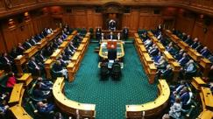
We want people who understand how things work in:
the Government

the public sector
private enterprise.

The public sector is the organisations that do work for the Government.

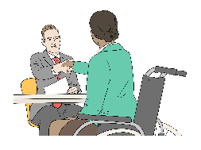
Private enterprise is the
companies / businesses that are not part of the Government.

How to apply

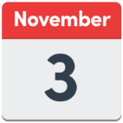
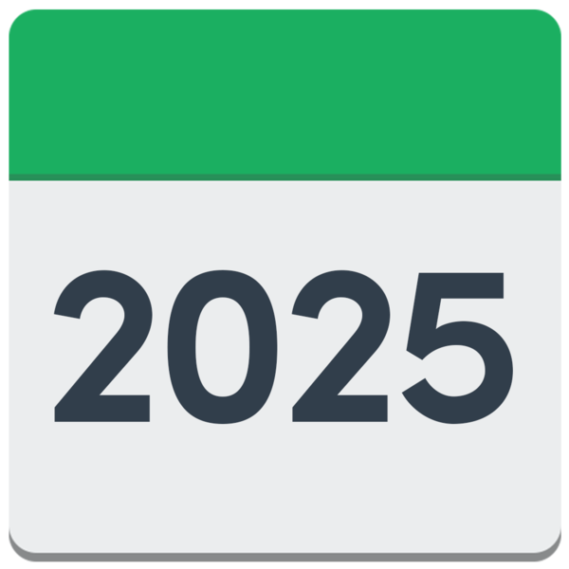
Applications must be put in by
3 November 2025.


You can download the Expression of Interest form at this website:

www.whaikaha.govt.nz/aag

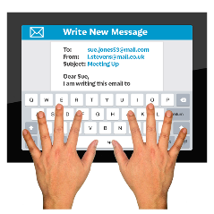
You can send your filled in form by email to:

outreach@whaikaha.govt.nz


If you would like to apply using a video recording please email us a link to your video.

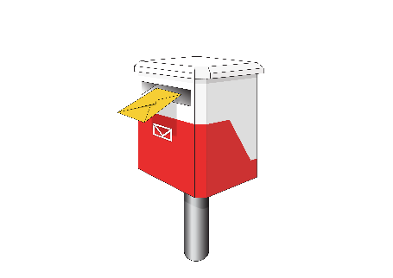
You can send your filled in form by post to:

Outreach and Innovation Group
Ministry of Disabled People – Whaikaha
Reply Paid: 262204
PO Box 1556
Wellington 6140
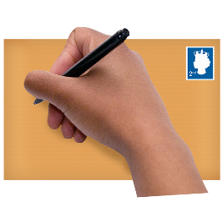

You do not need to put a stamp on the envelope.

What happens next?


A panel of people from the disability community will consider / think about all the people who have applied to join the rōpū / group.


This panel will be chaired by us.

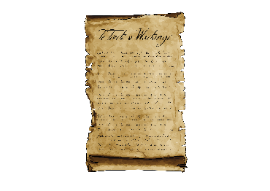
The panel / group will choose people by:
using the ideas from Te Tiriti o Waitangi / The Treaty of Waitangi
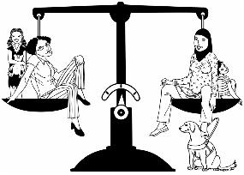
thinking about what people can do to make things equal for:
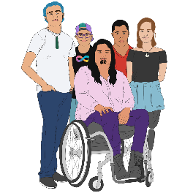
- tāngata whaikaha Māori / Māori disabled people
- Turi Māori / Māori deaf people.

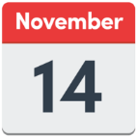
We will let people know they are being considered / thought of for the rōpū / group by Friday 14 November 2025.

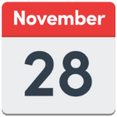
We will let people know if they are a rōpū / group member by Friday 28 November 2025.

The first meeting of the rōpū / group is planned to be:
in person
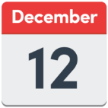
in Wellington
on Friday 12 December 2025.


This information has been written by the Ministry of Disabled People – Whaikaha.

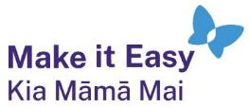
It has been translated into Easy Read by the Make it Easy Kia Māmā Mai service of People First New Zealand Ngā Tāngata Tuatahi.
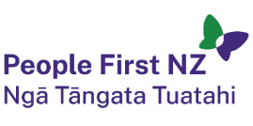
The ideas in this document are not the ideas of People First New Zealand Ngā Tāngata Tuatahi.

All images used in this Easy Read document are subject to copyright rules and cannot be used without permission.


Make it Easy uses images from:

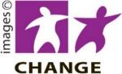
- Photosymbols

- Change Images


- Huriana Kopeke-Te Aho
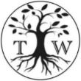
- SGC Image Works

- T Wood

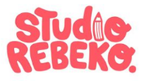
- Studio Rebeko

- Inga Kramer.

