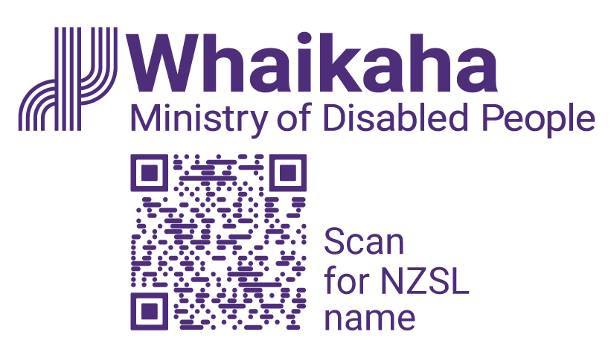
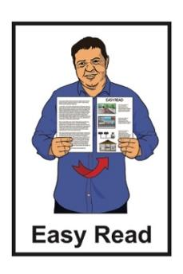

Accessibility Advisory Group – Expression of Interest form
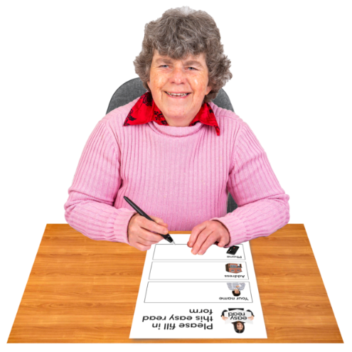

Published: October 2025

Whakataukī

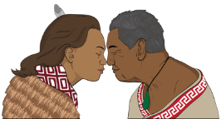
A whakataukī is a Māori saying that shares an important message.


Kia hiwa rā kia hiwa rā.

Kia kōkiri ake, kia mataara.

He karanga atu ki te ao whānui
ki te ao whaikaha.
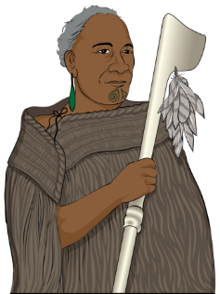

Haere mai ōu whakaaro rangatira ki tēnei kaupapa whakahirahira nau mai e te iwi e.


Here are the English words of the whakataukī.

Be watchful, be alert.

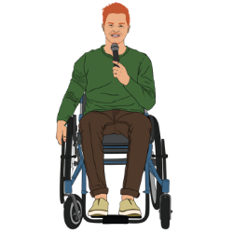
Rise up, come forward.

Be counted, be alert.


A call going out to the world, to the disabled world.

We welcome your chiefly thoughts to this important discussion.

We welcome all.

About this Easy Read

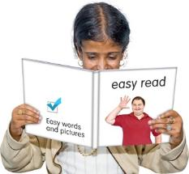
This Easy Read is the Expression of Interest form for the Accessibility Advisory Group.


An Expression of Interest is officially saying you would like to do something.


You can read more about what the Accessibility Advisory Group is on pages 5 to 10.


This Easy Read is from the Ministry of Disabled People – Whaikaha.


The Ministry of Disabled
People – Whaikaha works to make things better for disabled people by working with:
the Government
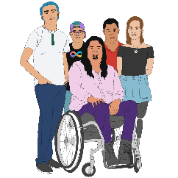
the community which includes:
- disabled people

- tāngata whaikaha
Māori / Māori disabled
people
businesses.


In this Easy Read when we say Whaikaha this means the Ministry
of Disabled People – Whaikaha.

Where it says we / our this means Whaikaha.

What is the Accessibility Advisory
Group?


Members of the Accessibility Advisory Group will give us advice on how to make accessibility in Aotearoa New Zealand better.

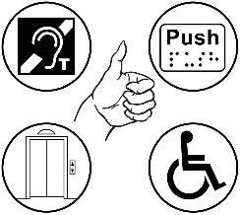
Accessibility means making sure disabled people can be part of something.


The Accessibility Advisory
Group will have 10 people from the disability community in it.


We want the members of the Accessibility Advisory Group to:
be creative / come up with interesting ideas

be strategic thinkers
know lots of things about accessibility issues.


A strategic thinker is someone who knows:
what is going on with an issue

how to make plans
how to use information to solve problems.

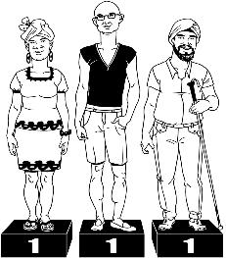
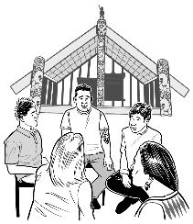
The Accessibility Advisory
Group will work together using the values:
mana taurite – equity drives us

mana kaha – we strengthen and support
mana tūhura – we explore and learn.


Values are beliefs that people use to decide how to:
live

behave
work.

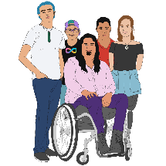
People who are an important part of this work are:

tāngata whaikaha Māori / Māori disabled people
Turi Māori / Māori deaf people.

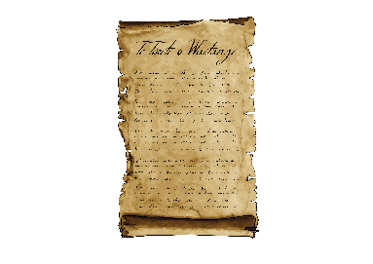
The Accessibility Advisory
Group will do their work using the ideas in Te Tiriti o Waitangi / The Treaty of Waitangi.

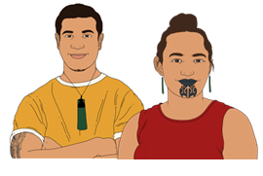
Te Tiriti o Waitangi / The Treaty of Waitangi is an important agreement between:
Māori

and
the Crown.


The purpose of Te Tiriti is to:
protect Māori:
- rights
- taonga / things that are very important to Māori

keep peace and order
set up government.


Rights are things that the
law says every person should:
have
be able to do.


Peace and order means following laws / rules.

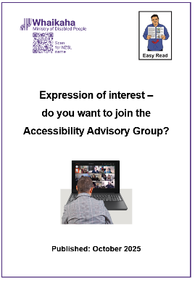
There is more information about the Accessibility Advisory Group in the Easy Read Expression of Interest – do you want to join the Accessibility Advisory Group?

https://www.whaikaha.govt.nz/aag

Sending in the form



Please return your filled in form to us by Monday 3 November 2025.


You can send your filled in form by email to:

outreach@whaikaha.govt.nz


If you would like to apply using a video recording please send us a link to your video by email to:

outreach@whaikaha.govt.nz

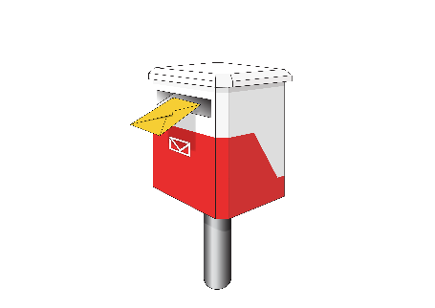
You can send your filled in form by post to:

Outreach and Innovation Group
Ministry of Disabled People – Whaikaha
Reply Paid: 262204
PO Box 1556
Wellington 6140

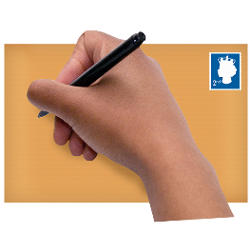

You do not need to put a stamp on the envelope.

Extra information

You can add more pages to your application if you need more space for your answers.

Expression of Interest



Name and contact details

Please write your information in the boxes.


My name is:


My email address is:

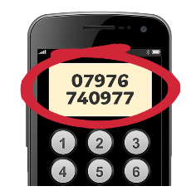
My phone number is:

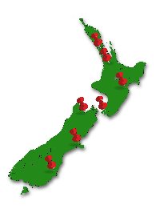
I live in this town / city:


Please fill in the box below if you are not a citizen of Aotearoa New Zealand.

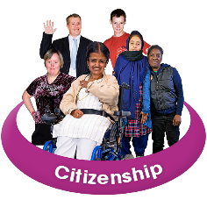
My citizenship is:

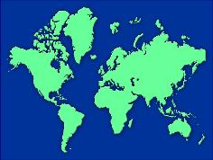
Citizenship means the country you:
were born in
or
have a passport for.


You can become a citizen of another country.

Identity

We want lots of different people for the Accessibility Advisory
Group.


Please tick all the boxes in this list that are right for you:

tāngata whaikaha
Māori / whānau hauā / Māori disabled

Deaf

Turi Māori / Māori deaf person
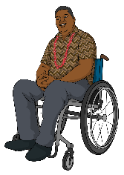
disabled person

Pacific disabled person / Pacific person with a disability.


Please tick all the boxes in this list that are right for you:

takatāpui /
MVPFAFF+ /
rainbow / LGBTQIA+
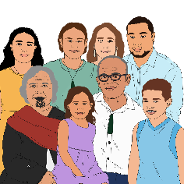
whānau / family of disabled adult

whānau / family of disabled child or children

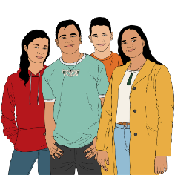
youth / young person

rangatahi Māori

disabled older person
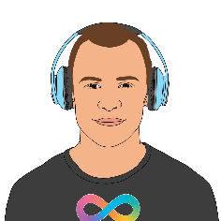
live in a rural area

neurodivergent

something else – please write in the box below:

Experience and background

Please write your answer in the box below each question.

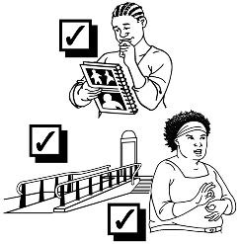
What are your:
experiences with accessibility issues
skills that would be good for the Accessibility Advisory
Group?

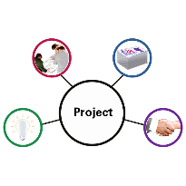
What accessibility projects have you done?

What accessibility:
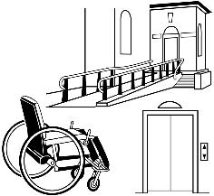
barriers do you know about
and
solutions have you come up with?


Here barrier means something that stops things from being accessible for disabled people.
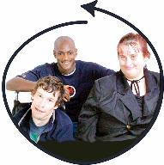
How do you make sure accessibility solutions are good for everyone?


What are your:
disability networks / connections with disabled people
leadership roles?

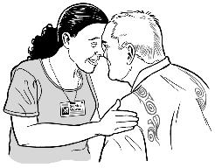
What do you know about using kaupapa Māori to make accessibility better?


Kaupapa Māori means using all the parts of Māori:
knowledge

skills
attitudes
values.

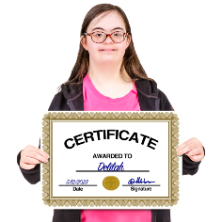
Work experience

In the box below tell us about your:
qualifications
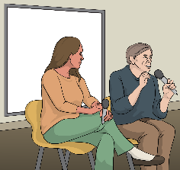
work experience
mahi
volunteer experience.

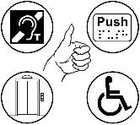
What work have you done on accessibility for disabled people?


What is your work experience:
on boards
in industry groups
with public sector groups?


The public sector is the organisations that do work for the Government.

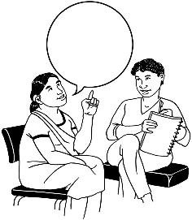
Is there anything we should know about your current:
roles
memberships?

Please tell us about:

any conflicts of interest that might happen
how you might manage conflicts of interest.


A conflict of interest is when someone has different things they need to do like:
their job
supporting a family member.


Doing different things at the same time can make it hard to make a fair decision.

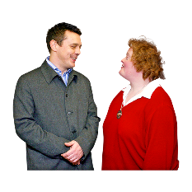
It is important to tell people about a conflict of interest so things can be kept honest.


Representing an organisation

Most members of the Accessibility Advisory Group will be there as an individual / 1 person.


Please tell us if you would like to represent an organisation.


Tick the box that is right for you:

Yes – I will represent an organisation

No – I will be there as an individual / 1 person

I am not sure.

Please write in the box below:
which organisation you will represent
why you would like to represent them.


Referees / people who can support your application

Please write the names of 2 people who can be referees / support your application.

1.

Their name is:


Their organisation / company is:


Our relationship / how I know them is:

Their phone number is:

Their email address is:

2.
Their name is:

Their organisation / company is:

Our relationship / how I know them is:

Their phone number is:

Their email address is:

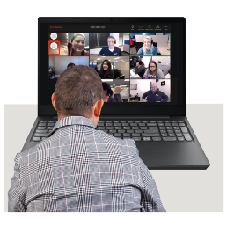
Availability

Can you do:
6 online meetings of 4 hours each

and
2 hours of work getting ready for each meeting?


Please tick the box that is right for you:

Yes

No

I will need to check.


Length of membership

Please tick the box that is right for you:


I would like to do a 1 year term for the Accessibility Advisory Group


I would like to do a 2 year term for the Accessibility Advisory Group


I have no preference / do not mind how long my term is.


Support and reasonable accommodations

Please let us know if you need support like:
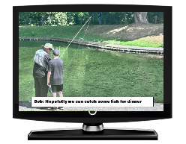
NZSL interpreter
captioning
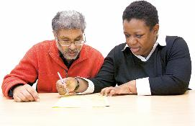
note-taker
meeting assistant.


Please write what support you will need in the box below:

Criminal record

We might ask for your permission to look at information about any criminal convictions you may have.


A criminal conviction means you have been found guilty by a court of breaking the law.


A criminal conviction might not stop you being on the Accessibility Advisory Group.


We do not need to know about any criminal convictions that come under the rules of the Criminal Records (Clean Slate) Act 2004.


You can find more information about criminal convictions at this website:

www.justice.govt.nz/criminal-records/

Confirmation


I consent / agree to Whaikaha talking to my referees to ask for information about me.

I understand that the information given by my referees will:

only be used to think about my application
be kept confidential / private
not be shared with me.


I have written in this form about any conflicts of interest I think there might be.


The information about my conflicts of interest is correct as far as I know.


I have told you about my conflicts of interest in good faith / to be honest about them.


I confirm that the information I have given is:
true
complete
correct.


I have given information about everything that may be
relevant / useful for Whaikaha to think about my application.


I confirm what I say here is true.

My name is:


My signature is:


The date I filled in this form is:

Extra information

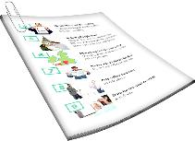
You can include more information.


Tick the boxes that are right for you.

I have included:

more pages with my answers

curriculum vitae / CV / resume


video / other way of applying

cover letter

something else – please write what it is in the box below:

Privacy


We are collecting your personal information from this Expression of Interest to think about you for the Accessibility Advisory Group.

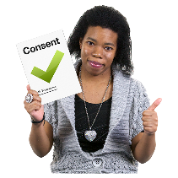
We will not use this information for anything else unless you say we can.

You have the right to ask:
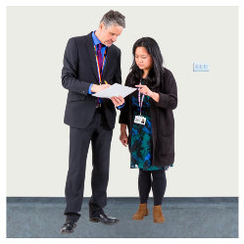
for a copy of personal information we have about you except from referees
for the information to be fixed if you think it is wrong.


You can ask about this by email at:

privacy@whaikaha.govt.nz

This information has been written by the Ministry of Disabled People – Whaikaha.

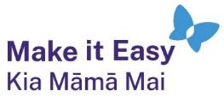
It has been translated into Easy Read by the Make it Easy Kia Māmā Mai service of People First New Zealand Ngā Tāngata Tuatahi.

The ideas in this document are not the ideas of People First New Zealand Ngā Tāngata Tuatahi.

All images used in this Easy Read document are subject to copyright rules and cannot be used without permission.


Make it Easy uses images from:


- Photosymbols

- Change Images


- Huriana Kopeke-Te Aho

- SGC Image Works

- T Wood


- Studio Rebeko

- Inga Kramer.

