easy read

Disability Action Plan 2014 – 2018

2015 update

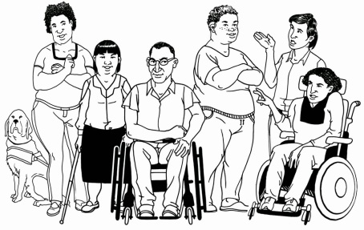

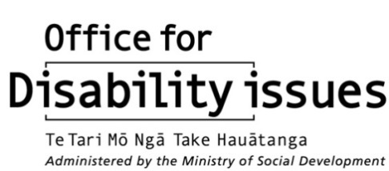
New Zealand’s plan for making the rights of the United Nations Disability Convention real

What is in this document?

Tips before you start reading | page 3
About the Disability Action Plan | page 4
Who made the Plan? | page 6
Working together with DPOs | page 10
The Plan: 5 key things that must happen | page 13
The Plan: 4 parts | page 16

Part 1: More jobs and opportunities | page 17
Part 2: Changing the disability support system for the better | page 23
Part 3: Make sure disabled people are safe and feel safe | page 31
Part 4: Making the community easy for everyone to access | page 38
What now? | page 53
What is not in this Plan? | page 57
How to get more copies of the Disability Action Plan | page 58

Tips before you start reading


This is a plan about what work will be done on disability issues in New Zealand from 2014-2018.


It is a long document.

While it is written in Easy Read it can be hard for some people to read something this big.

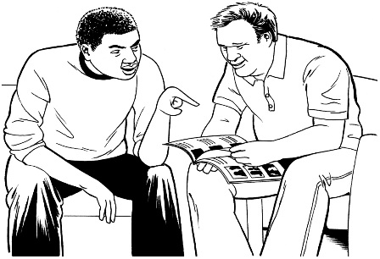
Some things you can do to make it easier are:
- read it a few pages at a time
- have someone to help you understand it.
About the Disability Action Plan
2014-2018

The Disability Action Plan:
4 Year Plan

- started in 2014 and will end in 2018

- was updated by the Government in December 2015 after talking to disabled people and other people to make sure it was still the best plan

- says what things need to happen to make the rights in the United Nations Convention on the Rights of Persons with Disabilities real.

It is also called the Disability Convention.

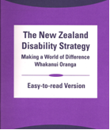
- says what things need to happen to make the New Zealand Disability Strategy real

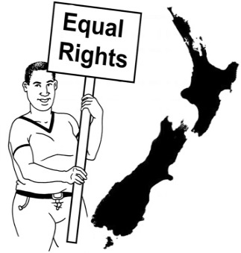
- tries to make sure disabled people have the same rights as everyone else who lives in New Zealand

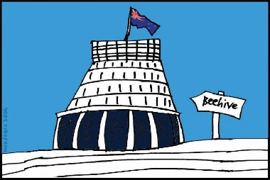
- talks about how people working in government agencies need to work together with Disabled People’s Organisations
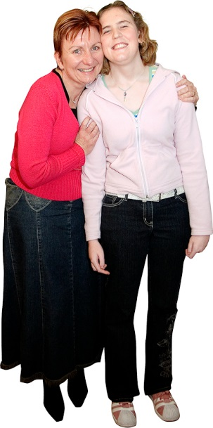

- says other people and organisations need to be part of the plan too

- has some new things in it to make life better for disabled people

- has other things in it that the Government is already doing.
Who made the Plan?

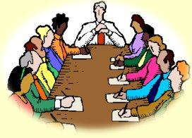
In July 2013 there was a meeting to talk about disability issues.

People from different groups said they wanted changes in the way things were done in the disability sector.


They wanted everyone to work together to make life better for disabled people.

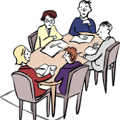
A group called the Chief Executives’ Group then met with the Independent Monitors.

The Chief Executives’ Group is a group of people who work for the Government on disability issues.

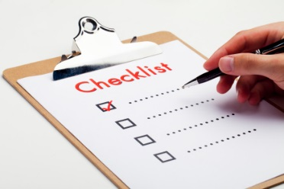
Independent Monitors are people who check that New Zealanders are getting the rights in The Disability Convention.

The Monitors are people from:
- Convention Coalition Monitoring Group

- Human Rights Commission


- Office of the Ombudsman.

The Monitors said the Government needed to work more closely with DPOs.

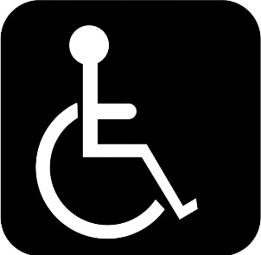
DPO means Disabled People’s Organisation.

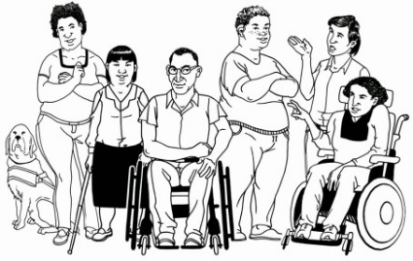
DPOs:
- organisations that are led by disabled people

- have members that are disabled people

- are set up to talk about things that affect disabled people.

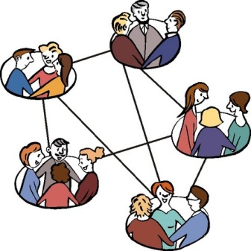
New Zealand has 7 DPOs at the moment:
- Association of Blind Citizens of New Zealand

- Balance New Zealand

- Deaf Aotearoa

- Deaf Blind New Zealand Inc.
- Disabled Person’s Assembly New Zealand (DPA)

- Kāpo Māori o Aotearoa

- People First New Zealand Inc. Ngā Tāngata Tuatahi.


You can find out more about DPOs on this website:

http://www.odi.govt.nz/community/disabled-peoples-organisations.html

Working together with DPOs

Working with DPOs will:
- make sure the voices of disabled people are heard
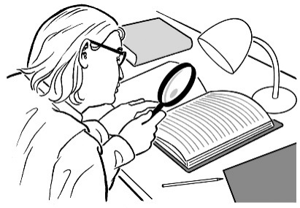
- make sure the work makes a real difference to the lives of disabled people

- help DPOs and others to see what is working well

- show that the money that is being spent is making a real difference.

Article 4 of the Disability Convention says this must happen.
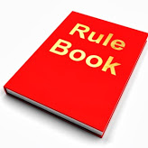
Articles are like rules and laws
In August 2013 the Chief Executives’ Group agreed that government agencies will:
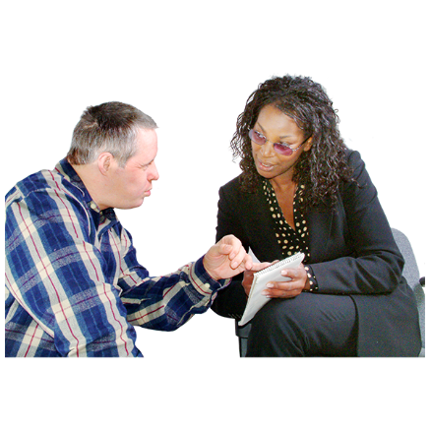
- work with DPOs

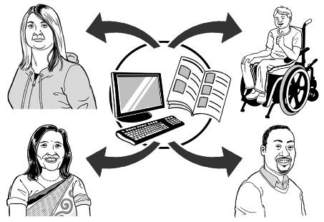
- make it easy for disabled people to take part

- involve the right people, at the right time, in the right work

- value what everyone has to say

- keep telling everyone what the government agencies are working on.

Since then the Office for Disability Issues, other government agencies and the DPOs have worked together to:
4 Year Plan

- make the Disability Action Plan

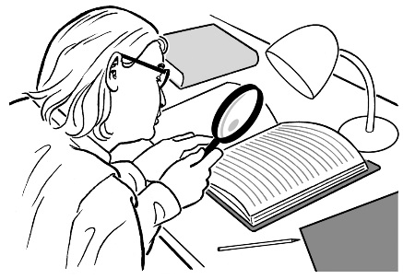
- make the work from the Plan happen

- update the Plan in 2015.

The Plan:
5 key things that must happen

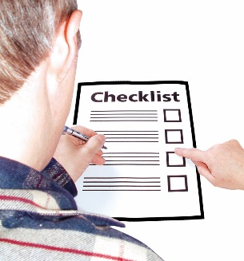
DPOs have said there are 5 key things that must happen to make sure disabled people have the same rights as everyone.
1. Safety and autonomy

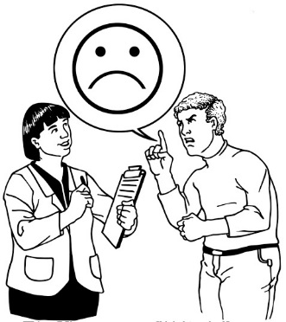
This means:

- I am safe in my home, community and where I work

- I feel safe to speak up, make a complaint and I am heard
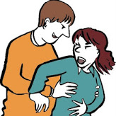
- I am not abused

- people understand what I need and want and I get the support I need.

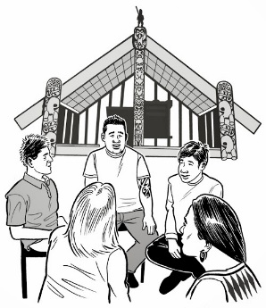
2. Wellbeing

This means:

- I feel respected

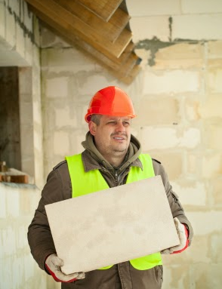
- I can take part in my culture and community

- I can earn my own money like everyone else.

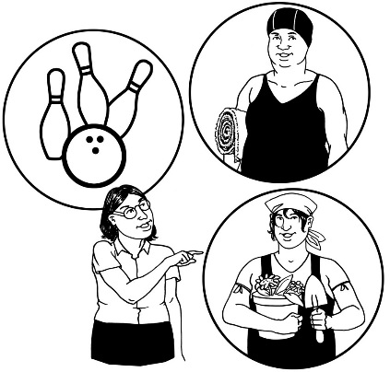
3. Making my own decisions

This means:

- I can make my own decisions about what I want to do
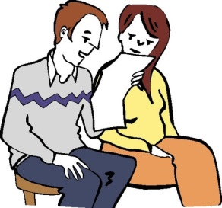
- I have the information and support I need to make decisions in a way I understand.
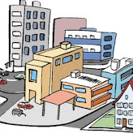
4. Community

This means:

- I feel part of my community
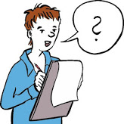
- what I think is respected

- what I have to say is listened to just like everyone else.

5. Nothing about us, without us

This means:


- DPOs speak for disabled people about disability issues

- DPOs are strong and supported to keep doing the work they need to.
The Plan: 4 parts

1
2
1
4
3

There are 4 parts to the Disability Action Plan:
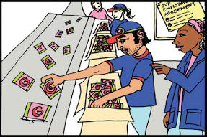
1
- More jobs and opportunities

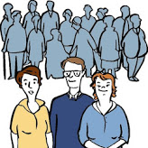
- Changing the disability support system for the better
2
1

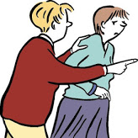
- Make sure disabled people are safe and feel safe
3

4
- Making the community easy for everyone to access.

Each part has actions.

The actions are the work that will be done.
Part 1: More jobs and opportunities
1
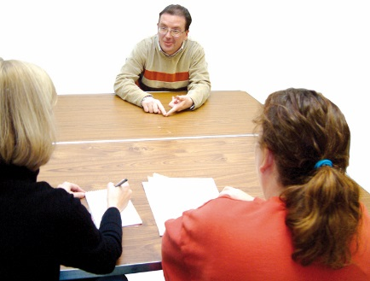
Part 1 looks at:
- showing everyone what jobs disabled people can do

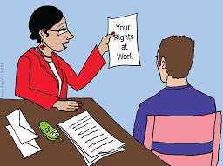
- making sure disabled people have:

  - good places to work

  - job rights

  - rules and pay like everyone else.

Part 1 is about making the rights of Articles 24 and 27 of the Disability Convention real.

There are 3 actions in part 1 of the Plan.


Action 1:
To have more disabled people in jobs after finishing school or further education


How will this be done?
By working on transition services.


Who will do it?
The Ministry of Education will make this happen.


Action 2:
To have more disabled people in paid jobs or working for themselves
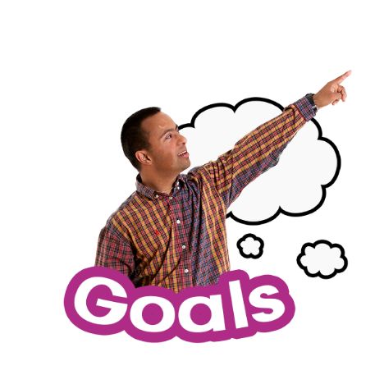

How will this be done?
By making a long term plan for making better job opportunities for disabled people.
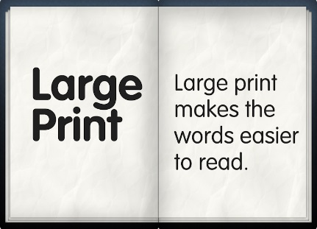
Having more information on reasonable accommodations in the workplace will help this happen.

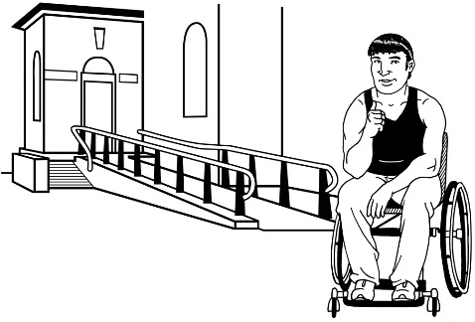
Reasonable accommodations are changes to the workplace that:
- will help disabled workers to do their job

- are not too hard or cost too much money.
Disabled people have the right to have reasonable accommodations in the Disability Convention.


Who will do it?
The Ministry of Social Development will make this happen.

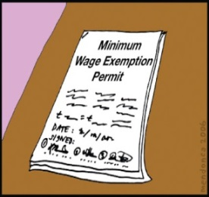
Another way this will be done is:
By finding a better way to pay disabled people so the Minimum Wage Exemption can be taken away.

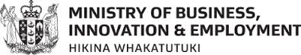
Who will do it?
The Ministry of Business, Innovation and Employment and the Ministry of Social Development will make this happen.

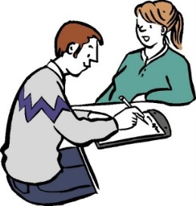
Action 3:
To have more employers that feel like they can hire disabled people as workers.

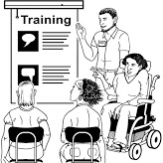
How will this be done?
By having more disabled people working and training in government agencies.

Who will do it?
The Ministry of Social Development will make this happen.

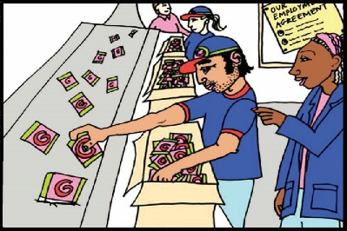
Another way this will be done is:
The Government will do more work with employers to help disabled people get jobs.

Who will do it?
The Ministry of Social Development will make this happen.

Part 2: Changing the disability support system for the better
2
1

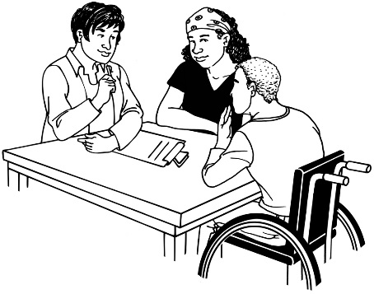
Part 2 looks at making sure:

- different agencies work with disabled people

- disabled people are part of decisions and actions.

Part 2 is about making Articles 19, 20 and 26 of the Disability Convention real.

There are 3 actions in part 2 of the Plan.

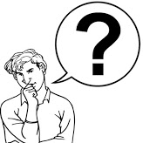
Action 4:

- To make sure that disabled people have choice and control about support and services
- To make better use of disability support funding.

How will this be done?
DPOs will work with the Government and the National Enabling Good Lives Leadership Group.
They will:
- work together to make changes to disability support services

- use the important ideas that worked well from the Enabling Good Lives Project.
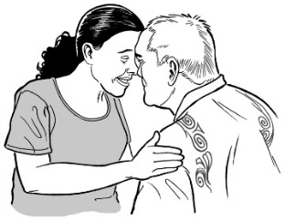
These are the important ideas from the Enabling Good Lives Project:
- meet the cultural needs of disabled people

- use what people are good at

- look at all the different parts of a disabled person’s life
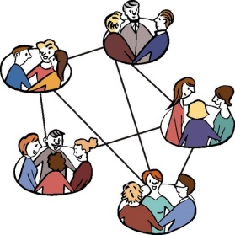
- involve whānau / family

- work together with all the different supports in disabled peoples’ lives.

Who will do it?
The Ministry of Social Development, Ministry of Education and the Ministry of Health will make this happen.


Another way this will be done is:
The Government will use a project called:
A good start in life.
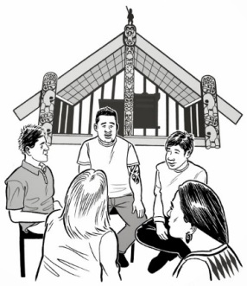
A good start in life is a project that will:
- be for family/ whānau of disabled children who are 0 to 6 years old

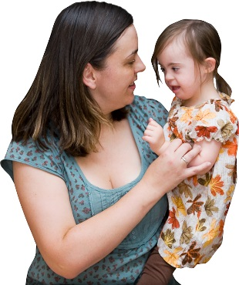
- make better supports for parents of disabled children

- make better supports for wider family / whānau.

Who will do it?
The Ministry of Education will make this happen.

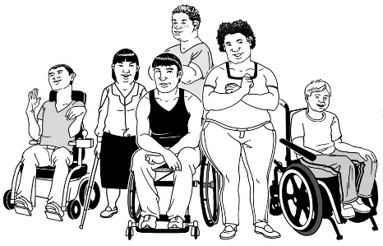
Action 5:
Disabled People’s Organisations (DPOs) to take part in:

- the setting up of disability support systems
- checking the changes to the disability support system.

How will this be done?
- DPOs and the Government will work together.

- DPOs will take part in all decisions about disabled people.

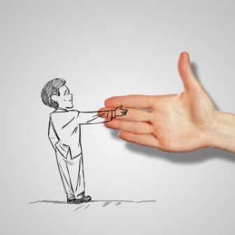
- The Government will support DPOs so they are more able to work with the Government and communities
- By thinking about the different groups of people the DPOs represent.

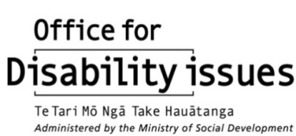
Who will do it?
The Office for Disability Issues and DPOs will make these things happen.


Action 6:
To make disability support services better for disabled people.

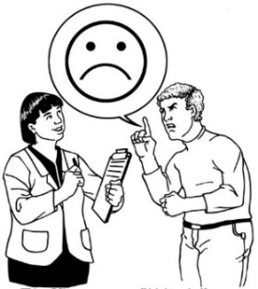
How will this be done?
- By:
- making ways for disabled people to give feedback on services safely

- making ways for DPOs to give feedback about services

- making ways to check that money for disability services is used well

- looking at ways to collect information about how well a service is doing

- looking at how well services are doing

- making sure service providers are doing what disabled people need

- making sure service providers are able to change what they do to match what disabled people want.

Who will do it?
The Ministry of Health will make these things happen.

Part 3: Make sure disabled people are safe and feel safe
3

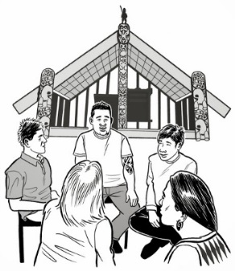
Part 3 looks at:

- making better systems and ways to work so disabled children and adults are safe everywhere.

Part 3 is about making the rights in Articles 11, 12, 13, 14, 15, 16, 17 and 23 of the Disability Convention real.

There are 2 actions in part 3 of the Plan.

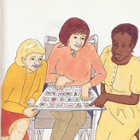
Action 7:
To make it easier for disabled people to make their own choices about their lives.

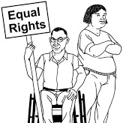
How will this be done?
By making sure that disabled people have:
- their legal rights
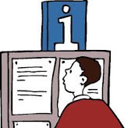
- good information to make choices

- good support to make their own decisions.

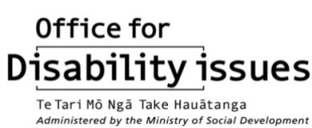
Who will do it?
The Office for Disability Issues will make this happen.

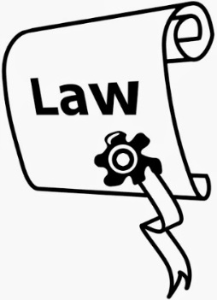
Another way this will be done is:
By looking at the laws that protect disabled people from having medical treatment when:

- it is not needed to treat an illness or condition

- they have not given their full consent for it.

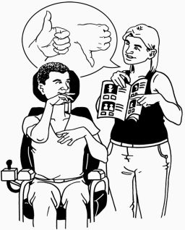
Consent means knowing all of the information about something and then choosing whether or not to go ahead with it.

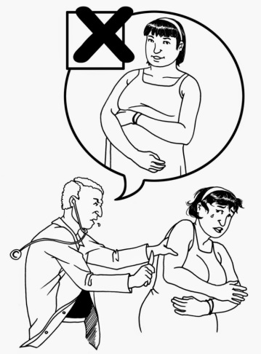
This action will start by looking how to protect disabled people from sterilisation without their full consent.

Sterilisation means having an operation to stop you from being able to have a baby.

Who will do it?
The Ministry of Health and The Ministry of Justice will make this happen.

Action 8:
To make sure that less disabled people are victims of violence, abuse or neglect.

How will this be done?
By looking at the care and support for disabled children who are looked after under a law called the Children, Young Persons and Their Families Act 1989.

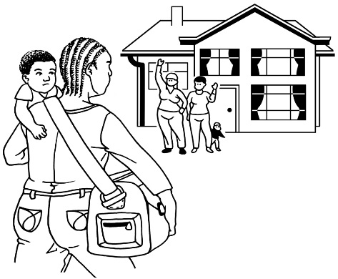
The care and support of disabled children under this Act will be checked to see if children are:
- being treated fairly

- getting the best care for their needs.

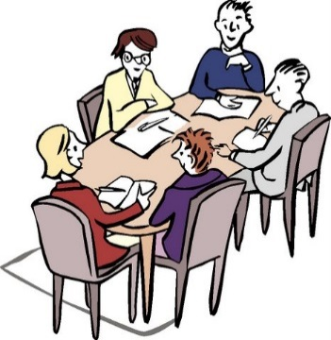
If disabled children under this Act do not always get these things the Government will look at what changes need to be made to New Zealand’s laws to make sure they do.

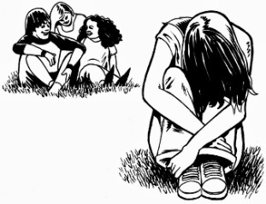
Another way this will be done is:
By looking at ways to have less:
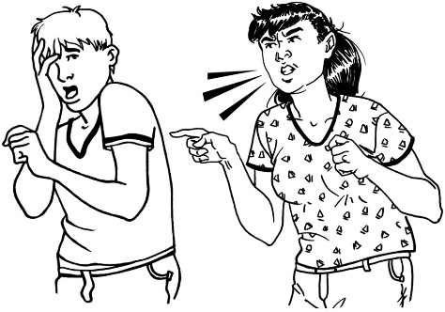
- bullying of disabled people

- violence towards disabled people

- neglect of disabled people.
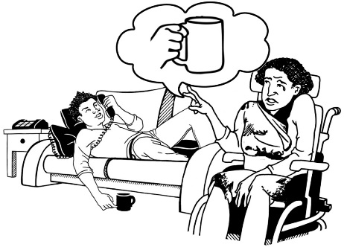

Neglect means when people are not given the care they need.

Some of the ways to have less bullying, violence and neglect toward disabled people are:

- teaching disabled people about their rights
- making sure the needs of disabled people are part of the Family Violence work programme
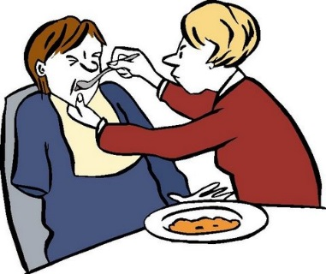
- making a new work programme that is about abuse by people who are not family members, like support workers and people in the community.

Who will make this happen?
The Ministry of Social Development will make these things happen.

Part 4: Making the community easy for everyone to access
4

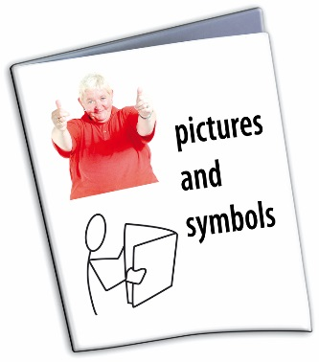
Part 4 is about accessibility.

If something is accessible it means it is easier for people to use.

Part 4 looks at:
- accessible buildings, spaces, transport, towns and cities

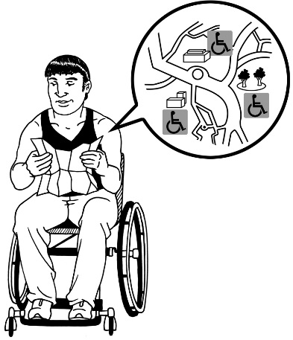
Disabled people have the right to get into and around buildings and the community.

- accessible information

Disabled people have the right to get information in ways they can understand.

- access to health and justice services


Disabled people have the right to:
  - the same health services as others

  - get the health services they need because of their disability

  - be treated the same as everyone else by the law when taking part in what happens in court.

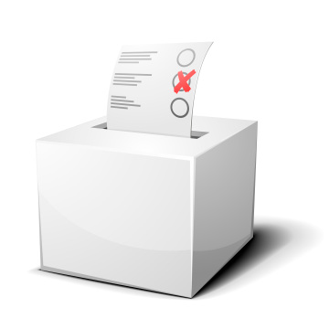
- taking part in politics and community issues

Disabled people have the right to vote and take part in decisions that the Government makes.

Part 4 is about making Articles 5, 8, 9, 21, 25, 29 and 30 of the Disability Convention real.

There are 4 actions in part 4 of the Plan.

Action 9:
To make sure government services work better for disabled people.

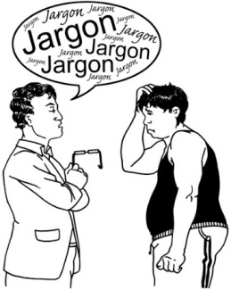
How will this be done?
By telling government agencies how to make their information easy for everyone to understand.

Who will do it?
The Office for Disability Issues and DPOs will make this happen.


Another way this will be done is:
By looking into what the justice system is like for:
- disabled adults
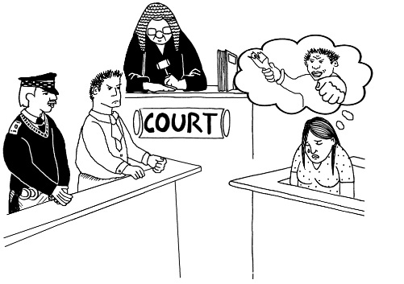
- disabled children

- family / whānau of disabled people.

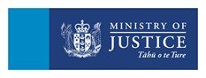
Who will do it?
The Ministry of Justice will make this happen.


Another way this will be done is:
By making sure disabled people have:
- better access to health services

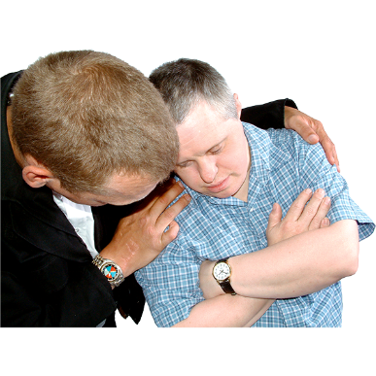
- better health.

People with learning (intellectual) disability often have poor health and healthcare.

This work will look at making things better for these people.

Who will do it?
The Ministry of Health will make this happen.

Another way this will be done is:
By looking at a law called the Mental Health (Compulsory Assessment and Treatment) Act 1992.


The Ministry of Health will look to see if it fits with the New Zealand Bill of Rights Act 1990 and The Disability Convention.

Who will do it?
The Ministry of Health will make this happen.

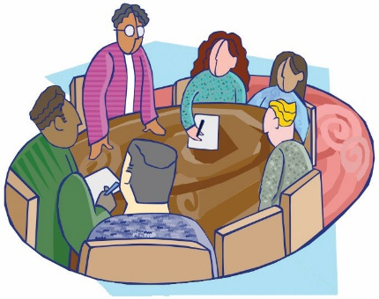
Another way this will be done is:
Through the work of the new Disability Data and Evidence Working Group.
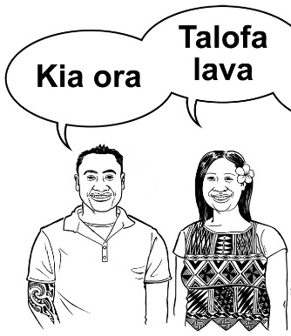
The work of this group will focus on Māori and Pasifika disabled people.

Who will do it?

The Office for the Disability Issues and Statistics New Zealand will make this happen.

Another way this will happen is:
By:
- looking at New Zealand’s laws and making sure they are the same as The Disability Convention.

Who will make it happen?
The Office for Disability Issues and DPOs will make this happen.

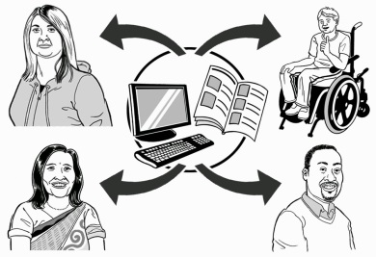
Another way this will happen is:
By looking at ways that technology can make it easier for disabled people to take part in:
- work

- community

- politics.

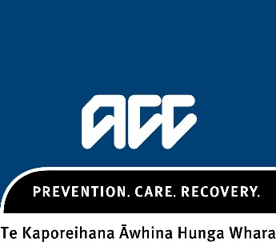
Who will make this happen?
ACC will make this happen.


Another way this will happen is:
By making an easy way to be able to see:
?
- how much the Government spends on disability

- how the Government pays for this work.


Another way this will happen is:
By looking at how the Government could work in a way that uses the ideas of Whānau Ora for disabled people who want this.

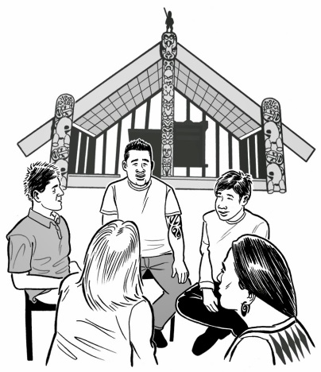
Whānau Ora:
- is a way of giving services that is respectful of Māori culture

- says that whānau / family is an important part of getting services.


When will this happen?
This work will not happen until 2017-2018.

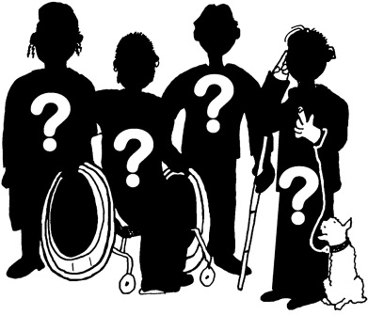
Who will make it happen?
This has not been decided yet.

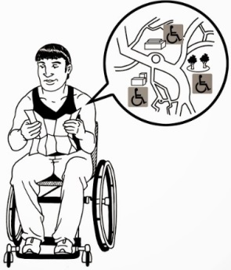
Action 10:
To make it easier for disabled people to:
- use transport
- get around in buildings and the community.

How will this be done?
By making the changes from the research that was done on how easy public transport is to get to and use in New Zealand.


Who will do it?

The Ministry of Transport and the New Zealand Transport Agency will make this happen.

Another way this will be done is:
By starting the work from the Accessibility Plan that is about making public buildings easy for disabled people to get around in and use.

Who will do it?
The Ministry of Business, Innovation and Employment will make this happen.

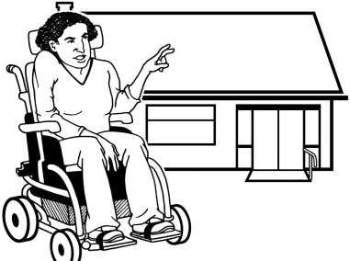
Another way this will be done is:
By:
- finding out what kinds of houses are right for disabled people
- telling government departments that work with social housing what kinds of houses are right for disabled people.

Who will do this?
The Office for Disability Issues will make this happen.

Action 11:
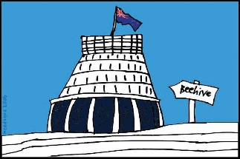
To make it easier for disabled people to take part in politics and community issues like everyone else.
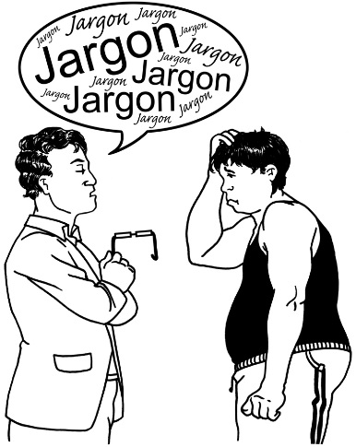

How will this be done?
By:
- finding out what is making it hard for disabled people to take part
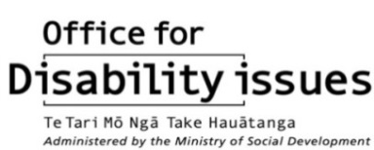
- working together with the Government to make sure voting is easy to do and understand.

Who will do it?
The DPOs will make this happen.

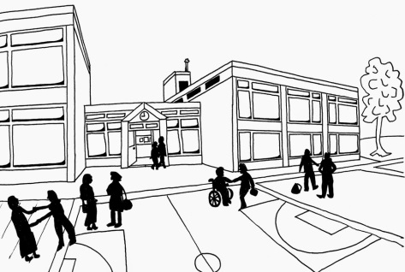
Action 12:
To make it easier for disabled people to take part in:
- cultural events
- sports
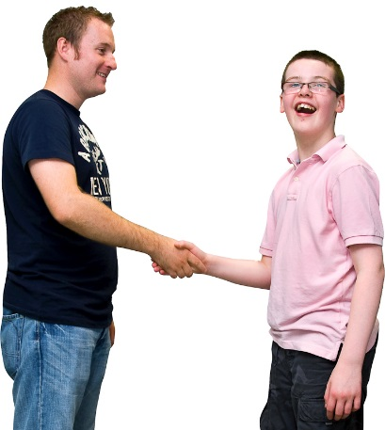
- fun things.

How will this be done?
Some disabled people need a support person to go with them to events.
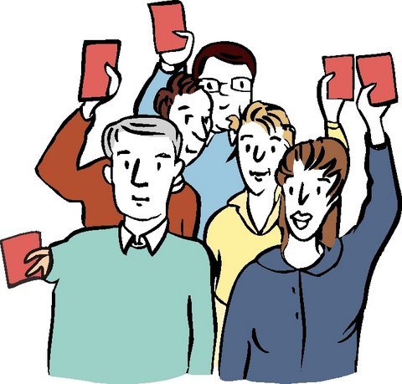

The Ministry will look at whether or not it can run a programme that would give some disabled people a companion card.


A companion card would make the support person’s ticket cost less money.
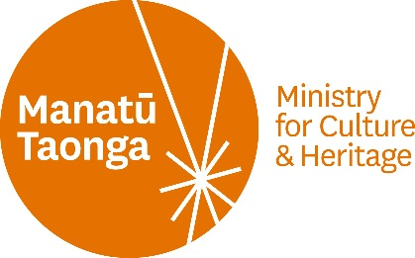
Who will do it?
The Ministry for Culture and Heritage will make this happen.

What now?

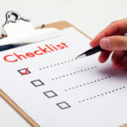
A plan is in place that will make sure that:
- what is in the Disability Action Plan happens

- DPOs are part of making it happen.

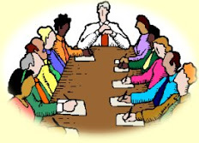
Ministerial Committee
Step 1
The Ministerial Committee on Disability Issues is in charge of what is in the Action Plan.

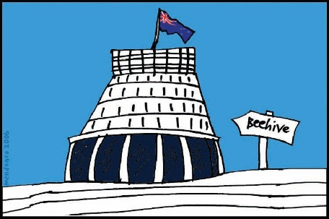
The Ministerial Committee is a group of government ministers who work on disability issues.


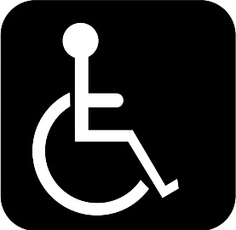
They talk about what needs to happen to make life better for disabled people.


They get government departments to work together.

The Committee will have 1 meeting a year with the Independent Monitors of The Disability Convention.

These meetings will give the Committee a real idea of how well disability issues are being worked on.

Step 2
DPOs will have meetings with the people who support the Chief Executives Group.

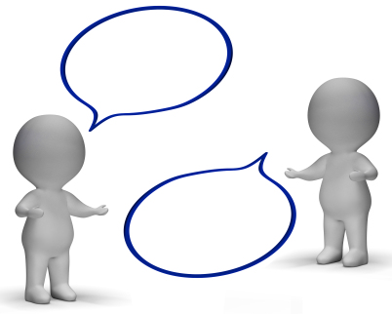
The meetings will give them a chance to talk about any issues with the Plan before telling the Chief Executives Group about them.

Government agencies will come to some DPO meetings to support the work of the Disability Action Plan.
4 Year Plan


Step 3
DPOs will meet with the Chief Executives’ Group 4 times a year to:
- work together to make sure that what is in the Disability Action Plan happens
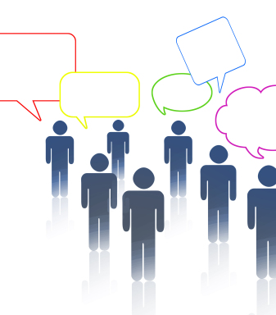
- look at how the actions in the Plan are going

- tell other people how the actions in the Plan are going

- make any changes to the work in the Plan.

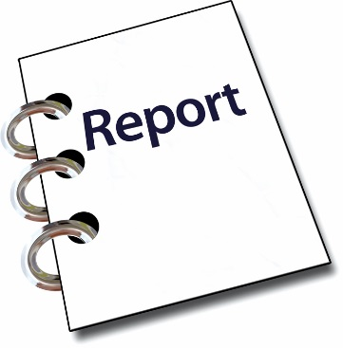
Step 4
The Office for Disability Issues will make reports about how the work is going.
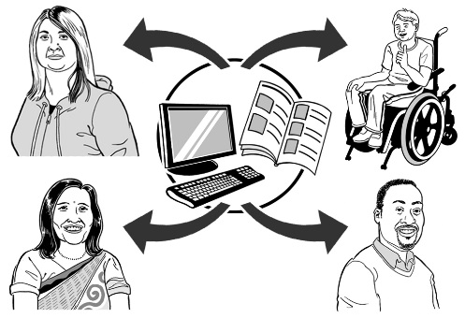

They will give them to everyone that is part of the work.

Step 5
The Minister for Disability Issues will report to Parliament on how the Plan is going every year.

What is not in this Plan?
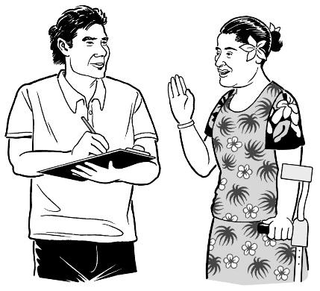

The Government asked for feedback from the community on the Plan in 2015.

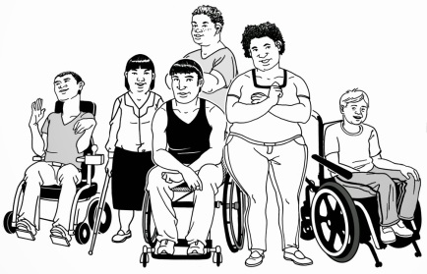
Disabled people said some important things about work that needed to be done.

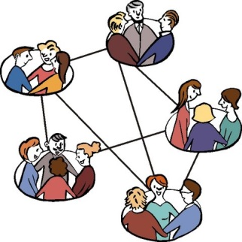
The Government decided that:
- some work that needs to be done does not need a lot of agencies working together on it

- when work only needs 1 agency working on it the work will not be part of this Plan

- The Office for Disability Issues will work with DPOs in 2016 to make sure disabled people still have a say on the work that is not in this Plan.
How to get more copies of the Disability Action Plan


You can also get the Action Plan in:

Standard English
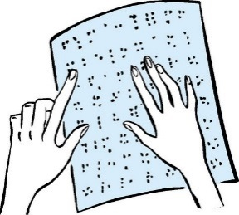

Braille

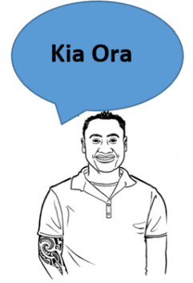

Māori

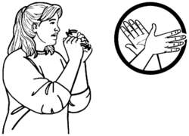
- New Zealand Sign Language.


You can find the Action Plan on this website:

http://www.odi.govt.nz

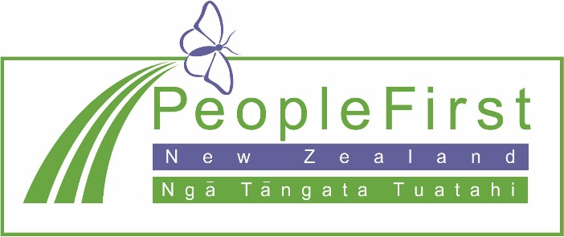

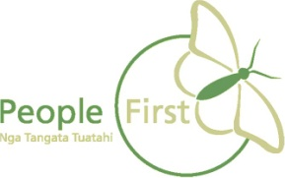
This information has been translated into Easy Read

by People First New Zealand Inc. Ngā Tāngata Tuatahi
