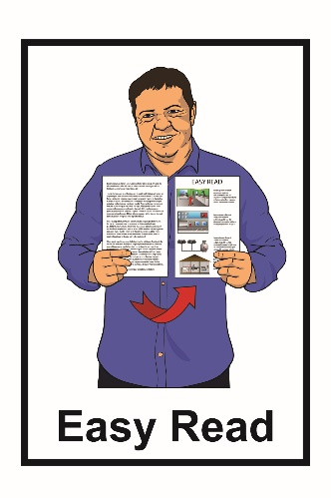
Disability
Action Plan
2019 - 2023

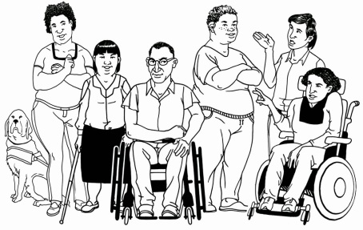

Putting the New Zealand
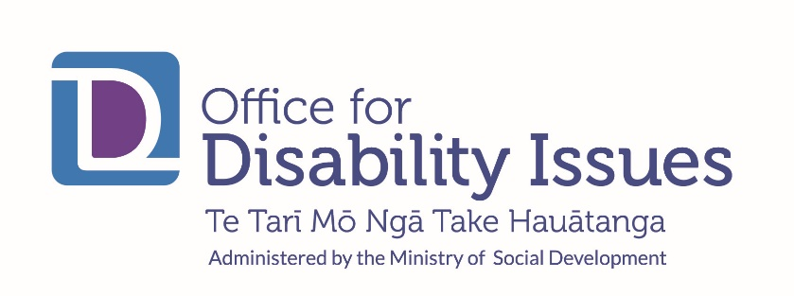
Disability Strategy into action

What is in this book?

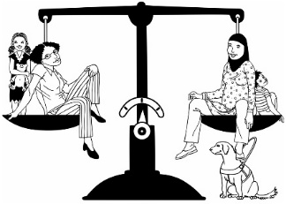
Page
How we want things to be 2


About this Disability Action Plan 3
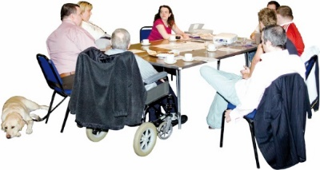

How did we make this plan? 7




The work to be done 10


Issues that affect all the 24
other work

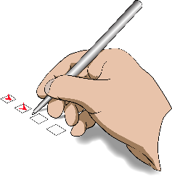
How will we make sure the 25
work happens?

How we want things to be
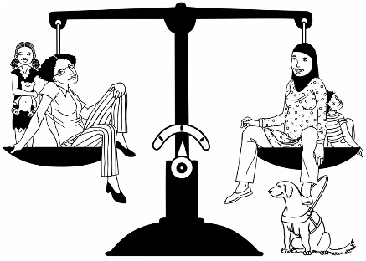
We want New Zealand to be a place where disabled people have the same chances as everyone else to do the things that are important to them.

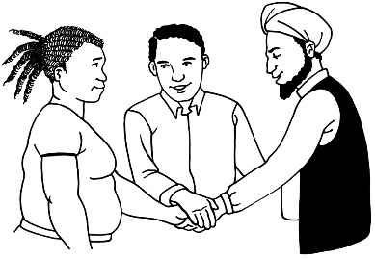
We want all of New Zealand to work together to make this happen.

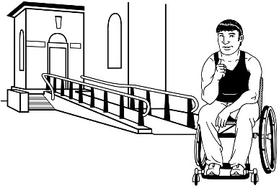

We want New Zealand to be
non-disabling.

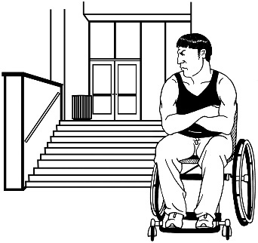

Non-disabling means that the way we set things up should not make life harder for disabled people.

About this Disability Action Plan
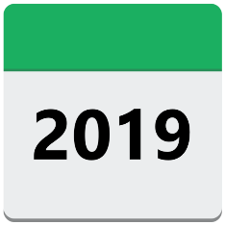
This Disability Action Plan is for the next 4 years:
- from 2019
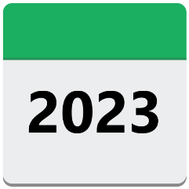
- to 2023.

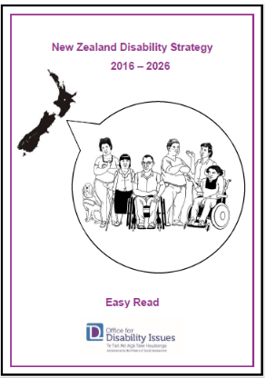

The Disability Action Plan says what work needs to be done to make the New Zealand Disability Strategy happen.


The New Zealand Disability Strategy lasts for 10 years:
- from 2016
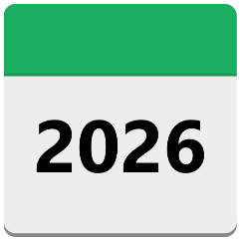
- to 2026.

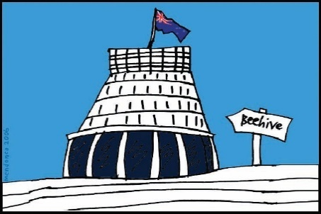
The New Zealand Disability Strategy looks at the big picture of how the New Zealand Government will do what it agreed to in the Disability Convention.

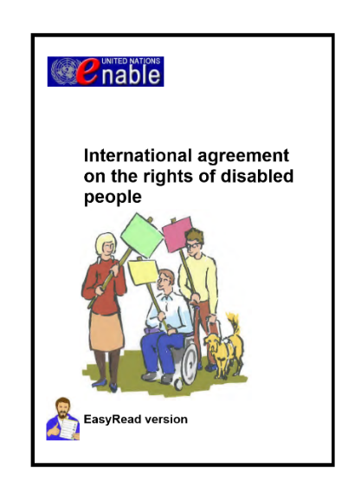
The full name of the Disability Convention is the United Nations Convention on the Rights of Persons with Disabilities.

The Disability Convention says:
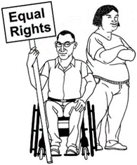
- how disabled people should be treated

- what governments need to do to make sure disabled people get their rights.


There is also a group called the Independent Monitoring Mechanism that:
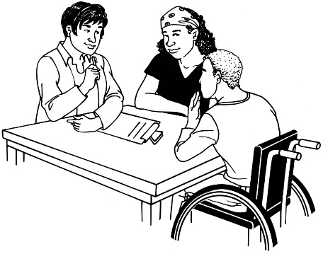
- looks to see if the Government is following the Disability Convention

- gives advice about how to follow the Disability Convention

- writes reports to say how the Government is doing.


The Independent Monitoring Mechanism is made up of 3 groups:
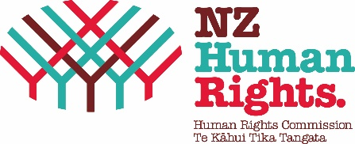
- The Office of the Ombudsman

- The Human Rights Commission

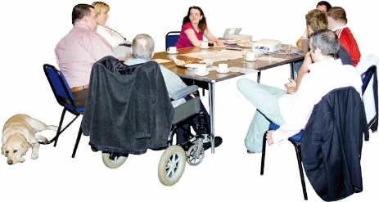
- The Disabled Person’s Organisations Coalition.

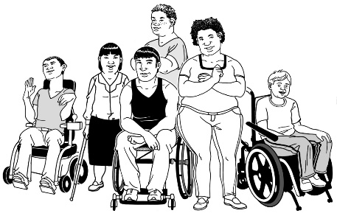
Disabled Person’s Organisations are also called DPOs.

DPOs:
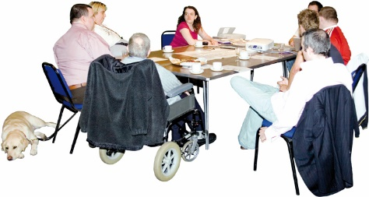
- are led by disabled people

- are set up to talk about things that affect disabled people.

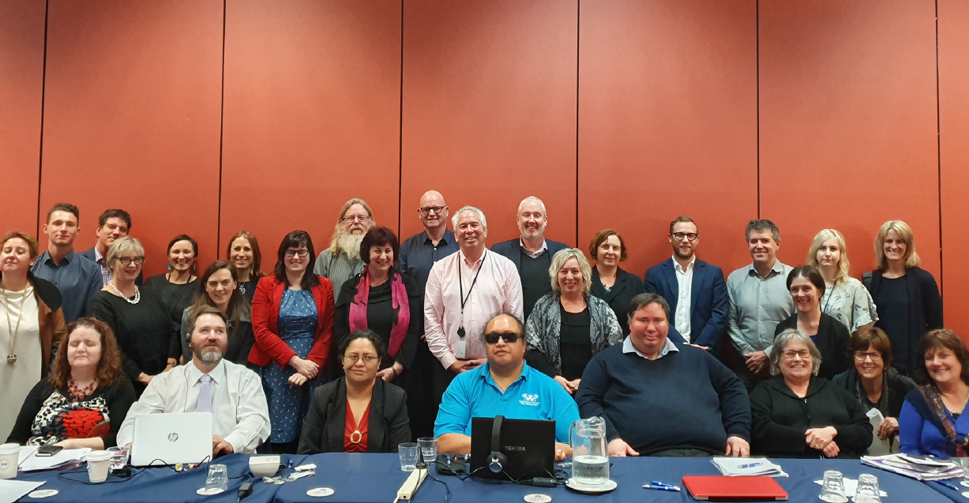
The Disabled Person’s Organisations Coalition is also called the DPO Coalition.

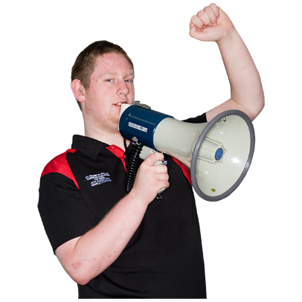
The DPO Coalition is where DPOs can:
- talk to each other

- have a strong voice on issues that affect disabled people.

How did we make this plan?
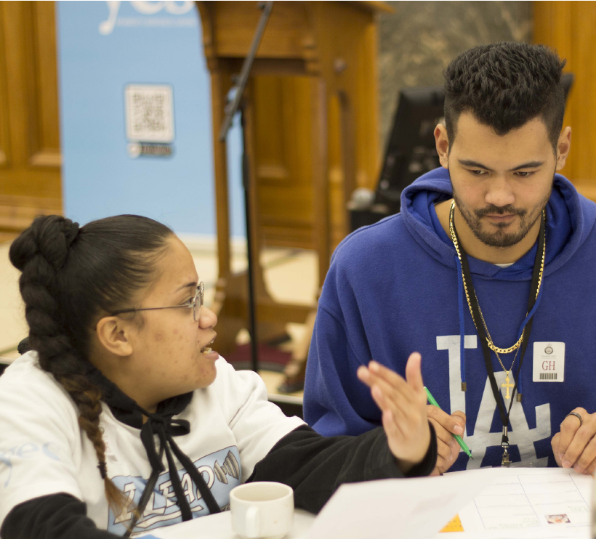
We asked disabled people what work needs to happen.

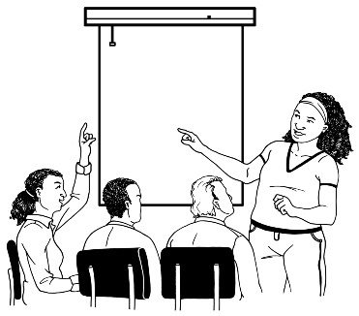
There were public meetings where anyone could have a say.

There were meetings between:
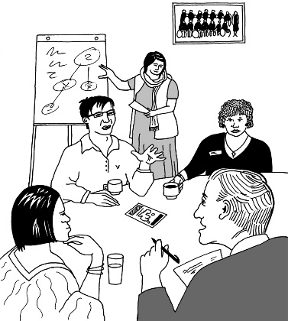
- the DPO Coalition

and

- government agencies.

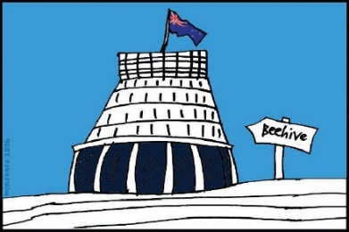
Government agencies are organisations that do work for the government like:
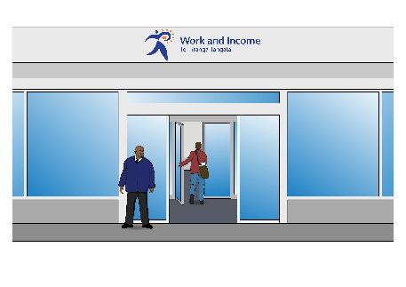
- the New Zealand Transport Authority (NZTA)

- Work and Income.

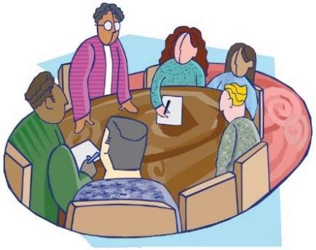
There were also meetings where the Minister for Disability Issues talked to stakeholders.

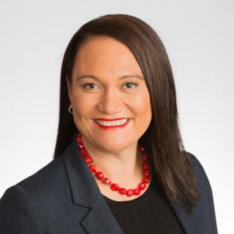
The Minister for Disability Issues is Carmel Sepuloni.

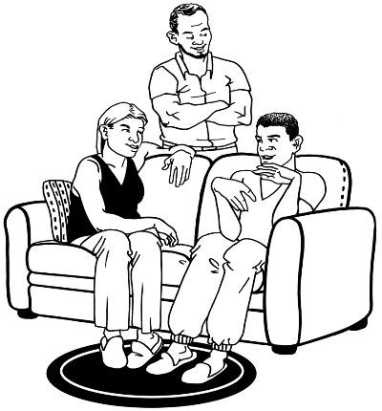
In this plan stakeholders means:
- disabled people

- family / whānau of disabled people
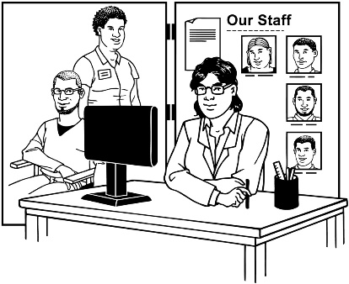
- disability service providers

- disability advocacy services.

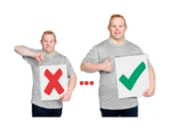
Some of the work in this Disability Action Plan are things the Independent Monitoring Mechanism said we need to do better.

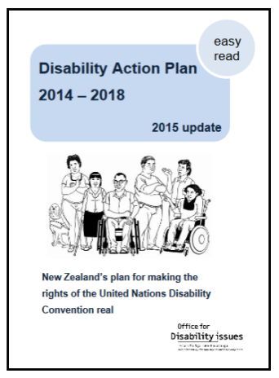
Some of the work started as part of the 2014 - 2018 Disability Action Plan.

If work was not finished we put it in this Disability Action Plan too.
The work to be done
The work comes under the 8 outcomes in the Disability Strategy 2016-2026.

Outcomes are the things we want to happen.

The 8 outcomes in the Strategy are:


- Education

- Jobs and money

- Health and wellbeing

- Accessibility

- Disabled people as leaders

- Disabled people having choices and control over their own lives

- Protecting the rights of disabled people

- Attitudes towards disability.

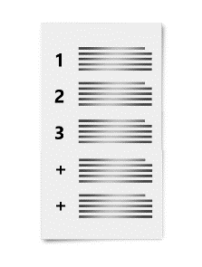
More work might be added to the plan over the next 4 years.

A lot of the work will carry on for longer than 4 years.


Most of the work will be paid for with money that agencies already have.

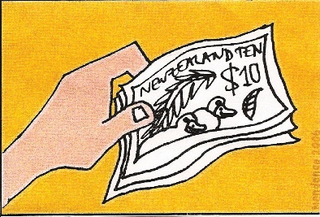
Agencies might need more money to do some of the work.

Education

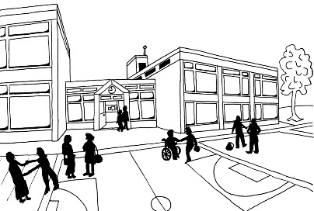
The Ministry of Education is working on:
- the Early Learning Strategic Plan

- the Tomorrow’s Schools Review


- the NCEA Review

- the Review of Vocational Education


- the Curriculum, Progress and Achievement conversation

- the Learning Support Action Plan.

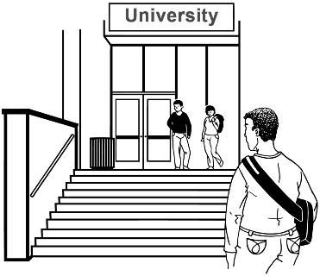
The Tertiary Education Commission is doing work that will help disabled learners get better results.


Work and money

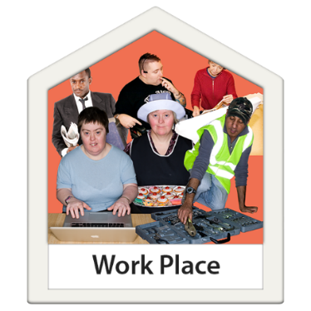
The Ministry of Social Development is working on:
- the Disability Employment Action Plan

- work for disabled people in the public sector
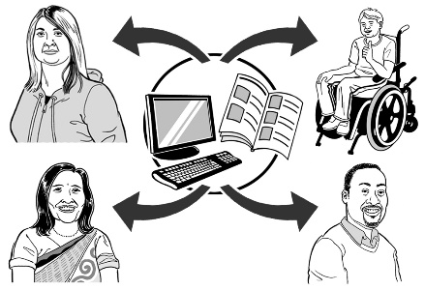
- a National Information Hub and Regional Networks.

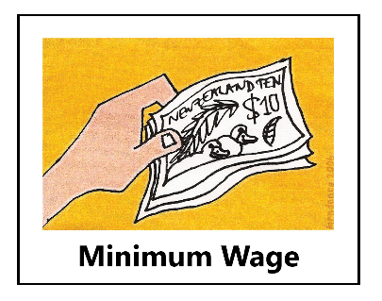
The Ministry of Social Development and the Ministry of Business, Innovation and Employment are working together to change the law so that disabled people are not paid less than the minimum wage.

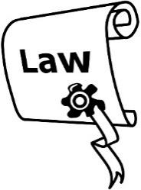
Most adults in New Zealand must be paid the minimum wage or more.
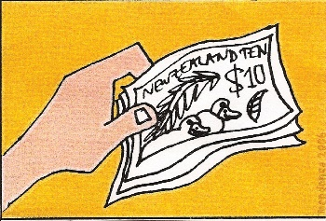
The minimum wage is 17 dollars 70 cents for every hour that you work.

At the moment some disabled people get paid less than the minimum wage for their work.

Health and wellbeing

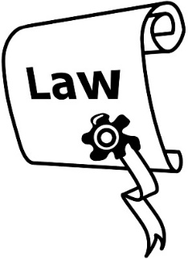
The Ministry of Health is working to:
- change the law about mental health treatment so that it fits with the Disability Convention

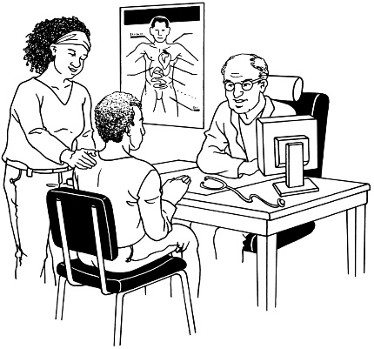
- make it easier for disabled people to get good healthcare

- protect disabled children and disabled adults from medical treatments that will not help them
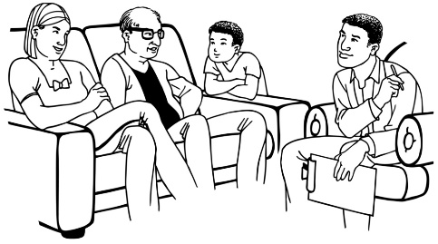
- change the Funded Family Care policy.

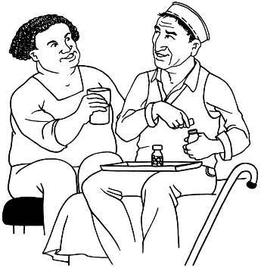
Funded Family Care is for people who pay someone in their family to help with:
- personal care

- running their household.

Sport New Zealand is working on the Play, Active Recreation and Sport Action Disability Plan.

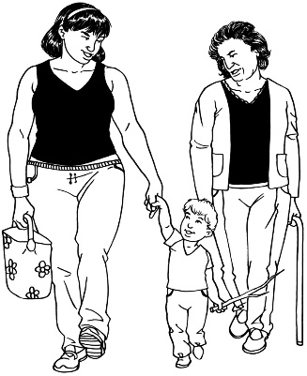
The Office for Seniors is working on Better Later Life – He Oranga Kaumātua 2019–2034.

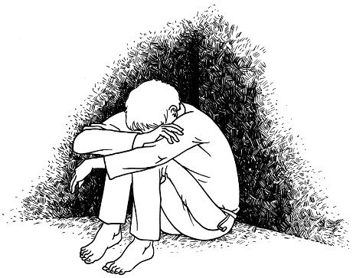
The Ministry of Health and the Department of Corrections are working together so there will be less:
- keeping patients or prisoners alone

- keeping patients or prisoners restrained.
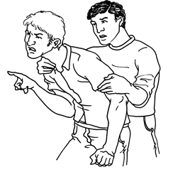
If someone is restrained it means they cannot move freely because they are tied up or held back in some way.

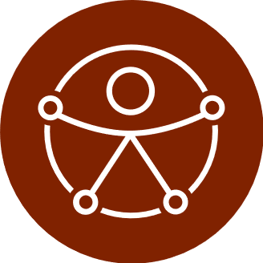
Accessibility

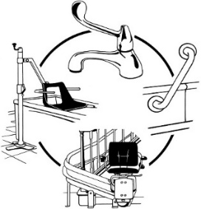
The Ministry of Social Development is working on:
- the Accelerate Accessibility work programme.

- making information more accessible.
If something is accessible it means people with disabilities are able to use it.
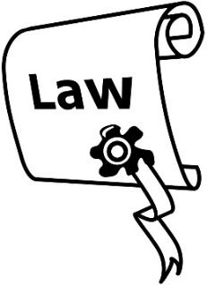

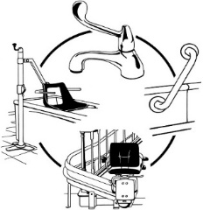
The Accelerate Accessibility work programme will look at changing the law around accessibility.

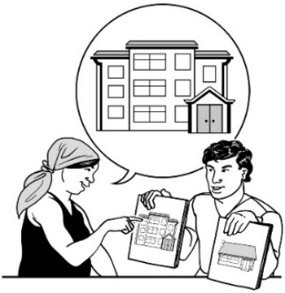
The Ministry of Housing and Urban Development and Housing New Zealand are working together to make the New Zealand housing system more accessible.

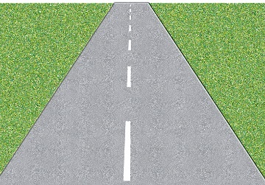
The New Zealand Transport Agency is working on the NZTA Action Plan.


The Ministry of Transport is working on the Ministry of Transport Action Plan.

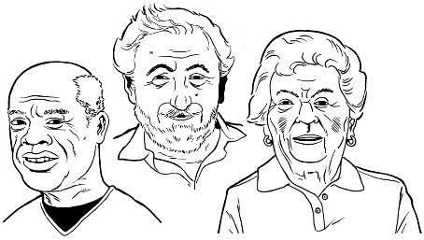
The Office for Seniors is working on Age-friendly Aotearoa / New Zealand.

Disabled people as leaders

The Office for Disability Issues is working on their Nominations Database.
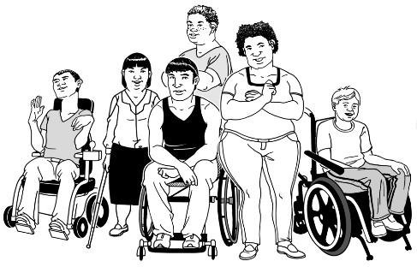
The Nominations Database:
- helps government agencies find disabled people who would be good leaders

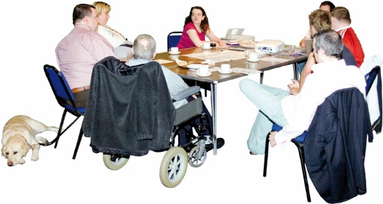
- helps make sure there are disabled people taking part in making important decisions.

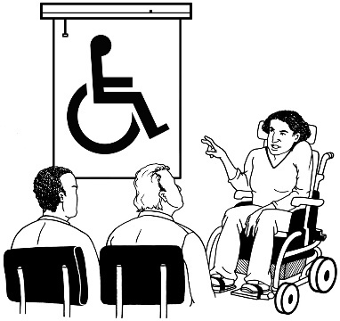
The New Zealand Transport Agency is working to get better at talking to people with disabilities before making decisions


Disabled people having control over their own lives

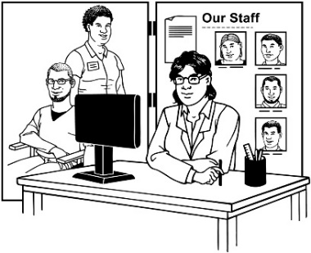
The Ministry of Health is making big changes to the disability support system.

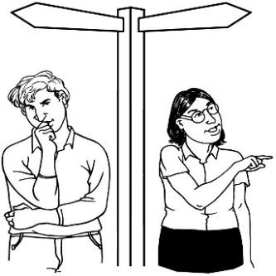
The Ministry of Social Development is working to make sure more people can use supported decision making.

Supported decision making is when you have the things you need to make your own choices like:
- information you can understand
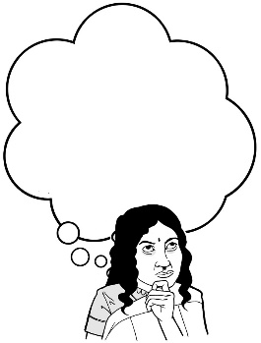
- someone to talk to

- time to think.

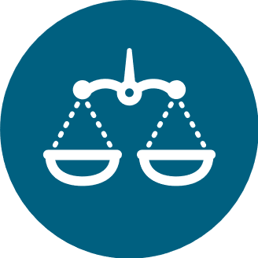
Protecting the rights of disabled people

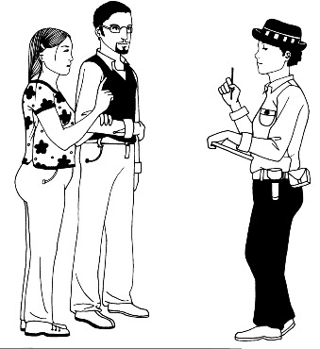
The Ministry of Justice and justice sector agencies are working together.

The justice sector is made up of:
- the police

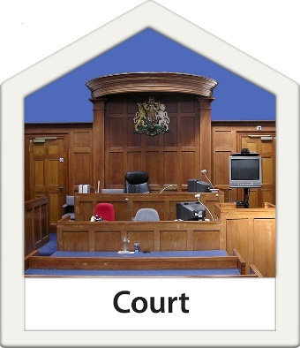
- courts

- prisons and community service

- Oranga Tamariki.

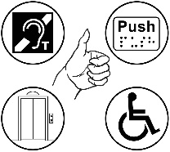
The Ministry of Justice and agencies are working to make justice services:
- accessible to disabled people

- easier to understand.


Attitudes towards disability

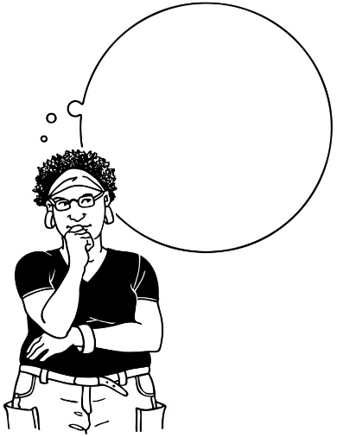
The New Zealand Transport Agency is working to get bus drivers thinking about disability issues.

The work that comes under other headings will also help change how people think about disability.

Issues that affect all other work

There are 2 things government agencies need to do as part of all their other work:
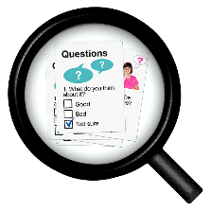
- Agencies need to collect better information about disabled people.

Statistics New Zealand and the Office for Disability Issues are in charge of this work.

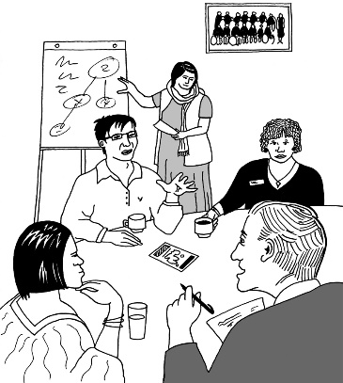
- When agencies are making big decisions they need to find out what disabled people think.

The government agreed to this in the Disability Convention.

How will we make sure the work happens?

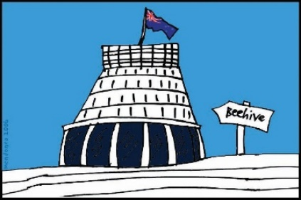
The Ministerial Leadership Group on Disability Issues is in charge of making sure that the work in this action plan happens.
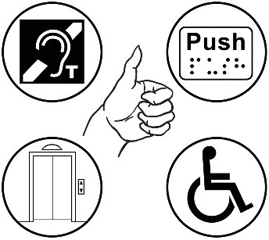
The Ministerial Leadership Group on Disability Issues is a group of government ministers who work on disability issues.

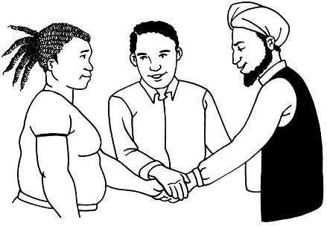
The Ministerial Leadership Group on Disability Issues gets government departments to work together.

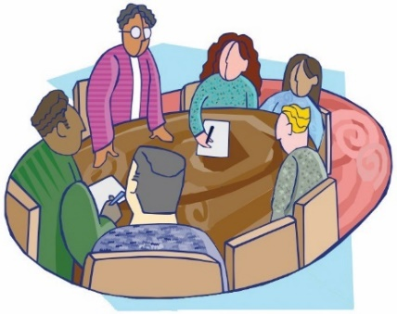
The Ministerial Leadership Group on Disability Issues will meet 2 times every year.
The DPO Coalition will also play a big part in making sure this plan is going well.

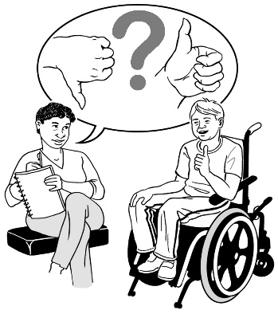
The DPO Coalition will:
- give feedback about how the work is going

- give advice on the work
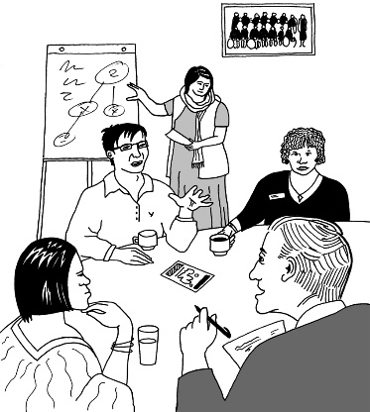
- meet with agencies when needed

- meet with the Minister for Disability Issues 2 times a year.

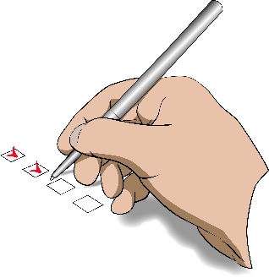
The Independent Monitoring Mechanism will also look at the work done as part of this action plan.

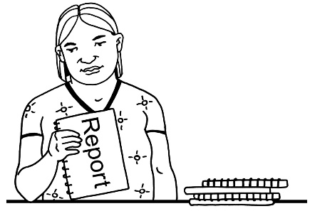
Every 6 months the Office for Disability Issues will get a report on the work.

Every year the Minister for Disability Issues will report to Parliament.

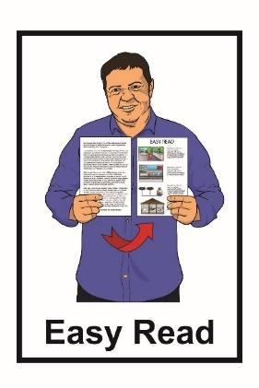
This information has been translated into Easy Read by the Make It Easy service of People First New Zealand Inc. Ngā Tāngata Tuatahi.

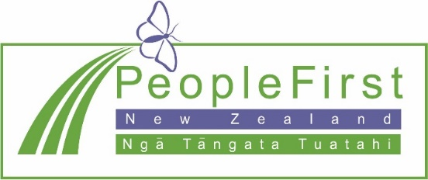
The ideas in this document are not the ideas of People First New Zealand Ngā Tāngata Tuatahi.

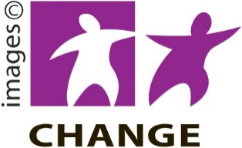
Make It Easy uses images from:

- Changepeople.org.nz


- Photosymbols.com

- Sam Corliss


- Steve Bolton

November 2019
Online at: www.odi.govt.nz
ISBN: 978-0-473-50366-6 (print)
ISBN: 978-0-473-50367-3 (PDF)


