Towards a non-disabling New Zealand
The annual report from the Minister for Disability Issues to the House of Representatives on implementation of the New Zealand Disability Strategy

December 2020

Author
Office for Disability Issues, Ministry of Social Development
Acknowledgements
This report was presented in December 2020 to the House of Representatives by the Minister for Disability Issues under Section 8 of the New Zealand Public Health and Disability Act 2000.
Published
This report is available online at: www.odi.govt.nz
ISSN: 2537-7701

Contents
Minister’s foreword 2
Background 4
Section one: COVID-19 impacts and response 5
Section two: Key achievements contributing to disabled people’s wellbeing in 2020 7
DAP Outcome One: Education 8
DAP Outcome Two: Employment and Economic Security 13
DAP Outcome Three: Health and Wellbeing 16
DAP Outcome Four: Rights Protection and Justice 21
DAP Outcome Five: Accessibility 26
DAP Outcome Six: Attitudes 31
DAP Outcome Seven: Choice and Control 33
DAP Outcome Eight: Leadership 36
New Zealand Sign Language 38
i.Lead 40
Disability Data 41
New Zealand’s International Obligations 43
Section three: Looking forward to 2021 and beyond 44
Appendix one: Relationship between the UNCRPD, the New Zealand Disability Strategy, and the Disability Action Plan 45
Appendix two: Disability Action Plan 2019-2023 46
Appendix Three: DAP Outcome Indicators 47

Minister’s foreword
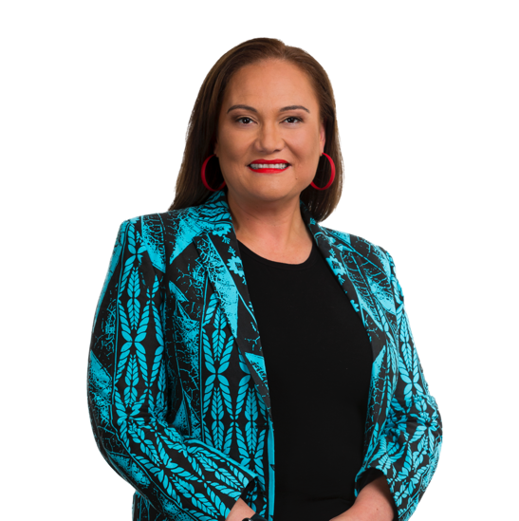
One million New Zealanders (24%) are disabled. The Government is committed to building a more inclusive and accessible society and ensuring disabled people have the full rights and opportunities like other New Zealanders. I am pleased to have the opportunity to continue as Minister for Disability Issues for a second term.

I’m also pleased to release this annual report on implementation of the New Zealand Disability Strategy 2016-2026. This report provides a snapshot of the work across government portfolios to progress the rights of and opportunities for disabled people. This report, the New Zealand Disability Strategy, and the Disability Action Plan 2019-2023 are important mechanisms to focus on and celebrate the combined efforts to improve outcomes for disabled people in New Zealand.

Several initiatives in 2020 have continued the work to improve the identification and removal of barriers that disabled people experience, ensuring they have the same opportunities and life-outcomes as other New Zealanders. This is especially positive considering the significant pressure on essential services and government agencies from the COVID-19 response.

COVID-19 highlighted many good things in the disability sector and also highlighted many things that still need to be addressed. I believe there is an opportunity to strengthen the Government’s focus on disability and to enhance outcomes for disabled people as we work on the COVID-19 response and recovery.

I was thrilled to hear that New Zealand’s campaign for Sir Robert Martin’s re-election to the Committee on the Rights of Persons with Disabilities was successful. The election was highly contested (28 candidates for nine seats), with a rigorous and focused campaign led by the Ministry of Foreign Affairs and Trade, the Office for Disability Issues and People First New Zealand. The re-election is recognition of Sir Robert’s great commitment and unique contribution over the last four years to the work of the Committee.

In 2020, New Zealand also had other notable achievements that contributed to the wellbeing of disabled people and the realisation of the Disability Strategy. All government agencies have now signed up to the Accessibility Charter, demonstrating their commitment to ensuring that all information intended for the public is accessible to everyone, and that everyone can interact with government services in a way that meets their individual needs.

Government agencies are now reporting six-monthly on their progress against work programmes they have initiated as part of their work to realise the Disability Strategy. Work to improve data collection is progressing and, for the first time, this report includes progress on measures against some of the Disability Action Plan outcomes.

I am looking forward to building on these achievements next year and continuing the focus on bringing about meaningful, long-lasting improvements in the daily lives of disabled New Zealanders.



Hon Carmel Sepuloni
Minister for Disability Issues

Background
Every year, the Minister for Disability Issues provides an Annual Report to Parliament on the progress made to implement the New Zealand Disability Strategy 2016-2026 (Disability Strategy). The report summarises activities and work programmes, underway or completed, that are contributing to improving disabled New Zealanders’ wellbeing and the progressive realisation of their human rights.

The Disability Strategy represents New Zealand’s approach for the progressive realisation of the United Nations Convention on the Rights of Persons with Disabilities (UNCRPD) in the New Zealand context.

This report notes key achievements and activities to improve disabled people’s wellbeing and quality of life in 2020. The report also notes the significant impact of COVID-19 on the disabled community and New Zealand more broadly in 2020.

Section one: COVID-19 impacts and response
In 2020, New Zealand faced its largest public health challenge in over a century, the COVID-19 pandemic. This put significant pressure on essential services and the labour market, with an economic downturn causing higher levels of unemployment and financial hardship for many families/whānau and communities.

The Office for Disability Issues (ODI) implemented a set of online surveys on “How life is going for the disability community”’ to gain greater understanding of the COVID-19 experiences of disabled people, their family/whānau, service providers and carers, and the wider disability sector.

Given the self-selected nature of participation, the surveys provided a snapshot of disabled New Zealanders’ life circumstances in the COVID-19 environment. COVID-19 has had an impact on every New Zealander’s life, and the results from the surveys show that the disabled community is no exception. Although many of the issues raised by respondents did not point to fundamental change, comments were made on significant risks, and on issues still being experienced by disabled people, including:
  - access to adequate and appropriate support services;
  - isolation, loneliness, and a lack of emotional support;
  - financial strain, unemployment and underemployment;
  - disabled people being ‘left off the radar’;
  - lack of adequate and timely communication to vulnerable groups;
  - anxiety about COVID-19 returning to the community;
  - lack of accessible housing; and
  - information not being available in accessible formats.
ODI was part of the National Welfare Coordination Group (NWCG) for the COVID-19 emergency response. The NWCG represents a national-level cluster of agencies that are collectively responsible for providing strategic oversight of planning and development of integrated welfare services delivered in an emergency. The team worked to ensure that the needs of disabled people were considered in the provision of services, for example by ensuring communications are provided in accessible formats. The team has been stood down but remains ready to be recalled should the need arise.

ODI worked closely with the Ministry of Health and other government agencies, service providers and the wider disability community to support the COVID-19 response. A COVID-19 Disability Senior Officials’ Group was established to monitor disabled peoples’ rights and ensure that their access to services was not disproportionately impacted by the pandemic compared to other population groups.

Joint research by Waka Kotahi (the New Zealand Transport Agency), te Manatū Waka (the Ministry of Transport) and market research company, IPSOS, on how people were impacted by COVID-19 also provided insights into the issues affecting disabled people. The research provided agencies with valuable insights into how the disabled community is impacted by a serious crisis. The data also illustrated the relatively higher use of public transport by the disabled population and, therefore, the relatively higher impact of public transport changes on disabled people during the COVID-19 lockdowns.

Section two: Key achievements contributing to disabled people’s wellbeing in 2020
This report summarises what has been achieved in 2020 on the eight Disability Action Plan 2019-2023 (DAP) Strategy outcomes and initiatives that drive progress towards the overall vision:

“New Zealand is a non-disabling society - a place where disabled people have an equal opportunity to achieve their goals and aspirations, and all of New Zealand works together to make this happen.”
New Zealand Disability Strategy 2016-2026

Launched in November 2019, the DAP is the primary vehicle for implementing the Disability Strategy over the next four years. The DAP aims to improve the wellbeing of disabled people through progress on the eight interconnected outcomes in the Disability Strategy: education, employment and economic security, health and wellbeing, rights protection and justice, accessibility, attitudes, choice and control, and leadership.

The DAP includes a package of 29 cross-government work programmes, underway or planned, by 15 government agencies and their partners. The DAP is not static, and work programmes can be added as required. These work programmes are not business-as-usual disability programmes; they are intended to create a significant shift in outcomes for disabled people.

ODI, with the Disabled Peoples Organisations (DPO) Coalition, manages six-monthly reporting against the DAP. The first report, covering January to June 2020, was delayed due to COVID-19 and was finalised in November 2020. The next report, covering July to December 2020, will be finalised in February 2021. These reports will be published on the ODI website.

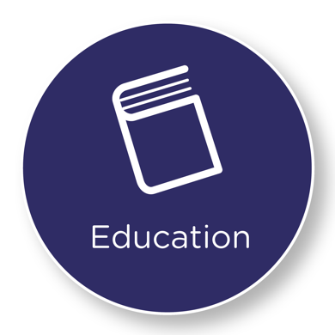

DAP Outcome One: Education
We get an excellent education and achieve our potential throughout our lives

Ministry of Education
Disabled people’s participation, progress and achievement in Early Childhood, Primary, Secondary and Tertiary education has continued to be a key area of focus for the Ministry of Education in all areas of its work programme in 2020. COVID-19 provided an opportunity for the Ministry to work differently in order to ensure best outcomes for learners. These ways of working differently were focused on both policy and service delivery.

COVID-19 provided the Ministry of Education the opportunity to refocus on the key areas which will enable educationally powerful connections, including:
- a key focus on equity and wellbeing;
- curriculum reform; and
- improving pathways between education and employment.

In all these areas, the participation and progress of disabled young people will be key to further improving outcomes for them.

COVID-19 Urgent Response fund
An example of a different way of providing services to disabled people is the $50 million COVID-19 Urgent Response fund, which enabled schools, kura and early learning centres to ensure that wellbeing and re-engagement with education was prioritised in flexible ways.

Learning Support Coordinators
600 Learning Support Coordinators (LSCs) are now working in Learning Support Clusters all over New Zealand to coordinate access to and delivery of Learning Support services to students.

Policy and system changes
Policy and system changes have also sought to improve educational outcomes for disabled people. These include:
- reform of Vocational Education, including further work on how to best support disabled learners in tertiary settings;
- updating the New Zealand Curriculum, and development of indicators of curriculum progress which seek to deliver on the UNCRPD;
- further progress on the Review of Achievement Standards, including ensuring that Achievement Standards are inclusive and that barriers to access are reduced;
- passing the Education and Training Act, including an explicit inclusion of the right that all students have to attend their school for all the hours it is open, and the enablement of a new disputes resolution process to hear complaints about school board decisions;
- the release of the Statement of National Education and Learning Priorities, which contains explicit reference to ensuring that places of learning are safe, inclusive and free from racism, discrimination or bullying; and
- the development of a Disability Strategic Framework, based on the UNCRPD and the New Zealand Disability Strategy, to assist Ministry of Education decision makers to ensure that their decision making is guided by those things that are most important to disabled people and their families/whānau.

Strengthening tertiary education responses to support disabled people’s access, participation and success
The Tertiary Education Commission (TEC) has, as its primary focus, equity of access, participation and outcomes for all New Zealanders. Particular attention is focused on the needs of disabled people as they face a long legacy of being significantly underserved in the tertiary education system.

TEC seeks to enable tertiary education organisations and the tertiary sector to better support disabled learners, to greatly improve the access to, participation in, and achievement in, tertiary education for disabled people. All work is being undertaken in conjunction with disabled people as experts in lived experience.

TEC Disability Action Plan
The TEC has developed and implemented a Disability Action Plan (TEC DAP). The TEC DAP is the Commission’s documentation of its commitment to ensuring the best possible outcomes for disabled New Zealanders. Its implementation is now part of TEC’s day to day business practice.

Kia Ōrite
Development of Kia Ōrite, TEC’s Code of Practice for an Inclusive Tertiary Education Environment for Students with Impairments, is now progressing well, following delays due to COVID-19.

The updated guide, Kia Ōrite, will be finalised and launched in April 2021. The guide will be adapted into an accessible and web-based resource. Kia Ōrite is being developed as a living resource and will continue to be added to over time.

Data regarding supports for disabled learners in the tertiary system
2020 is the second year TEC has collected detailed data from tertiary institutions regarding the supports they provide for disabled learners. The Commission requires all universities, Wānanga and Polytechnics (the latter are now subsidiaries of Te Pūkenga) to report how they are spending equity funding for disabled learners. Analysis of this data is being used to help identify best practice, determine system gaps and inform the design of a Unified Funding System. Reporting on this data will continue into 2021 and beyond.

Tiro Whetū development
TEC is developing a new careers planning solution that will supersede the careers.govt.nz website from mid-2021. Tiro Whetū will be a personalised and targeted careers planning system that supports all New Zealanders to build a fulfilling career. The system will ensure that all New Zealanders, including disabled people, are able to use and get value from the site. The Tiro Whetū site will be designed to meet accessibility requirements and be bilingual, wherever possible.

Increasing focus on the needs of neurodiverse learners
TEC has instigated a work programme to develop tools and resources to support tertiary organisations and employers in work-based learning, to support neurodiverse learners. The first focus area is dyslexia.

Reporting on effective practices in other jurisdictions has been completed, and an Advisory Group has been established. In 2021, development of support material for tertiary organisations will be undertaken, along with an expansion of focus into other areas of neurodiversity.

Indicators
ODI and the Disability Data and Evidence Working Group (DDEWG) continue to develop and finalise indicators for the Disability Strategy Outcomes Framework. Performance on some measures related to this DAP Outcome Area is shown below. Appendix Three provides more detail on these indicators.

Outcome | Indicator description / Variables | Disabled (%) | Non-Disabled (%) | Data Source | Last updated
Education | Proportion of people that have attained NCEA level 3 qualification (MOE, 2020) | 33 | 58 | Ministry of Education | 2020
Education | Proportion of people with a post-school qualification as highest qualification (Level 1+, Bachelor's, Postgrad & higher) (HLFS, 2020) | 39.1 | 55.4 | Household Labour Force Survey (HLFS) | 2020
Education | Proportion of people that are enrolled in non-compulsory education (HLFS, 2020) | 3.4 | 11.6 | HLFS | 2019
Education | Proportion of Māori and Pasifika youth that feel like a part of school (Youth, 2019) | 64.7 | 88.8 | National Youth Health and Wellbeing Survey | 2019
Education | Proportion of people that hold a high level of trust (7 or above out of 10) for the education system (GSS, 2018) | 54 | 66.9 | NZ General Social Survey (GSS) | 2018

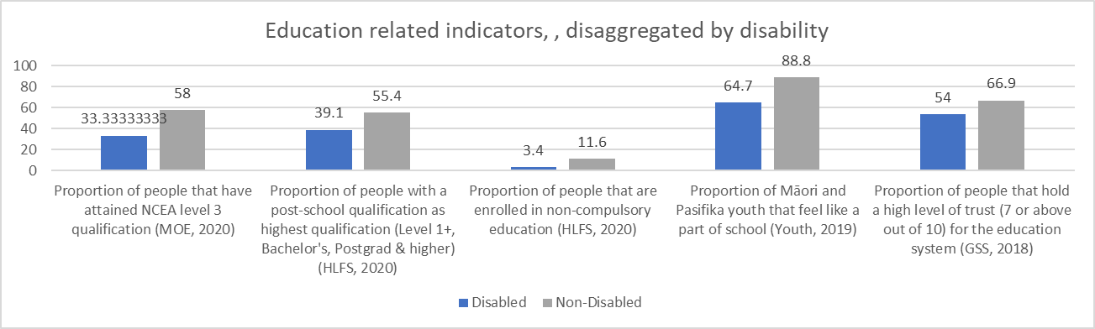



ADAP Outcome Two: Employment and Economic Security
We have security in our economic situation and can achieve our full potential

Disability Employment Action Plan
In August 2020 the Government launched “Working Matters”’, the Disability Employment Action Plan (Action Plan) to help ensure disabled people and people with heath conditions have an equal opportunity to access quality employment.

This Action Plan is one of several plans that support the Government’s Employment Strategy to create a more productive, sustainable and inclusive labour market. It also supports the DAP. The Action Plan provides guidance for all government agencies and industries (e.g. industry specific employers, trainers, regulators and unions), currently working on employment initiatives, including COVID-19 economic recovery initiatives.

Implementation of the plan will be monitored by a group of Ministers with a focus on employment, education, and training. The group can ensure they leverage new opportunities to improve employment outcomes for disabled people as they arise across different government work programmes.

Public consultation on the draft Action Plan opened in November 2019, and by February 2020, officials had heard from over 375 stakeholders representing the views of organisations or wider membership groups. The respondents overwhelmingly supported the objectives and proposals in the draft Action Plan and emphasised its importance.

A cross-agency work programme to support the Action Plan was further developed following the COVID-19 lockdown. It was important to make adjustments to help ensure an inclusive economic recovery from COVID-19, where disabled people and people with health conditions can participate in employment as they wish, on an equal basis with others.

Supporting Employment Outcomes
The Lead Toolkit was launched in 2019 to help business owners, leadership teams, managers and human resources teams employ disabled people within their businesses. Originally public-service focussed, in 2020 the toolkit was updated to include all sectors and employers. It is now available on the Ministry of Social Development’s (MSD) website, along with additional resources and information. A new resource, “Retaining Existing Employees”, was also completed in 2020.

Funding has been secured for an Internship Coordinator. They will work with the tertiary sector and public service internship and graduate programmes to support access for disabled students. The Coordinator will also provide support for successful intern candidates and their managers.

Indicators
ODI and DDEWG continue to develop and finalise indicators for the Disability Strategy Outcomes Framework. Performance on some measures related to this DAP Outcome Area is shown below. Appendix Three provides more detail on these indicators.

Outcome | Indicator description / Variables | Disabled (%) | Non-Disabled (%) | Data Source | Last updated
Employment | Employment rate (HLFS, 2020) | 22.5 | 69.3 | HLFS | 2020
Employment | Unemployment rate (HLFS, 2020) | 7.4 | 3.9 | HLFS | 2020
Employment | Labour force participation rate (HLFS, 2020) | 24.3 | 72.1 | HLFS | 2020
Employment | Underutilisation rate (HLFS, 2020) | 21.6 | 11.6 | HLFS | 2020
Employment | Job Satisfaction = "Satisfied or very satisfied" for main job in last 4 weeks for employed people aged 15+ (GSS, 2018) | 63.6 | 77.3 | GSS | 2018
Employment | Hourly wage above the household median (HLFS, 2020) | 37.7 | 50.2 | HLFS | 2019
Employment | Adequacy of income to meet everyday needs: "Enough money/More than enough money" (HLFS - wellbeing module, 2020) | 55.7 | 71.2 | HLFS-wellbeing module | 2020

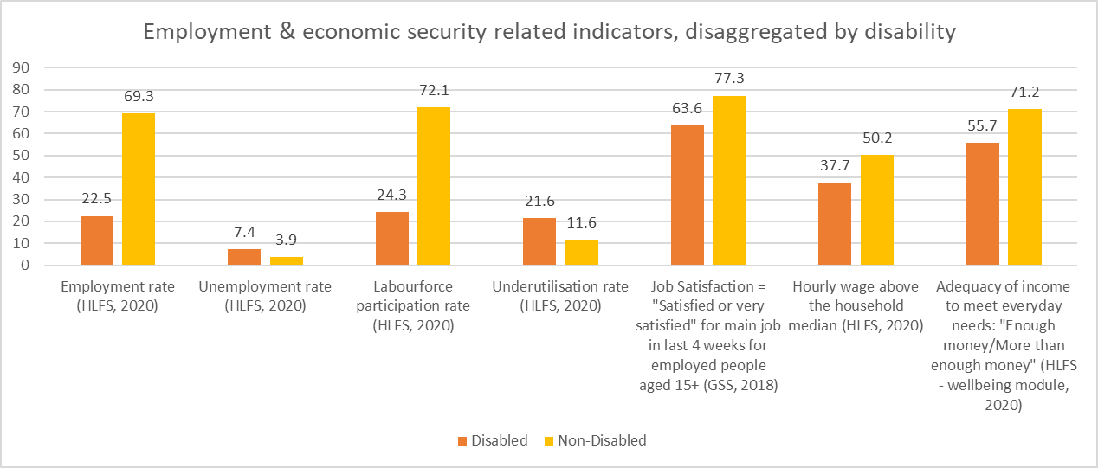

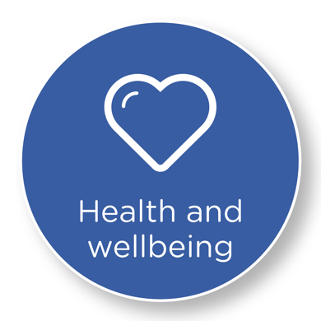

DAP Outcome Three: Health and Wellbeing
We have the highest attainable standards of health and wellbeing

Funded Family Care has changed (the repeal of Part 4A)
The Government passed the New Zealand Public Health and Disability Amendment Bill 2020 on 4 August 2020 to repeal Part 4A.

Since 2013, the Ministry of Health and District Health Boards (DHBs) have had policies to enable payment of people to provide personal care or household management support for eligible family/whānau members assessed as having high or very high support needs relating to:
- disability, administered by the Ministry of Health as “Funded Family Care” under Disability Support Services; and
- long-term chronic health conditions, mental health and addiction, and aged care needs administered by DHBs as ”Paid Family Care” through the purchase of services by contracted providers which, in turn, employ eligible family/whānau members.

The payment of family carers under Part 4A of the NZ Public Health and Disability Act 2000 (Part 4A) attracted significant national and international concerns about discriminatory human rights aspects, and about eligibility and employment arrangements. In 2018, the government announced the intent to make changes. This was an agreed priority for both the DAP and the Mahi Aroha Carers’ Strategy Action Plan 2019-2023.

In 2020, changes to the Ministry of Health and DHB paid family care policies were implemented. This included increased pay rates for family/whānau carers, choice on employment arrangements, lowering the minimum age of carers from 18 to 16 years old, and enabling eligible partners and spouses to be paid in their carer role.

On 30 September 2020, the repeal of Part 4A came into force. This also signalled the end of all statutory, policy, operational and payment components of the “Funded Family Care” framework. However, the payment of family/whānau carers now continues under different arrangements.

Sport New Zealand Disability Plan
The launch of the Sport New Zealand Disability Plan in October 2019 and the employment of a Disability Consultant in December 2019 were significant milestones for ensuring that the play, active recreation, and sport sector is inclusive of disabled people, especially disabled tamariki and rangatahi.

The Disability Consultant has focused on working with other Sport New Zealand staff and initiatives to ensure that Sport New Zealand is catering for the needs of disabled tamariki and rangatahi, and acting as a role model for the play, active recreation, and sport sector.

The Disability Fund will be launched in 2021 to enable Sport New Zealand to invest in a range of national and local initiatives which will improve the provision of quality and equitable play, active recreation, and sport opportunities for disabled tamariki and rangatahi.

Better Later Life - He Oranga Kaumātua
The 2013 Disability Survey showed that people aged 65 or over were much more likely to be disabled (59 percent) than adults under 65 years (21 percent) or children under 15 years (11 percent). A Ministerial Steering Group for the Better Later Life - He Oranga Kaumātua Strategy was established and met in February and July 2020. A set of initial indicators for the Strategy has been developed and published on the SuperSeniors website.

Development of an Action Plan to implement the Strategy is underway and will be substantially completed in the first half of 2021. It will take account of the impact of COVID-19 on older people, including issues in relation to unemployment and underemployment, social isolation and digital inclusion.

A set of indicators for measuring the impact of COVID-19 on older people has also been developed and published on the SuperSeniors website.

Indicators
ODI and DDEWG continue to develop and finalise indicators for the Disability Strategy Outcomes Framework. Performance on some measures related to this DAP Outcome Area is shown below. Appendix Three provides more detail on these indicators.

Outcome | Indicator description / Variables | Disabled (%) | Non-Disabled (%) | Data Source | Last updated
Health and wellbeing | Experienced one or more types of unmet need for primary health care in the past 12 months (NZHS, 2019/20) | 47 | 29.4 | New Zealand Health Survey (NZHS)
Health and wellbeing | Psychological distress in the last 4 weeks (NZHS, 2019/20) | 27 | 5.7 | NZHS | 2018/2019
Health and wellbeing | Proportion of Māori/Pasifika youth that have attempted suicide in the last year (Youth19,2019) | 22.7 | 8.3 | Youth19 | 2019
Health and wellbeing | Good, very good, or excellent self-rated health (NZHS, 2019/20) | 56 | 89.9 | NZHS | 2019/20
Health and wellbeing | Felt lonely "most" or "all of the time" in the last 4 weeks. (GSS, 2018) | 9.2 | 3.5 | GSS | 2018
Health and wellbeing | High level of satisfaction (7 rating or above out of 10) (GSS, 2018) | 64.8 | 82.5 | GSS | 2018
Health and wellbeing | High level of life worthwhile (7 rating or above out of 10) (GSS, 2018) | 75 | 88.9 | GSS | 2018

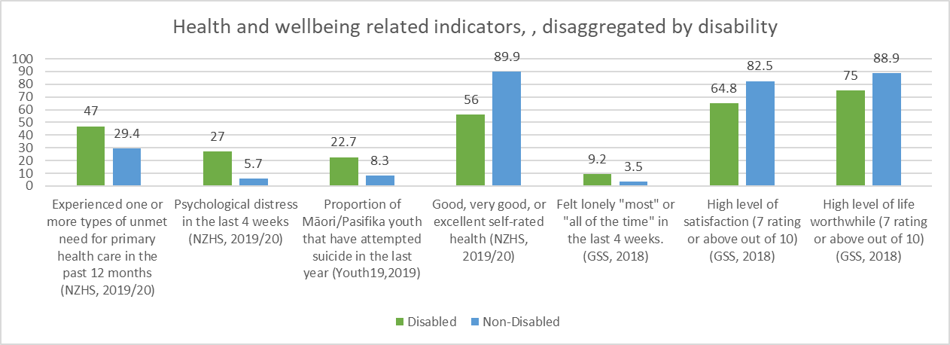



DAP Outcome Four: Rights Protection and Justice
Our rights are protected, we feel safe, understood and are treated fairly and equitably by the justice system

Ara Poutama Aotearoa (the Department of Corrections) has three work programmes under the DAP. While COVID-19 restrictions impacted the work programme, Ara Poutama Aotearoa is expecting to release its Disability Action Plan in 2021. The Plan will reflect the intent of Ara Poutama Aotearoa’s Hōkai Rangi Strategy and align with the NZ Disability Strategy and the DAP.

In response to COVID-19, Ara Poutama Aotearoa developed a Vulnerability Dashboard as a mechanism for identifying people in their care who are more at risk should they contract COVID-19. Initial work focussed on Ministry of Health COVID-19 guidelines. However, the dashboard can be further developed to identify those with mental health needs and disabilities who may be more vulnerable.

Ara Poutama Aotearoa is in the early planning stages to undertake a Health Needs Assessment process to better describe the prison population. This will inform the delivery of health services, including opportunities for improvement which reflect Ara Poutama Aotearoa’s Hōkai Rangi Strategy.

A key action identified in the DAP is to reduce the use of segregation and restraint – in response, tie-down beds were removed from all prisons in 2020.

Ara Poutama Aotearoa have supported the Ministry of Justice work programme to improve accessibility and ensure services are accessible and understood. While some work was delayed due to COVID-19, this has included:
- new accessible signage at community Corrections sites;
- COVID-19 lockdown information within all prisons was reviewed and presented in a format appropriate for all levels of health literacy; and
- a multi-agency Intellectual Disability workshop reviewed the journey of a person in Ara Poutama care with an identified intellectual impairment. A follow up workshop is planned for early 2021.

Joint Venture: Eliminating family violence and sexual violence
The Joint Venture of the Social Wellbeing Board, established by Cabinet in 2018, is made up of ten Chief Executives across the public sector. The Joint Venture Chief Executives are collectively accountable and responsible for leading the whole-of-government response to family/whānau violence and sexual violence. The Joint Venture is chaired by the Public Service Commissioner and supported by the Joint Venture Business Unit (JVBU) and its Director.

Violence Prevention for Diverse Communities project
Consistent with international research and anecdotal evidence in New Zealand, certain population groups, such as disabled people (particularly disabled women and girls), older people, and rainbow and new migrant communities, are disproportionately affected by family/whānau violence and sexual violence. Multiple and overlapping factors, including disadvantage, discrimination, stigmatisation and isolation, increase the risk of these diverse communities experiencing family/whānau violence and sexual violence. It is also known that family/whānau violence and sexual violence prevention approaches are not currently meeting the needs of diverse communities.

In Budget 2019, the Government committed $2.0 million in contingency funding over two years to support community-led prevention of family/whānau violence and sexual violence for disabled people, older people, and rainbow and new migrant communities. The JVBU is responsible for coordinating the Violence Prevention for Diverse Communities project with support from Joint Venture agencies.

In March 2020, Ministers agreed to draw down $0.3 million to work with a co-design specialist to facilitate engagement with diverse communities, including disabled people, to identify their priorities and preferred approach for committing this contingency funding.

The procurement process for the selection of a co-design provider has been completed. The co-design provider will work with disabled people (and the other diverse communities) and the JVBU from November 2020 to March 2021 to identify:
- the needs and aspirations of disabled people (and the other communities) in relation to the prevention of family/whānau violence and sexual violence;
- violence prevention initiatives or actions that diverse communities could quickly implement with or without government support (short-term);
- how existing violence prevention initiatives can be enhanced or extended, or how new initiatives can be trialled over the next few years (medium-term); and
- a longer-term strategy for investment in violence prevention for diverse communities that could contribute to any national strategy and action plan.

In December 2020, an interim report will be sent to Ministers seeking to draw down the remainder of the $2.0 million contingency fund. A final report on violence prevention initiatives, agreed to by disabled people (and the other diverse communities) and Joint Venture agencies, will be available in March 2021. Disabled people’s needs, aspirations and recommendations for a longer-term strategy will, then, feed into the National Strategy to Eliminate Family Violence and Sexual Violence and Action Plan.

Indicators
ODI and DDEWG continue to develop and finalise indicators for the Disability Strategy Outcomes Framework. Performance on some measures related to this DAP Outcome Area is shown below. Appendix Three provides more detail on these indicators.

Outcome | Indicator description / Variables | Disabled (%) | Non-Disabled (%) | Data Source | Last updated
Rights, protection and justice | Age standardised victimisation rate (NZCVS, 2018/19) | 40 | 30 | NZ Crime and Victims Survey | 2018/19
Rights, protection and justice | Feeling of safety when at home by yourself at night (feeling safe/very safe) (HLFS-Wellbeing module, 2020) | 81 | 87.2 | HLFS - Wellbeing module | 2020
Rights, protection and justice | Feeling of safety when walking alone in the neighbourhood after dark (feeling safe/very safe) (HLFS-Wellbeing module, 2020) | 60.9 | 75.3 | HLFS- Wellbeing module | 2020
Rights, protection and justice | Feeling of safety when using/waiting for public transport at night(feeling safe/very safe) (HLFS-Wellbeing module, 2020) | 39.2 | 53.8 | HLFS- Wellbeing module | 2020
Rights, protection and justice | Feeling of safety when using the internet for online transactions (GSS, 2018) | 56.8 | 72.8 | GSS | 2018

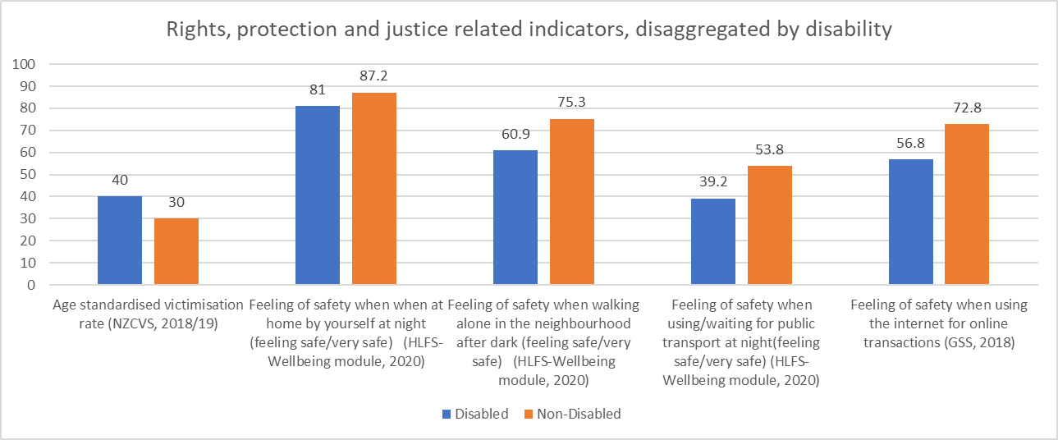

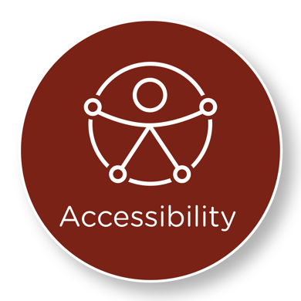

DAP Outcome Five: Accessibility
We access all places, services and information with ease and dignity

The Accessibility Charter (MSD)
The public sector is taking a leadership role in recognising accessibility as an enabler of inclusion with all government agencies having now signed the Accessibility Charter.

Signing the Charter indicates all government agencies are committed to ensuring that all information intended for the public is accessible to everyone, and that everyone can interact with government services in a way that meets their individual needs and promotes their independence and dignity. The Ministry of Social Development continues to work with Local Government and DHBs to encourage them to also sign the Accessibility Charter.

Ensuring accessibility of messages was critical during the COVID-19 response and MSD worked with the National Emergency Management Agency to develop accessible messages. The Accessibility Guide was updated to reflect a new all-of-government alternative process for developing accessible materials.

An accessibility training programme continues to support the Accessibility Guide. Monthly training sessions continue to be run for government agencies with 175 people attending the 2020 courses.

Accessibility Work Programme
During 2020, MSD has continued to work in partnership with the Access Alliance to accelerate accessibility.

In June 2020, Cabinet noted the Minister for Disability Issues’ intended policy approach to accelerate accessibility with a new legislative framework. The framework will act as a vehicle for progressive realisation of accessibility over time, and will sit alongside, awareness raising, education and training. The framework will focus on the prevention and removal of barriers to ensure disabled people can access the same opportunities on an equal basis with others. Cabinet agreed to officials progressing further work on detailed aspects of the legislative framework, such as: costs and institutional arrangements, development of accessibility domains and standards, and giving effect to Te Tiriti o Waitangi.

COVID-19 presented additional challenges for disabled people in 2020, but also provided a unique spotlight on barriers to accessibility and opportunities to develop and progress work to improve accessibility in New Zealand, while supporting overall recovery efforts.

Detailed development of the new legislative framework for accelerating accessibility is currently underway and the Minister will report back to Cabinet in May 2021 with a detailed legislative framework and complete policy proposal.

Accessibility and Transport
Assessment of the provision of services for people with different transport needs
Te Manatū Waka had planned to undertake an assessment of the provision of services for people with different transport needs in early 2020. This would have included a review of the Total Mobility Scheme. Due to COVID-19 and reallocation of resources, the project start was delayed.

Waka Kotahi is currently commissioning research to:
- gain a better understanding of the transport experiences of disabled people;
- determine what barriers exist for people wanting to use the Total Mobility Scheme; and
- explore opportunities to improve the scheme.
The findings of this research will be used to inform the te Manatū Waka’s review of the Total Mobility Scheme in 2021.

Accessible Streets regulatory package
The Accessible Streets regulatory package proposes a number of new rules to respond to the rise of micro-mobility devices, such as e-scooters.

The disability community is concerned that these proposals will create an increased safety risk for disabled people and limit their ability to access places. To address these concerns, Waka Kotahi undertook targeted engagement with the disability sector to complete a disability impact assessment.

In 2021 te Manatū Waka and Waka Kotahi will continue to work with the disability sector to minimise the impact of any changes on disabled people.

Improving Accessibility in Transport
To improve accessibility in transport in 2020, Waka Kotahi:
- reviewed and updated the Pedestrian Planning and Design Guide, which provides guidance for the walking environment for all users, including those with mobility impairments.
- developed Public Transport Design Guidelines. The final draft Guidelines are expected to be ratified in late 2020/early 2021.
- reviewed the Requirements for Urban Buses in New Zealand 2014 to standardise urban bus requirements in all regions, to create efficiencies, and improve the usability and accessibility of contracted urban buses for customers. Waka Kotahi has held detailed consultation meetings with regional councils, bus industry builders and operators, and representatives from the disability sector to gather feedback and input. Public consultation continued and formal ratification is planned for the first half of 2021; and
- reviewed public facing websites for accessibility and building accessibility into our Business as Usual processes. Waka Kotahi have created accessibility guidelines for user experience and design teams, ensured robust accessibility testing and advice for the Road User Charge calculator, Crash Test Simulator and Right Car website, and updated social media guidelines to include guidelines for video content.

For 2021, Waka Kotahi’s work programme includes defining how to present bilingual content in an appropriate and accessible way and making online versions of the Road Code more accessible.

Indicators
ODI and DDEWG continue to develop and finalise indicators for the Disability Strategy Outcomes Framework. Performance on some measures related to this DAP Outcome Area is shown below. Appendix Three provides more detail on these indicators.

Outcome | Indicator description / Variables | Disabled (%) | Non-Disabled (%) | Data Source | Last updated
Accessibility | Ease of getting to nearest supermarket or dairy=Easy/Very easy (GSS, 2018) | 84.9 | 92.8 | GSS | 2018
Accessibility | Ease of getting to doctor=Easy/Very easy (GSS, 2018) | 78.8 | 88 | GSS | 2018
Accessibility | People in New Zealand living in unsuitable or very unsuitable homes (GSS, 2018) | 7.2 | 3.9 | GSS | 2018
Accessibility | Difficulty keeping their home warm (HLFS-wellbeing module, 2020) | 25 | 17 | HLFS- Wellbeing module | 2020
Accessibility | Perceived housing affordability (7 or above out of 10; 10 = very affordable) (GSS, 2018) | 45.9 | 51.2 | GSS | 2018
Accessibility | Ease of getting to your nearest park or green space = Very easy (GSS, 2018) | 58.3 | 67.8 | GSS | 2018

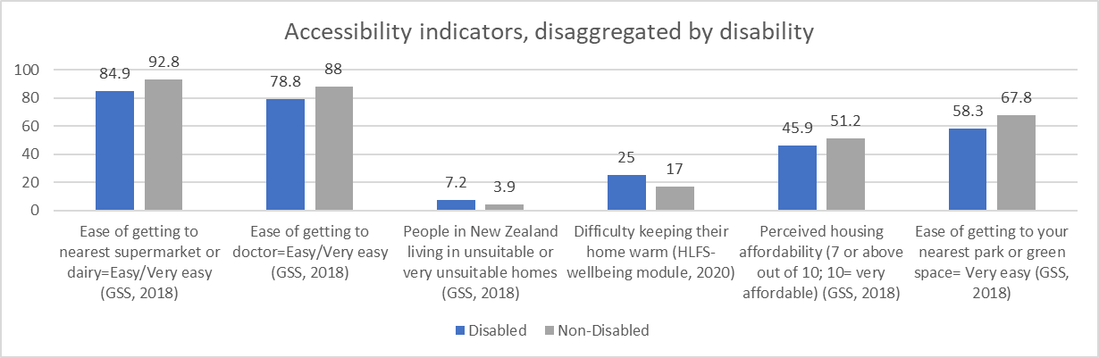

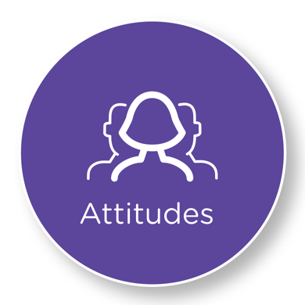

DAP Outcome Six: Attitudes
We are treated with dignity and respect.

In developing the DAP no specific actions or work programmes were identified or agreed to progress this outcome. The outcomes are seen as interconnected, and it was acknowledged that if the programmes of work achieve their intended outcome, a shift in attitudes will also be achieved.

Addressing attitudes is incorporated into a range of programmes, including, but not limited to:
- improving access and accessibility in education;
- improving employment outcomes;
- participation in sports and recreation; and
- the awareness raising, education and training programmes to support improving accessibility.

Indicators
ODI and DDEWG continue to develop and finalise indicators for the Disability Strategy Outcomes Framework. Performance on some measures related to this DAP Outcome Area is shown below. Appendix Three provides more detail on these indicators.

Outcome | Indicator description / Variables | Disabled (%) | Non-Disabled (%) | Data Source | Last updated
Attitudes | Proportion of people in New Zealand who have experienced discrimination in the past twelve months (GSS, 2018) | 20.7 | 17.3 | GSS | 2018
Attitudes | Proportion of people in New Zealand who have experienced discrimination when they were at work or while working&" (GSS, 2018)" | 20.9 | 9.4 | GSS | 2018
Attitudes | Experienced discrimination when using health services in the last 12 months. &" (GSS, 2018)" | 4.3 | 1 | GSS | 2018
Attitudes | Proportion rating it "Important" or "very important" that New Zealand becomes more accessible to live, work and travel in for people with a disability/access need. &" (Access, 2020)" | 97 | 93 | Access 2020 | 2020
Attitudes | High level for trust in the media (7 or above out of 10) (HLFS - wellbeing module, 2020) | 22.3 | 27 | HLFS- Wellbeing module | 2020

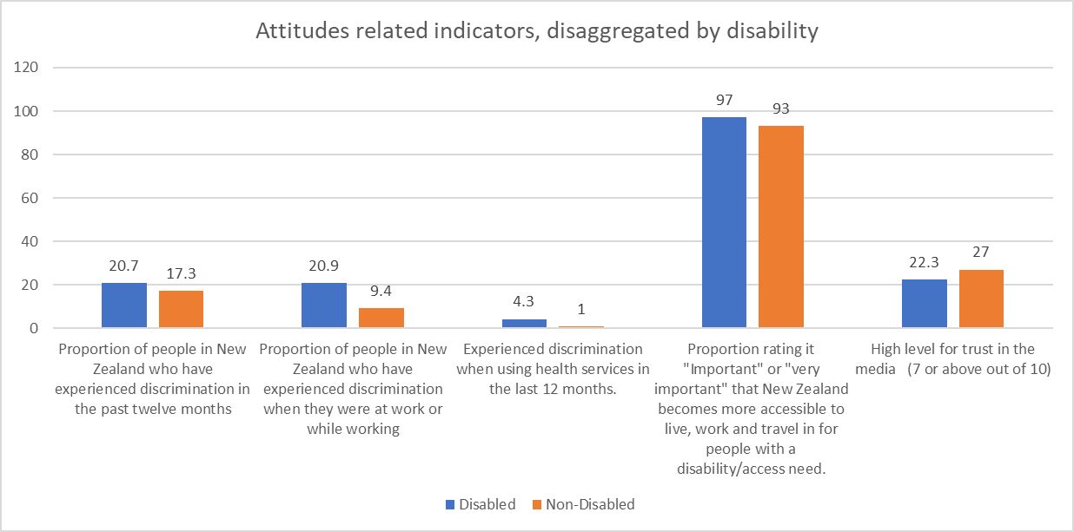

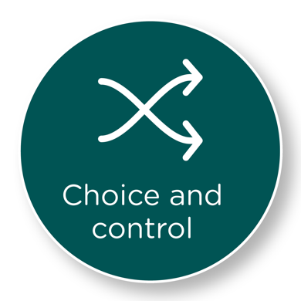

DAP Outcome Seven: Choice and Control
We have choice and control over our lives

Disability support system transformation
Transformation of the disability support system in line with the Enabling Good Lives (EGL) vision and principles is progressing and is a key strategic focus of the Ministry of Health.

The Disability Directorate within the Ministry of Health manages an annual appropriation of $1.7b from Vote Health to support approximately 40,000 eligible disabled people with long term supports provided through a suite of disability support services. This includes specialist disability services (e.g. Behaviour Support Services), support with everyday tasks (e.g. personal care or household management), and support and accommodation support (e.g. residential care). In addition, over 80,000 disabled New Zealanders have access to equipment and modification services and supports (e.g. hearing and vision services for people with a sensory disability).

Demonstrations of a transformed disability support system based on an EGL approach are being trialled in Christchurch and Waikato, and a prototype called Mana Whaikaha has been running in the MidCentral DHB region since 2018.

In 2021, the Ministry of Health will finalise an evidence brief, which will bring together evaluative information across the three EGL sites. This will inform advice that is being prepared for Ministers on the next steps for system transformation.

Supported decision making
During the COVID-19 lockdown MSD created a guide, Supported Decision Making, for managers of services and disabled people. As communities moved through the COVID-19 Alert Levels, the information aimed to remind managers or services, family/whānau, carers and supporters about their role when supporting people to make decisions for themselves. The information was translated into the five alternate formats: Braille; Large Print; Audio; Easy Read and New Zealand Sign Language.

Indicators
ODI and DDEWG continue to develop and finalise indicators for the Disability Strategy Outcomes Framework. Performance against only one indicator is available at this stage for this DAP Outcome Area. However, more indicators are in the process of being developed. Appendix Three provides more detail on the indicators.

Outcome | Indicator description / Variables | Disabled (%) | Non-Disabled (%) | Data Source | Last updated
Choice and control | Locus of control for people aged 15 years and over of Māori ethnicity and/or descent (1) (high rating of 7 or above out of 10) (Te Kupenga, 2018) | 13.5 | 83.5 | Te Kupenga, Stats NZ | 2018

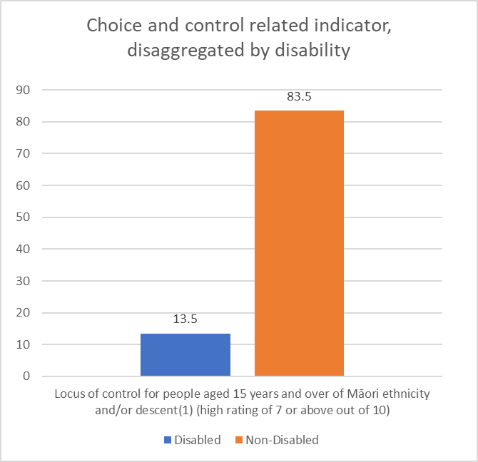



DAP Outcome Eight: Leadership
We have great opportunities to demonstrate our leadership
Nominations Database
ODI administers a Nominations Database for people with lived experience of disability who are interested in governance positions on Government Boards, Committees and Advisory Groups. The database aims to increase representation for disabled people on boards and in turn increase leadership and governance skills among the disabled community. There are currently 128 disabled people registered with the database.

ODI is part of a cross-agency group working towards improving diversity on government-appointed boards. There are four workstreams:
- building a value proposition for diversity on boards;
- addressing the lack of data on diversity on state sector boards;
- designing recruitment processes that are inclusive and transparent; and
- addressing the lack of accessible and targeted training and development.

During November 2020, ODI has teamed up with the Ministry for Women, Ministry of Pacific Peoples and Office of Ethnic Communities to run three trial Governance 101 workshops for people on our nominations databases. The workshops, run in Auckland, Wellington and Christchurch, will be evaluated by participants at the end of the workshop, and after six months, to inform further training opportunities.

Over the next year ODI will continue to work with the training and development workstream, and work to establish baseline data on the number of board members appointed through the Appointments and Honours Committee that are disabled people. ODI will also be contacting the 80 people who have indicated an interest in being on the database but have not completed the registration process.

Sir Robert Martin’s re-election to the United Nations Committee on the Rights of Persons with Disabilities
Sir Robert Martin (KNZM) was awarded a knighthood for his services to people with disabilities in October 2020.

In June 2016, Sir Robert was elected to the United Nations Committee on the Rights of Persons with Disabilities (UN Committee). The UN Committee is a body of 18 independent experts which monitors progress on implementation of the UNCRPD.

As the first person with a learning disability to serve on the UN Committee, Sir Robert has brought a valuable perspective to the role. He has been an advocate for the rights of people with a learning disability worldwide, particularly around issues such as independent living and supported decision-making.

New Zealand nominated Sir Robert for re-election to the UN Committee for the 2021-2024 term. The campaign for Sir Robert Martin’s re-election to the UN Committee was led by the Ministry of Foreign Affairs and Trade and ODI, alongside Sir Robert and People First New Zealand.

The election was deferred from June 2020 due to COVID-19 and was held virtually on 30 November. Sir Robert’s election for a second term on the UN Committee was successful.

Indicators
Indicators on leadership are currently being developed.

New Zealand Sign Language
The 2018 Census confirmed that 22,986 people can use New Zealand Sign Language (NZSL). NZSL, one of New Zealand’s official languages, remains a threatened language, with only 0.5 percent of the population using the language.

Demand for information in NZSL was highlighted throughout COVID-19 restrictions and the daily use of interpreters at the press conferences raised the visibility and status of NZSL as an official language in New Zealand. The NZSL Online Dictionary reported consistently higher user numbers during April 2020 than in previous years. The maintenance of the dictionary is a key strategic annual investment of the NZSL Fund.

The NZSL Board commissioned a series of ”by the community, for the community” NZSL videos during COVID-19. The videos focussed on everyday community issues and complemented the official Government messages.

COVID-19 had a significant impact on the NZSL Board work programme with many community grant projects and contracts needing to be extended. The Board took the opportunity to re-prioritise the work programme and consider how to better engage with the community, stakeholders and the Government.

NZSL Fund
The $1.645m per annum NZSL Fund, up by $395,000 from 2019, is allocated to activities designed to maintain and promote NZSL. In 2020, the following projects were funded:
- three-year contracting for the annual celebration of NZSL week;
- maintenance of the NZSL Online Dictionary;
- development of NZSL Interpreter Standards for general and legal settings; and
- thirteen community grants totalling $395,800, including four grants to support initiatives for the Māori Deaf community.

In May 2020, the NZSL Board committed $750,000 over five years to improve Māori Deaf access to Te Ao Māori and Te Reo Māori through NZSL. This initiative aligns with the NZSL Strategy 2018-2023, acknowledging the need to build capability and capacity for Māori Deaf before Te Ao Māori can be incorporated into NZSL.
NZSL Strategy Outcomes
Indicators to measure progress towards outcomes of the NZSL Strategy are being developed and will be discussed with the four government agencies critical to the maintenance and promotion of NZSL – Ministry of Education, Ministry of Health, Ministry of Justice and MSD by early 2021.

NZSL Board
ODI carried out a review of aspects of the NZSL Board Terms of Reference, gathering information from past and current members and the original Expert Advisory Group. Minor adjustments were made to strengthen governance processes from June 2020 onwards.

Logo
After five years of operation, the Board also updated its logo to better reflect the vibrancy of the language and its focus on the promotion of NZSL via transmission of the language within the Deaf community and in the wider society. Developing separate public-facing logos for the NZSL Board and the NZSL Fund enables a clear delineation between the Board’s work and that carried out by the wider community.
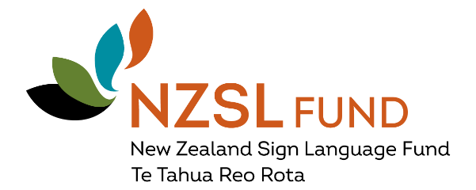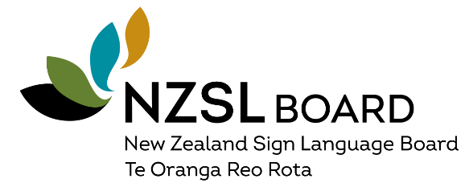

i.Lead
The i.Lead symposium in September 2019 was a forum for young disabled people from across New Zealand to come together and make their voices heard on the issues and barriers they face. The symposium aimed to empower young disabled people to be heard and participate in civil engagement.

ODI held a cross-agency working group meeting in September 2020 to discuss how to best respond to the recommendations from the 2019 conference. ODI will coordinate a cross-government response in early April 2021. The response aims to acknowledge the mahi the i.Lead Committee has put in and to indicate that their recommendations are being actively considered.

ODI continues to work with i.Lead and Yes Disability Resource Centre to establish their regional network. Initial locations being considered match the EGL locations and include Mid-Central (through Mana Whaikaha), Christchurch and Whangarei.

Disability Data
Improving the collection and analysis of data on disabled New Zealanders has been identified as a priority in the DAP. Having timely, reliable, and accessible data to inform policy and service development and delivery is crucial if disabled people in New Zealand are to have equal opportunities to participate in society.. The old adage, “if you aren’t counted, you don’t count”, holds true.

DDEWG comprises representatives from Disabled People’s Organisations, several government agencies, key service providers, and universities. It is jointly led by Statistics NZ and ODI. DDEWG developed its programme of work in 2020. The programme is managed by MSD and comprises five areas:
- development of key messages;
- resources;
- collection and use of data;
- research; and
- reporting progress.

DDEWG has secured funding of $60,000 to commission a project to develop resources to support the collection and analysis data and evidence on disability in New Zealand. This will be used to develop a toolkit resource for the State Sector.

New Zealand Disability Strategy 2016-2026 Outcomes Framework
ODI has continued to develop and finalise indicators for the Disability Strategy Outcomes Framework, building on the 2017 work with the New Zealand Strategy Revision Reference Group and Statistics NZ. 28 high-level indicators have been identified across the Disability Strategy’s eight outcome domains.

There has been an overall improvement in the availability of disability data in the last few years. To date, 258 measures have been identified. Further work on prioritising and refining indicators and measures will continue in 2021 to support reporting. We are now at a point where we can start reporting on New Zealand’s progress against DAP outcome measures agreed to date. This will be complemented by agencies disaggregating by disability the data they collect.

Disaggregated disability data is one of the cross-cutting themes of the DAP. In late 2020, the Ministry of Health published its New Zealand Health Survey statistics with disability status comparisons. This information will support many initiatives and particularly the health-focussed DAP work programmes to improve disabled people’s health outcomes and access to health services.

A number of reports were released in 2020 that provide information on disabled people in New Zealand and support monitoring of the DAP outcome measures. These reports include data from: Te Kupenga, Measuring equality for disabled New Zealanders, the NZ Health Survey, the NZ Crime and Victimisation Survey, Access 2020, and the NZ Household Labour Force Survey (including the additional Wellbeing Supplement that was included this year to monitor the impacts of COVID-19).

New Zealand’s International Obligations
COVID-19 has impacted on the work of UN Committees and forums with many international events being held virtually or deferred. ODI has participated in a range of COVID-19 specific international (virtual) events to support and learn from what other jurisdictions were doing.

Making Disability Rights Real, the third report of the Independent Monitoring Mechanism (IMM), was launched on 30 June 2020. It reports on the status of implementation of the UNCRPD in New Zealand. The IMM considers that education, housing, and seclusion and restraint are the most pressing issues for disabled people that the Government must take urgent action on. The report will guide development and monitoring of DAP work programmes focussed on disability.

Section three: Looking forward to 2021 and beyond
A key priority in 2021 will be supporting government agencies to respond to emerging needs from the COVID-19 pandemic, and ensuring the voice and needs of disabled people are included in planning for the welfare, economic and health response.

Also, important in 2021, will be continuing to monitor and implement the DAP work programmes, and prioritising strategic opportunities that will promote positive change for disabled New Zealanders and contribute to their wellbeing.

There may be other programmes of work identified for inclusion in the DAP. Government agencies continue to engage strongly with the DPO Coalition and other disability groups on development of work programmes focussed on disability.

Key work programme areas/achievements for 2021 include:
- Ara Poutama Aotearoa Disability Action Plan;
- launch of Kia Ōrite, a code of practice for an inclusive tertiary education environment for students with impairments;
- launch of Sport NZ Disability Fund;
- Action Plan developed for implementation of Better Later Life – He Oranga Kaumātua Strategy;
- detailed legislative framework and policy proposals for accelerating accessibility developed with report back to Cabinet in May 2021;
- Ministry of Transport review of the Total Mobility Scheme;
- Public Transport Design Guidelines and revised requirements for Urban Buses in New Zealand;
- Joint Venture report on violence prevention initiatives and recommendations for longer-term investment in violence prevention for diverse communities;
- consideration of machinery of government settings for disability funding and provision of services to support changes identified through the Health and Disability Review; and
- finalising EGL evidence brief and advice for Ministers on the next steps for system transformation.

Appendix one: Relationship between the UNCRPD, the New Zealand Disability Strategy, and the Disability Action Plan
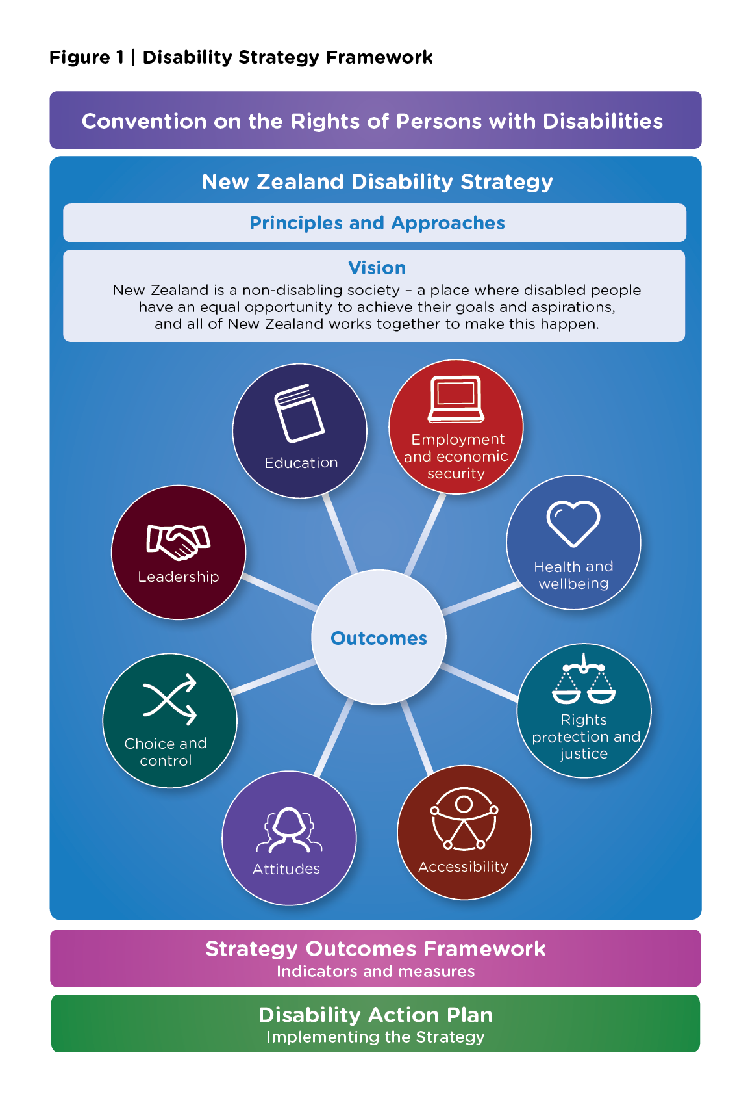

Appendix two: Disability Action Plan 2019-2023
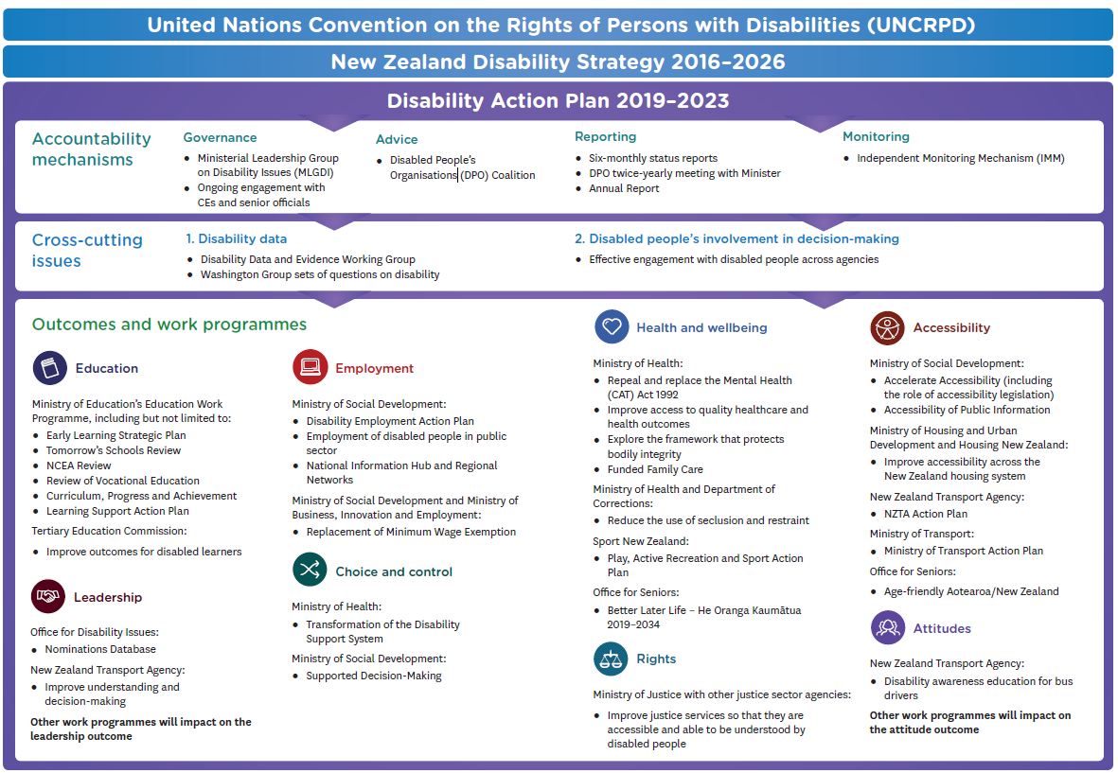

Appendix Three: DAP Outcome Indicators
This table displays a selection of agreed indicators, and their data sources, against some of the Disability Action Plan outcomes to illustrate the progress to improve data collection and monitoring.
Outcome | Indicator description / Variables | Disabled (%) | Non-Disabled (%) | Data Source | Last updated
Education | Proportion of people that have attained NCEA level 3 qualification (MOE, 2020) | 33 | 58 | Ministry of Education | 2020
Education | Proportion of people with a post-school qualification as highest qualification (Level 1+, Bachelor's, Postgrad & higher) (HLFS, 2020) | 39.1 | 55.4 | Household Labour Force Survey (HLFS) | 2020
Education | Proportion of people that are enrolled in non-compulsory education (HLFS, 2020) | 3.4 | 11.6 | HLFS | 2019
Education | Proportion of Māori and Pasifika youth that feel like a part of school (Youth, 2019) | 64.7 | 88.8 | National Youth Health and Wellbeing Survey | 2019
Education | Proportion of people that hold a high level of trust (7 or above out of 10) for the education system (GSS, 2018) | 54 | 66.9 | NZ General Social Survey (GSS) | 2018
Employment | Employment rate (HLFS, 2020) | 22.5 | 69.3 | HLFS | 2020
Employment | Unemployment rate (HLFS, 2020) | 7.4 | 3.9 | HLFS | 2020
Employment | Labour force participation rate (HLFS, 2020) | 24.3 | 72.1 | HLFS | 2020
Employment | Underutilisation rate (HLFS, 2020) | 21.6 | 11.6 | HLFS | 2020
Employment | Job Satisfaction = "Satisfied or very satisfied" for main job in last 4 weeks for employed people aged 15+ (GSS, 2018) | 63.6 | 77.3 | GSS | 2018
Employment | Hourly wage above the household median (HLFS, 2020) | 37.7 | 50.2 | HLFS | 2019
Employment | Adequacy of income to meet everyday needs: "Enough money/More than enough money" (HLFS - wellbeing module, 2020) | 55.7 | 71.2 | HLFS-wellbeing module | 2020
Health and wellbeing | Experienced one or more types of unmet need for primary health care in the past 12 months (NZHS, 2019/20) | 47 | 29.4 | New Zealand Health Survey (NZHS)
Health and wellbeing | Psychological distress in the last 4 weeks (NZHS, 2019/20) | 27 | 5.7 | NZHS | 2018/2019
Health and wellbeing | Proportion of Māori/Pasifika youth that have attempted suicide in the last year (Youth19,2019) | 22.7 | 8.3 | Youth19 | 2019
Health and wellbeing | Good, very good, or excellent self-rated health (NZHS, 2019/20) | 56 | 89.9 | NZHS | 2019/20
Health and wellbeing | Felt lonely "most" or "all of the time" in the last 4 weeks. (GSS, 2018) | 9.2 | 3.5 | GSS | 2018
Health and wellbeing | High level of satisfaction (7 rating or above out of 10) (GSS, 2018) | 64.8 | 82.5 | GSS | 2018
Health and wellbeing | High level of life worthwhile (7 rating or above out of 10) (GSS, 2018) | 75 | 88.9 | GSS | 2018
Rights, protection and justice | Age standardised victimisation rate (NZCVS, 2018/19) | 40 | 30 | NZ Crime and Victims Survey | 2018/19
Rights, protection and justice | Feeling of safety when at home by yourself at night (feeling safe/very safe) (HLFS-Wellbeing module, 2020) | 81 | 87.2 | HLFS - Wellbeing module | 2020
Rights, protection and justice | Feeling of safety when walking alone in the neighbourhood after dark (feeling safe/very safe) (HLFS-Wellbeing module, 2020) | 60.9 | 75.3 | HLFS- Wellbeing module | 2020
Rights, protection and justice | Feeling of safety when using/waiting for public transport at night(feeling safe/very safe) (HLFS-Wellbeing module, 2020) | 39.2 | 53.8 | HLFS- Wellbeing module | 2020
Rights, protection and justice | Feeling of safety when using the internet for online transactions (GSS, 2018) | 56.8 | 72.8 | GSS | 2018
Accessibility | Ease of getting to nearest supermarket or dairy=Easy/Very easy (GSS, 2018) | 84.9 | 92.8 | GSS | 2018
Accessibility | Ease of getting to doctor=Easy/Very easy (GSS, 2018) | 78.8 | 88 | GSS | 2018
Accessibility | People in New Zealand living in unsuitable or very unsuitable homes (GSS, 2018) | 7.2 | 3.9 | GSS | 2018
Accessibility | Difficulty keeping their home warm (HLFS-wellbeing module, 2020) | 25 | 17 | HLFS- Wellbeing module | 2020
Accessibility | Perceived housing affordability (7 or above out of 10; 10 = very affordable) (GSS, 2018) | 45.9 | 51.2 | GSS | 2018
Accessibility | Ease of getting to your nearest park or green space = Very easy (GSS, 2018) | 58.3 | 67.8 | GSS | 2018
Attitudes | Proportion of people in New Zealand who have experienced discrimination in the past twelve months (GSS, 2018) | 20.7 | 17.3 | GSS | 2018
Attitudes | Proportion of people in New Zealand who have experienced discrimination when they were at work or while working&" (GSS, 2018)" | 20.9 | 9.4 | GSS | 2018
Attitudes | Experienced discrimination when using health services in the last 12 months. &" (GSS, 2018)" | 4.3 | 1 | GSS | 2018
Attitudes | Proportion rating it "Important" or "very important" that New Zealand becomes more accessible to live, work and travel in for people with a disability/access need. &" (Access, 2020)" | 97 | 93 | Access 2020 | 2020
Attitudes | High level for trust in the media (7 or above out of 10) (HLFS - wellbeing module, 2020) | 22.3 | 27 | HLFS- Wellbeing module | 2020
Choice and control | Locus of control for people aged 15 years and over of Māori ethnicity and/or descent (1) (high rating of 7 or above out of 10) (Te Kupenga, 2018) | 13.5 | 83.5 | Te Kupenga, Stats NZ | 2018

2013 Census
The New Zealand Disability Strategy 2016-2026: https://www.odi.govt.nz/nz-disability-strategy/about-the-strategy/new-zealand-disability-strategy-2016-2026/.
The full report can be found here:https://www.nzta.govt.nz/resources/covid-19-impacts-on-transport/
A summary of the Disability Action Plan is attached as Appendix Two.
The relationship between the UNCRPD, the Disability Strategy and the Disability Action Plan is illustrated in Appendix One.
http://msd.govt.nz/what-we-can-do/disability-services/disability-employment-action-plan/index.html
https://www.msd.govt.nz/about-msd-and-our-work/work-programmes/initiatives/disabilityconfidentnz/lead-toolkit/index.html
http://www.superseniors.msd.govt.nz/
https://www.justice.govt.nz/justice-sector-policy/key-initiatives/reducing-family-and-sexual-violence/work-programme/
https://www.odi.govt.nz/guidance-and-resources/the-accessibility-charter/
The Access Alliance is a group of representatives from Disabled People’s Organisations, disability service providers, and community and disability advocacy organisations campaigning for accessibility legislation.
The Ministry of Health funds supports for disabled people (mainly) under the age of 65 who have a physical, intellectual or sensory disability (or a combination of these) which is likely to continue for at least 6 months and limits their ability to function independently to the extent that ongoing support is required. DHBs fund disability support services for older people, people with long-term conditions, and mental health and addiction needs.
http://msd.govt.nz/about-msd-and-our-work/work-programmes/accessibility/supported-decision-making.html
www.ileadchange.org
https://www.hrc.co.nz/our-work/people-disabilities/making-disability-rights-real/
New Zealand’s IMM partners are the Disabled People’s Organisations’ (DPO) Coalition, the Ombudsman, and the New Zealand Human Rights Commission.

