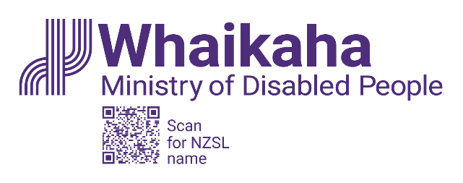
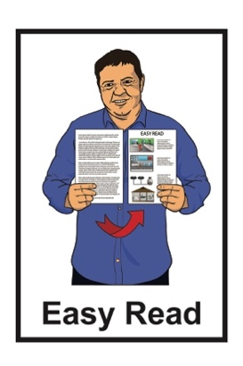

Getting the money to change the disability system
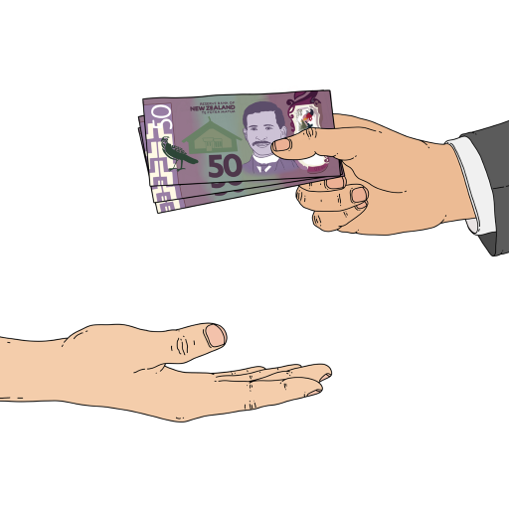

Published: February 2023

Before you start

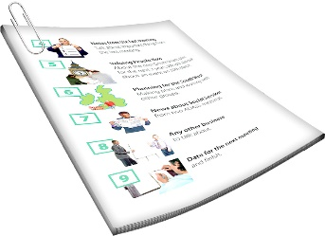
This is a long document.


It can be hard for some people to read a document this long.

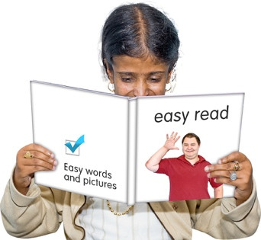
Some things you can do to make it easier are:
read it a few pages at a time
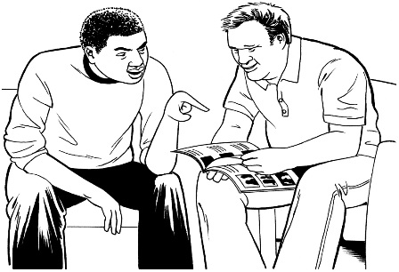
set aside some quiet time to look at it
have someone read it with you to support you to understand it.

What you will find in this document

Page number:


What is this document about? 4


What was the decision about? 6

How much money could Whaikaha
have got? 8
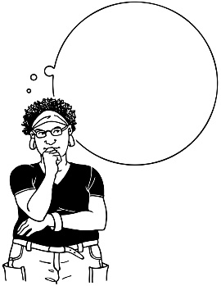
$

How much money will Whaikaha
now get? 9
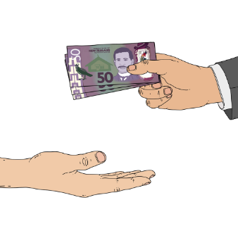

What is the money being
used for? 11

Page number:

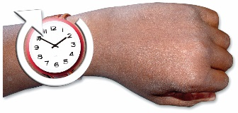
How long will this work take? 15


What will the changes look
like? 18


What are the risks? 22

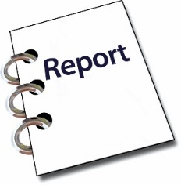
How will the money be made
to last? 26

Making reports 28
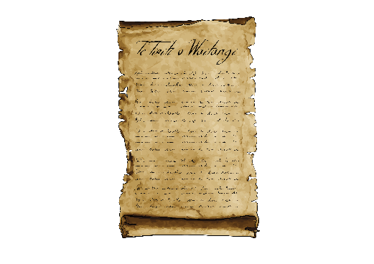

How do the changes fit in with
Te Tiriti o Waitangi? 30


Where to get more information 32

What is this document about?

This Easy Read document is about:
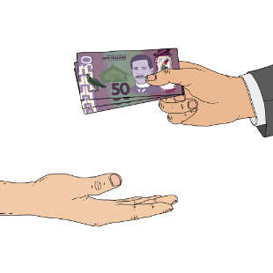
- how much money there is in the Budget for changing the disability support system
- how the money will be used to change the disability support system.

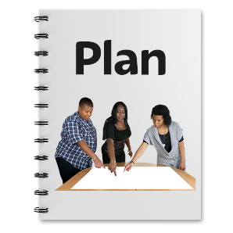
The Budget is the plan the Government makes for spending money on services in Aotearoa New Zealand.

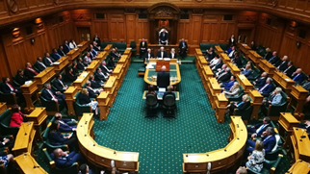
How Whaikaha – Ministry of Disabled People gets the money was a joint ministers decision.


A joint ministers decision is when different government ministers work together to make up their mind about something.


The full decision can be read at this website:

tinyurl.com/mr72e386

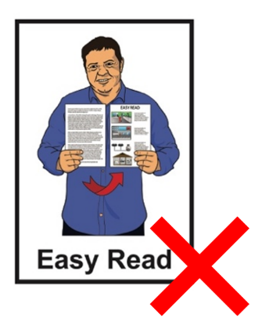
This website is not in Easy Read.

What was the decision about?

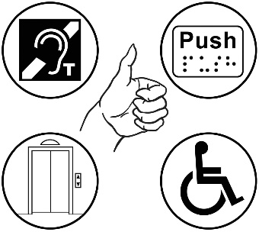
Whaikaha – Ministry of Disabled People decided they were ready to start the next steps in changing the disability support system.

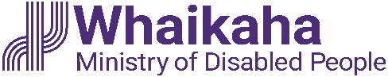
In this Easy Read document Whaikaha – Ministry of Disabled People will be called Whaikaha.

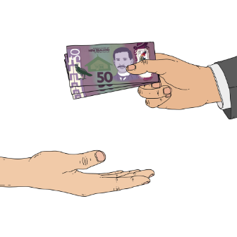
Whaikaha needs money from the Government to make changes to the disability system.


Whaikaha asked for the money from:
- the former Associate Minister of Finance
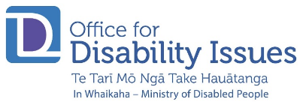
- the former Minister for Disability Issues.


Here former means the person who was Minister in the past.


Both Ministers said that Whaikaha could have the money.

How much money could Whaikaha have got?

Whaikaha were told they could get 2 different lots of money.

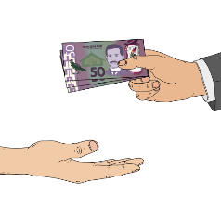
The first amount was
1 hundred million dollars.

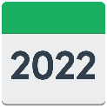
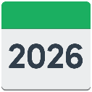
This amount would be used over
4 years from 2022 to 2026.

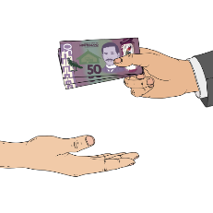
The second amount was
40 and a half million dollars a year.

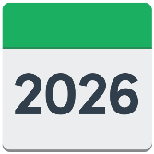
This amount would be used in the years after 2026.

How much money will Whaikaha now get?


The Government decided to change these amounts of money Whaikaha will get.

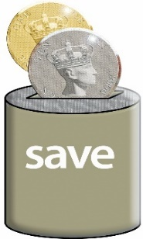
The Government did this because they wanted to save money.

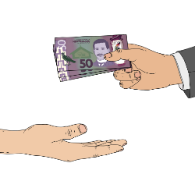
The first amount of money Whaikaha will get is now about
73 and a half million dollars.

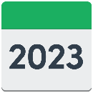
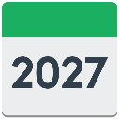
This amount will be used over 4 years from 2023 to 2027.

The second amount is still
40 and a half million dollars a year.

This amount will be used in the years after 2027.

What is the money being used for?


The money will let Whaikaha work on:
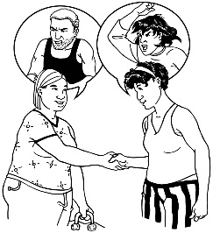
- making things safer for people who might get abused

- bringing Enabling Good Lives to 2 new communities
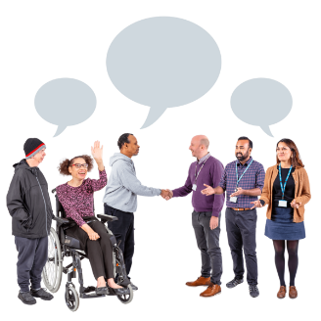
- changing the disability support system
- building support for communities to work together
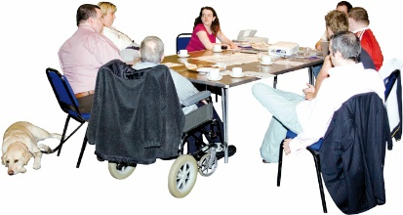
- creating the Transformation Management Board.

Enabling Good Lives is a different way of thinking about disability support.
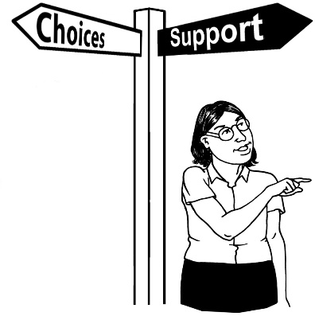

Enabling Good Lives is about having:
- choice / control in your life

- support you can use to do the things that are most important to you
- a good life.

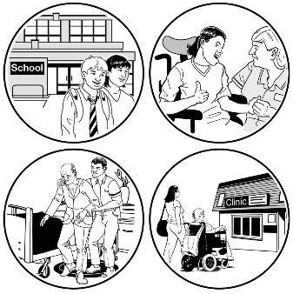
The Transformation Management Board is a group of people who will make the decisions about changing the disability support system.

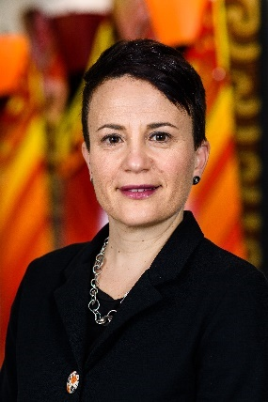
The Transformation Board will be headed by the Chief Executive.

The Chief Executive of Whaikaha is Paula Tesoriero.

The Chief Executive:
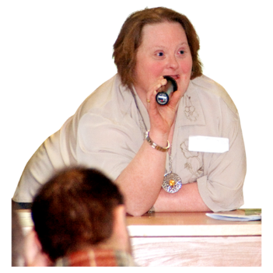
- is the leader of Whaikaha
- will lead the talks about making the changes to the disability support system.

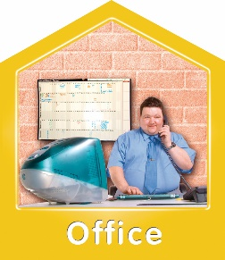
The Transformation Board will be supported by the Transformation Management Office.

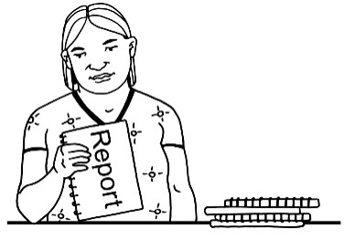
The Transformation Management Office will lead the work to change the disability support system.

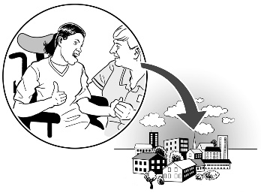
All these people will work with people in the disability community to make the changes happen.

How long will this work take?


Whaikaha thinks this work will take 10 years.

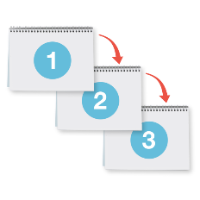
The work will be done in 3 phases.

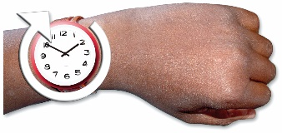
A phase is a part of the time in which things are done.

Phase 1

Whaikaha says that Phase 1:
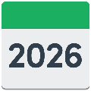
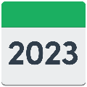
- will happen from 2023 until 2026
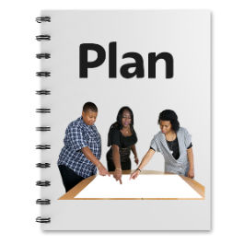
- is about planning the work
- is about creating the work for the next 2 phases.

Phase 2

Whaikaha says that Phase 2:
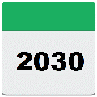
- will happen from 2026 until 2030
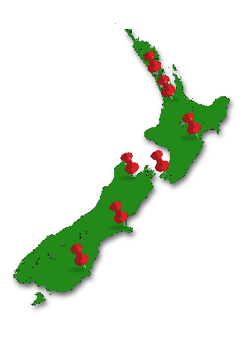
- is about putting Enabling Good Lives principles into everything Whaikaha does
- is about making Enabling Good Lives work across New Zealand.


Here a principle is an idea that guides an organisation to reach its goals.

Phase 3

Whaikaha says that Phase 3 will:
- happen from 2030

- is about making sure all the changes are working properly
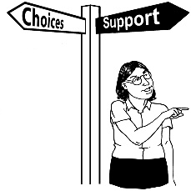
- is about changing the the disability support system other parts of the Government offer.

What will the changes look like?

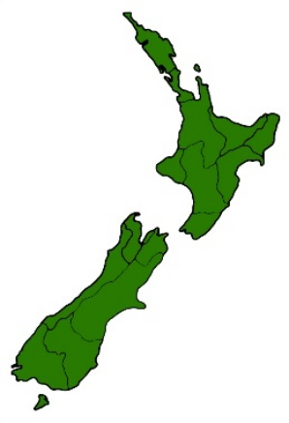
The changed disability support system will focus on the regions of Aotearoa New Zealand.

There will be 10 or 11 regional sites.


Each region will:
- have a Regional Director
- control the day to day work
- choose how they spend the money the Government gives them.

Regional sites will:
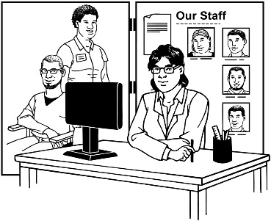
- invest in disabled people / whānau
- employ people who work as connectors.

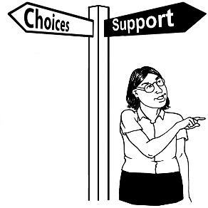
To invest in someone means:
- giving them the money they need
- giving them the support they need.

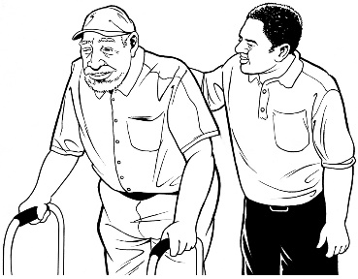
Connectors are people who support disabled people to make a life that is connected to their community.


Each region will have budget advisors.

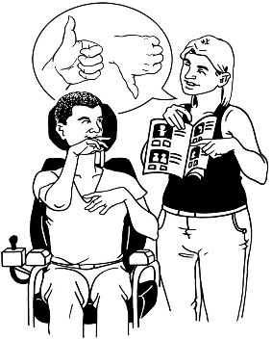
A budget advisor works with a person to decide how they use their money.

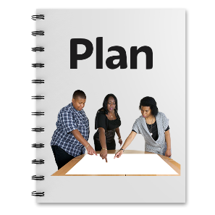
The budget advisor will then give money to the personal budget of the disabled person.

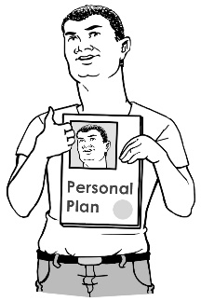
A personal budget is the plan a person uses for spending their money.


There will be purchasing guidelines.

Purchasing guidelines are rules for how the money can be used.
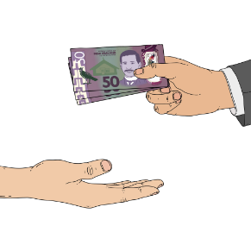
Budget advisors may also give money to support a person to move on from a crisis.

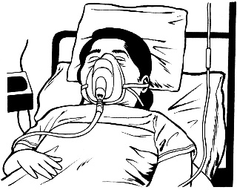
A crisis is a bad thing that happens to a person like:

- being very sick
- a natural disaster.

What are the risks?


Whaikaha has thought about the risks to changing the disability support system.

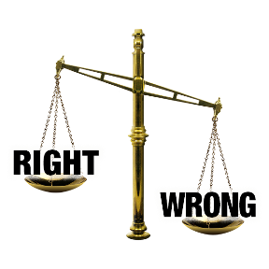
Risks means the chance of something going wrong.

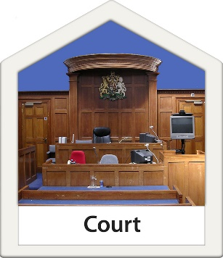
They think there are risks that will come up from the paid family carer dispute.


The paid family carer dispute is a court case where people are asking questions about who employs family carers.


Whaikaha thinks the Court of Appeal decision might make it harder to make some of the big changes to the disability support system.

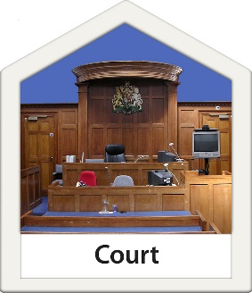
The Court of Appeal is where someone asks the court to change a decision made in the past.


Whaikaha will talk about the Court of Appeal decision when they have had time to think about it.

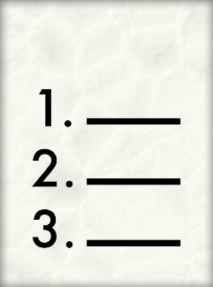
Whaikaha will also talk about the legal things they need to do to make the changes to the disability support system.

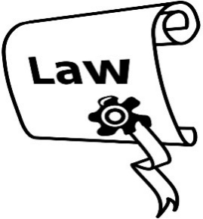
Legal means things that are connected to the law.
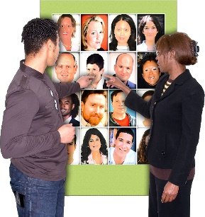
Whaikaha has also thought about what happens if:
- regions cannot get workers quickly

- the community gets upset at how slowly things are happening
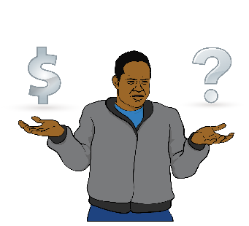
- the money is not split fairly between people
- personal budgets are not used for the right things
- the system changes do not work with Enabling Good Lives principles.


Whaikaha has worked out ways to deal with these problems.

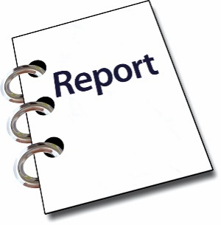
You can find out how Whaikaha will fix these problems in the full decision paper.

How will the money be made to last?

Whaikaha knows the cost of the disability support system has been growing fast.
$

The Government wants to make sure that as costs get bigger the money Whaikaha has pays for everything they need to do.

$

The Minister of Finance has asked people to work out a way to make the money last into the future.


The future is a time that has not happened yet.


This work will be done by people in:
- Whaikaha

- the Treasury.


The Treasury is a part of the Government that looks after things to do with money.

Making reports

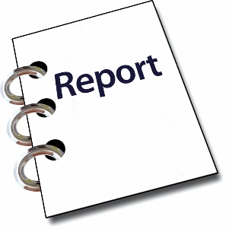
Whaikaha must make reports to the Cabinet about:
- system change
- funding.

Cabinet is a group of senior government ministers.

Cabinet meets in Parliament to make important decisions.

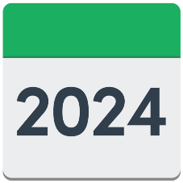
Whaikaha thinks they will make these reports in:
- early 2024
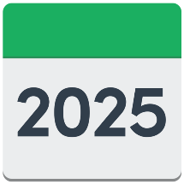
- late 2024
- mid 2025
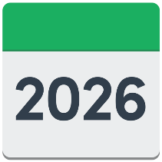
- September 2025
- at the time of the Budget 2026.

How do the changes fit in with Te Tiriti o Waitangi?

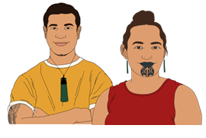
Te Tiriti o Waitangi / The Treaty of Waitangi is an important agreement between:
- Māori

and
- the Government.

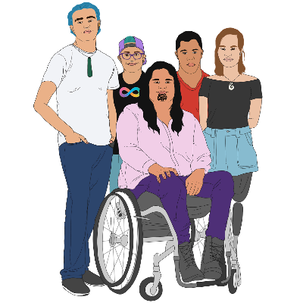
Māori are worried that the disability support system does not work well for:
- tāngata whaikaha Māori
- their whānau.

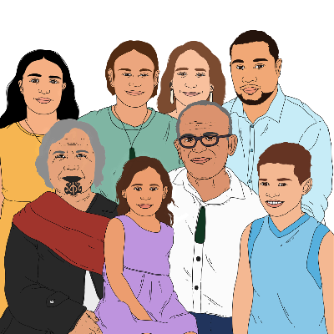
Disability services are not used very much by:
- tāngata whaikaha Māori
- their whānau.

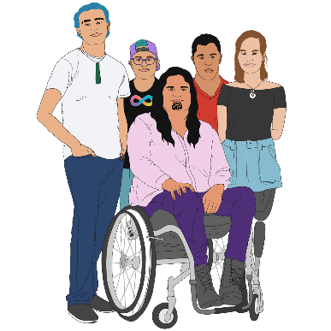
Whaikaha thinks the system changes
will:
- make the lifes of tāngata whaikaha Māori better
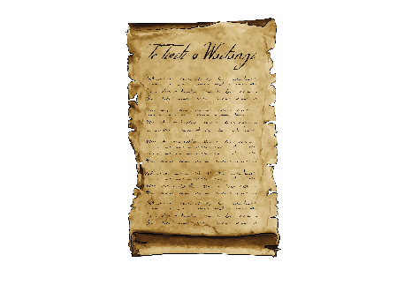
- fit in with the ideas in Te Tiriti o Waitangi / the Treaty of Waitangi.

Where to get more information

You can find more information about Whaikaha on this website:

www.whaikaha.govt.nz

You can contact Whaikaha by:

email at:
contact@whaikaha.govt.nz

phone on:
0800 566 601

text at:
4206


This information has been written by Whaikaha – Ministry of Disabled People.

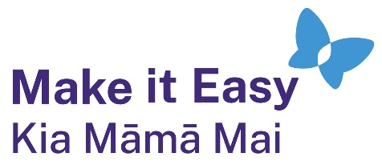
It has been translated into Easy Read by the Make it Easy Kia Māmā Mai service of People First New Zealand Ngā Tāngata Tuatahi.

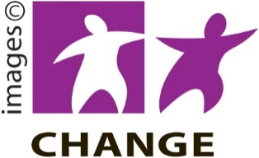
The ideas in this document are not the ideas of People First New Zealand Ngā Tāngata Tuatahi.

Make it Easy uses images from:


- Changepeople.org


            - Photosymbols.com

- SGC Image Works
- Huriana Kopeke-Te Aho

- T. Wood.

All images used in this Easy Read document are subject to copyright rules and cannot be used without permission.

